Revision activities
Data response 1
Morris Ltd and VH Engineering pic are both manufacturers of components used in UK car factories. Although both were founded in the 1980s, Morris Ltd has remained small, in contrast with VH Engineering pic which has pursued a strategy of rapid growth over the past 20 years.

Shareholders at VH Engineering pic are concerned that the company has developed a reputation of being slow to respond to market change. Although sales remain high, analysts attribute this to the firm's willingness to cut prices on its products which tend to offer fewer features than those of market-leading businesses.
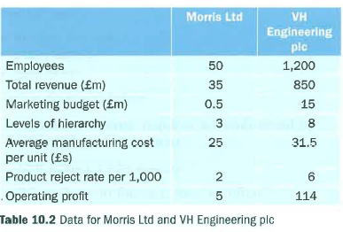
Questions (40 marks; 45 minutes)
1 Calculate the operating profit margin for both firms.(4)

2 Assess two possible reasons why cost per unit may be lower at Morris Ltd. (8)

3 Assess two possible reasons why Morris Ltd is faster at responding flexibly to changing customer needs. (8)

4 Evaluate the possible consequences of VH Engineering pic responding slowly to market change. (20)

