Revision questions

(25 marks; 25 minutes)
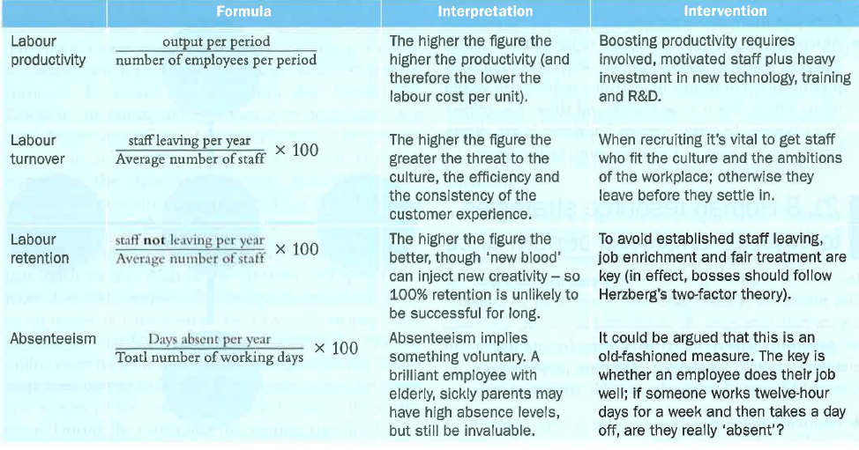

1 What may be the effects of managing human resources in the same way as all the other resources used by a business? (3)

2 Identify three important features of the job of a human resource manager. (3)

3 How could an increase in labour productivity help a firm to reduce its costs per unit? (3)

4 In what ways could a hotel business benefit if labour turnover rose from 2 to 15 per cent per year? (4)

5 Some fast food outlets have labour turnover as high as 100 per cent per year. What could be the effects of this on the firm? (4)

6 Explain two ways in which a human resources manager may be able to help increase productivity at a clothes shop. (8)

1 Evaluate the ways in which a firm may respond to an increasing rate of labour turnover. In your answer, refer to one retail business and one other organisation you have researched. (20)

