Trade Case Study: The making of the Wimbledon Tennis Ball
For the whole of the twentieth century, the tennis balls used at Wimbledon were manufactured in a factory in Barnsley, Yorkshire. However, in the early 2000s, Dunlop Slazenger’s decision to move tennis ball production to the Philippines provided an examples of the changing nature of international specialisation and division of labour. Before the Barnsley factory closure, the workers hoped that the EU would fund a new automated factory.
Although wages are higher in the UK than in the Philippines, increased labour productivity (amount goods and services produced by one hour of labour) might reduce costs and make production competitive. There would be fewer jobs in Barnsley, but the remaining jobs would be safe. But it was not to be. The factory closed and 134 workers lost their jobs. Dunlop Slazenger is just one of dozens of companies involved in the making of a tennis ball. All over the world right now, there are ships chugging across oceans towards Dunlop’s factory in the Philippines with a breathtakingly diverse range of ingredients.
Clay from South Carolina, sulphur from Korea, silica from mines in Greece, magnesium carbonate from Japan and zinc oxide from Thailand are but a few of the substances used to vulcanise the rubber and give it the right amount of stretch and bounce. The tins come from Indonesia; some of the dyes are shipped from the UK.

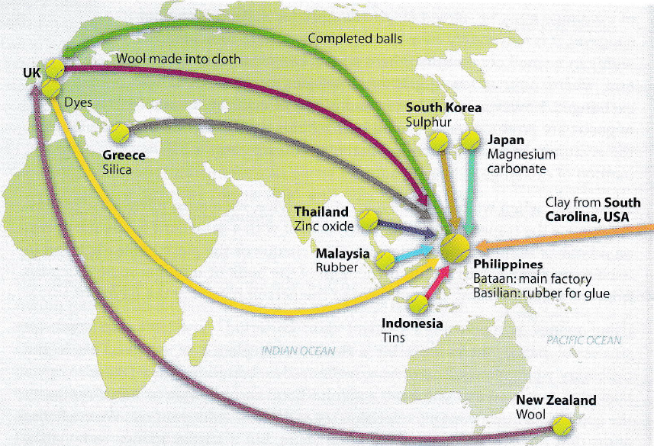

- Why do countries choose to trade with one another?
- What might be some disadvantages of trading with other countries?
- Can you think of any possible disadvantages of countries specialising?
- Explain why so many different countries contribute to producing the tennis ball, instead of one country producing the entire good? Refer to opportunity cost in your answer.

- Despite the benefits mentioned above, what extra costs are incurred through this method of many countries taking part in the production process?
Mr Wilson’s Thinking Further Challenge
How does the picture illustrate the changing nature of international specialisation and division of labour? Is this a good or bad occurrence? Considering current issues, what do you think the future holds for globalisation?

