4.2.4 Reasons for global mergers or joint ventures

Write a definition of joint ventures here:
________________________________________________________________________________________________________________________________________________________________________________________________________________________________________________________________________________________________________________________________________

Write a definition of mergers here:
________________________________________________________________________________________________________________________________________________________________________________________________________________________________________________________________________________________________________________________________________
Starter – joint venture or merger?
Sony Ericsson

Hero Honda

Exxon Mobil

Mars Wrigley

Spreading risk over different countries/regions

Spreading risk with a joint venture

Spreading risk with a merger

Entering new markets/trade blocs
Joint ventures and the Chinese car market

________________________________________________________________________________________________________________________________________________________________________________________________________________________________________________________________________________________________________________________________________

Joint ventures in Japan

________________________________________________________________________________________________________________________________________________________________________________________________________________________________________________________________________________________________________________________________________
Mergers and new markets
________________________________________________________________________________________________________________________________________________________________________________________________________________________________________________________________________________________________________________________________________

Advantages of joint ventures | Disadvantages of joint ventures

Acquiring national/international brand names/patents
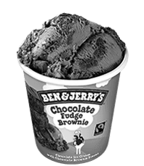
Brand name acquisition

________________________________________________________________________________________________________________________________________________________________________________________________________________________________________________________________________________________________________________________________________
Brand acquisition – Disney Pixar

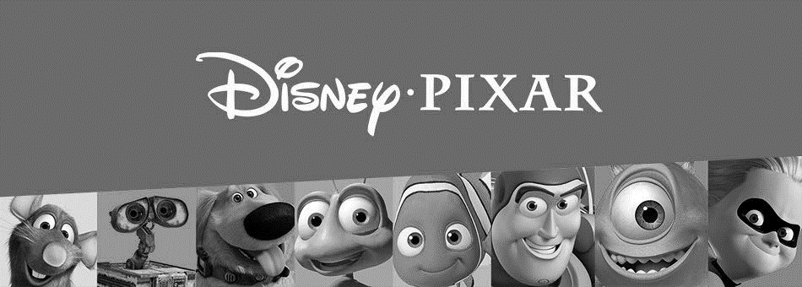
________________________________________________________________________________________________________________________________________________________________________________________________________________________________________________________________________________________________________________________________________

Brand Acquisition – Quaker and Snapple
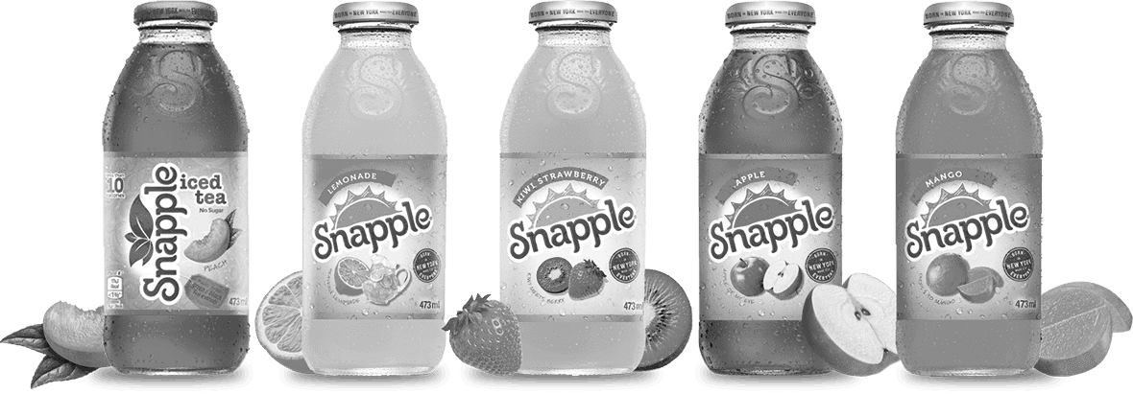
________________________________________________________________________________________________________________________________________________________________________________________________________________________________________________________________________________________________________________________________________
Patent acquisition

________________________________________________________________________________________________________________________________________________________________________________________________________________________________________________________________________________________________________________________________________
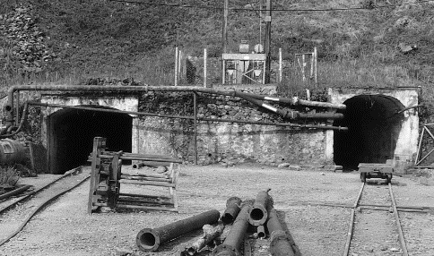
Securing resources/supplies

________________________________________________________________________________________________________________________________________________________________________________________________________________________________________________________________________________________________________________________________________
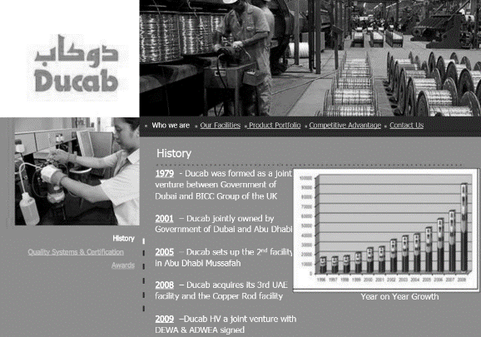
Maintaining global competitiveness

________________________________________________________________________________________________________________________________________________________________________________________________________________________________________________________________________________________________________________________________________

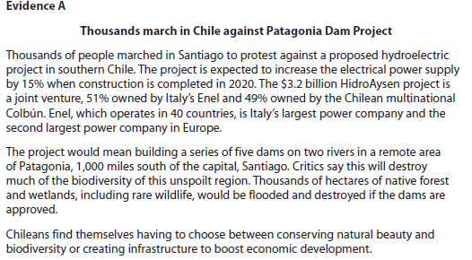
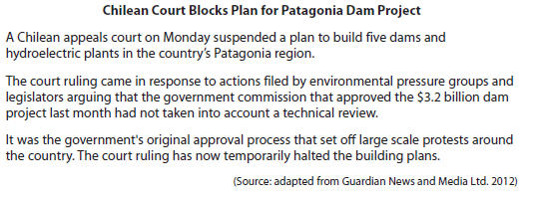

[6]

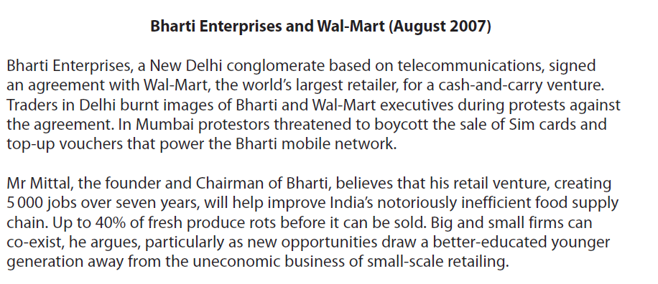

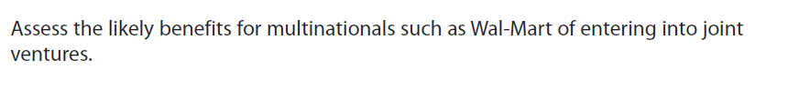

[8]

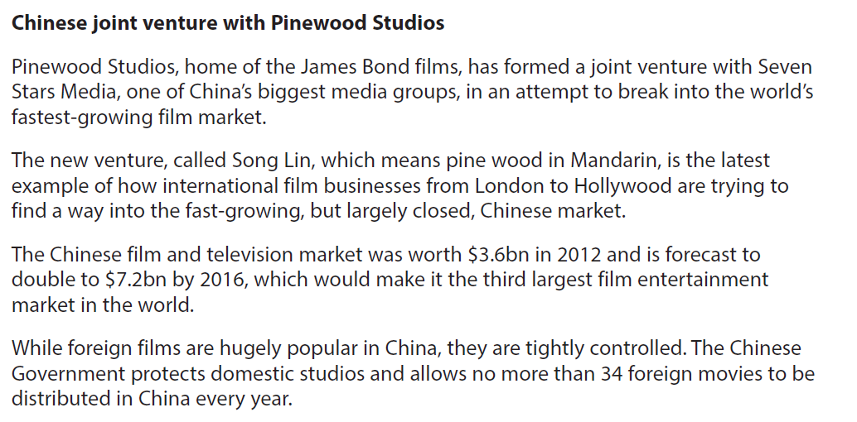

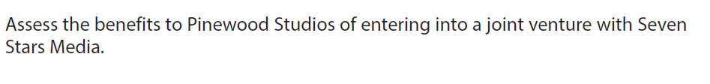

[8]

