3.5.3. Human resources

Write a definition of absenteeism here:
________________________________________________________________________________________________________________________________________________________________________________________________________________________________________________________________________________________________________________________________________
Calculations and interpretations
Labour Productivity
________________________________________________________________________________________________________________________________________________________________________________________________________________________________________________________________________________________________________________________________________
Labour productivity calculation:

Notes on productivity:
________________________________________________________________________________________________________________________________________________________________________________________________________________________________________________________________________________________________________________________________________
Labour Productivity Interpretation

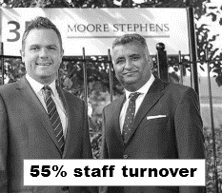
________________________________________________________________________________________________________________________________________________________________________________________________________________________________________________________________________________________________________________________________________
Labour Turnover Calculation

________________________________________________________________________________________________________________________________________________________________________________________________________________________________________________________________________________________________________________________________________

Labour turnover calculation:

Notes on calculation
________________________________________________________________________________________________________________________________________________________________________________________________________________________________________________________________________________________________________________________________________
Labour Turnover Interpretation
________________________________________________________________________________________________________________________________________________________________________________________________________________________________________________________________________________________________________________________________________

Absenteeism calculation:

Notes on calculation
________________________________________________________________________________________________________________________________________________________________________________________________________________________________________________________________________________________________________________________________________

Absenteeism Interpretation
________________________________________________________________________________________________________________________________________________________________________________________________________________________________________________________________________________________________________________________________________

Human resource strategies
Ways to reduce absenteeism

________________________________________________________________________________________________________________________________________________________________________________________________________________________________________________________________________________________________________________________________________
Financial rewards
________________________________________________________________________________________________________________________________________________________________________________________________________________________________________________________________________________________________________________________________________

Employee share ownership
________________________________________________________________________________________________________________________________________________________________________________________________________________________________________________________________________________________________________________________________________

Consultation strategies
________________________________________________________________________________________________________________________________________________________________________________________________________________________________________________________________________________________________________________________________________
Empowerment strategies
________________________________________________________________________________________________________________________________________________________________________________________________________________________________________________________________________________________________________________________________________

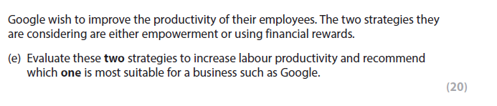

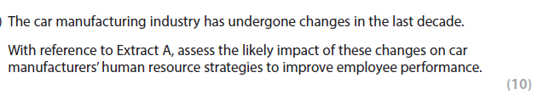

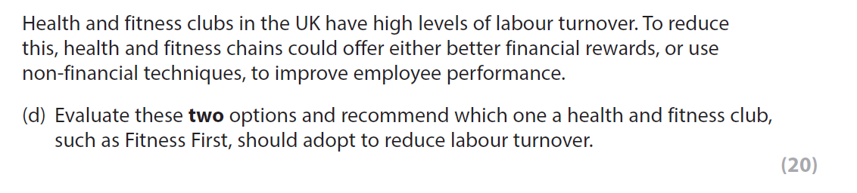

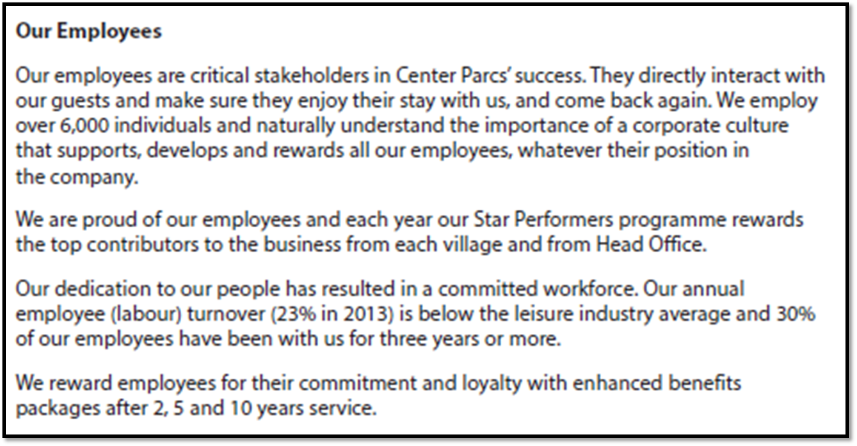
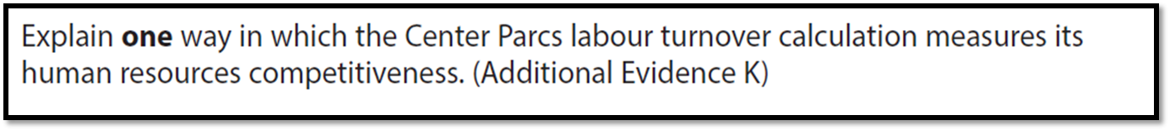
[4]

