Q1. Humans use receptors to help them to respond to stimuli in the environment. Match up each receptor with the correct sense. One has been done for you.
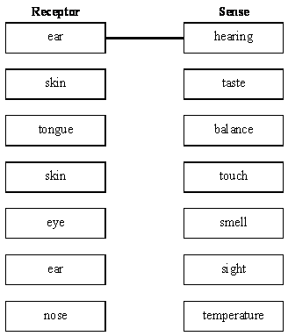
(Total 5 marks)

Q2.Car drivers need quick reactions to avoid accidents.
A student uses a computer program to measure reaction time.
The computer screen shows a traffic light on red. The traffic light then changes to green.
The diagram below shows the change the person sees on the computer screen.
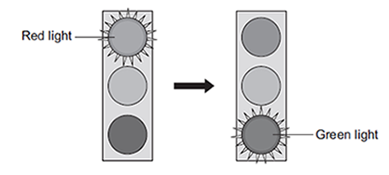
When the traffic light changes to green the person has to click the computer mouse as quickly as possible.
The computer program works out the time taken to react to the light changing colour.
(a) Special cells detect the change in colour.
(i) What word is used to describe special cells that detect a change in the environment?
Draw a ring around the correct answer.
(1)

(ii) Where in the body are the special cells that detect the change in colour of the traffic lights?
...................................................................................................................
(1)

(b) The student used the computer program on one computer to measure the reaction times of people of different ages.
(i) Give one variable the student should control so that a fair comparison can be made between the people of different ages.
...................................................................................................................
...................................................................................................................
(1)

(ii) The student did each measurement three times to calculate a mean value.
The table shows the results.

 | Age in years | Mean reaction time in milliseconds
 | 15 | 242
 | 30
 | 45 | 221
 | 60 | 258
 | 75 | 364
 | 90 | 526

The reaction times for the 30-year-old person were 192, 174 and 180 milliseconds.
Calculate the mean reaction time of the 30-year-old person.
...................................................................................................................
...................................................................................................................
Mean reaction time = ..................................... milliseconds
(1)

(iii) Which one of the following is an advantage of repeating each test three times and not doing the test just once?

Tick (✔) one box.
Any anomalies can be identified.
The results will be more precise.
There will be no errors.

(1)

(iv) Some people think that old people should not be allowed to drive a car.
Why is it more dangerous for old people to drive cars?
Use information from the table above to support your answer.
...................................................................................................................
...................................................................................................................
...................................................................................................................
...................................................................................................................
(2)
(Total 7 marks)

Q3. Reflex actions are rapid and automatic.
(a) Name the following structures in a reflex action.
(i) The structure that detects the stimulus.
...........................................................................................................................
(1)

(ii) The neurone that carries impulses to the central nervous system.
...........................................................................................................................
(1)

(iii) The neurone that carries impulses away from the central nervous system.
...........................................................................................................................
(1)

(iv) The structure that brings about the response.
...........................................................................................................................
(1)

(b) Describe what happens at a synapse when an impulse arrives.
.....................................................................................................................................
.....................................................................................................................................
.....................................................................................................................................
.....................................................................................................................................
.....................................................................................................................................
(2)

(c) Some people have a condition in which information from the skin does not reach the brain.
Explain why this is dangerous for the person.
.....................................................................................................................................
.....................................................................................................................................
.....................................................................................................................................
.....................................................................................................................................
.....................................................................................................................................
(2)
(Total 8 marks)

Q4.(a) Diagram 1 shows the neurones and parts of the body involved in a response to touching a hot object.

Diagram 1
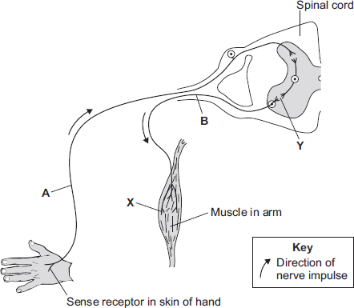

A neurone is a nerve cell. Neurones carry impulses around the body.
(i) Draw a ring around the correct answer to complete each sentence.

 | Neurone A is a | motor neurone.  relay neurone.  sensory neurone.

 | At point Y there is a tiny gap between two neurones called | an effector.  a receptor.  a synapse.

(2)

(ii) The hand touches a hot object. An impulse travels through the nervous system to the muscle (point X). The muscle moves the hand away from the hot object.
What does the muscle do to move the hand away from the hot object?
Tick () one box.
contract
relax
stretch

(1)

(iii) The action described in part (a) (ii) is a reflex action.
How can you tell that this action is not a conscious action?
Use information from the diagram.
...............................................................................................................
...............................................................................................................
(1)

(iv) Reflex actions like this are useful.
Explain why.
...............................................................................................................
...............................................................................................................
...............................................................................................................
...............................................................................................................
(2)

(b) Some students investigated the effect of caffeine on a person’s reaction time.
The students used the following steps.
1. One student held a ruler just above a second student’s hand, as shown in Diagram 2.

Diagram 2
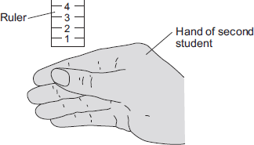

2. The student let go of the ruler. The second student caught it as soon as possible, as shown in Diagram 3.

Diagram 3
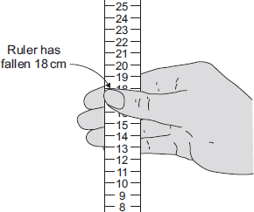

3. The students repeated this experiment seven more times.
4. The student catching the ruler then drank a cup of strong coffee.
Coffee contains caffeine.
5. Fifteen minutes after drinking the coffee the students repeated steps 1 to 3.
Table 1 and Table 2 show the students’ results.

 | Table 1 |  | Table 2
 | Distance ruler fell  before it was caught  in cm |  | Distance ruler fell  before it was caught  in cm
 | Before drinking coffee |  | After drinking coffee
 | 18 |  | 8
 | 21 |  | 13
 | 25 |  | 11
 | 15 |  | 17
 | 19 |  | 10
 | 16 |  | 14
 | 12 |  | 13
 | 21 |  | 13
 | Mean = 18.4 |  | Mean = 12.4

(i) The students used the reading on the ruler as a measure of the reaction time.
What do the results show about the effect of caffeine on reaction time?
...............................................................................................................
...............................................................................................................
(1)

(ii) Look carefully at all the data in Table 1 and Table 2.
Using the data in Table 1 and Table 2, give one reason why a scientist may not accept your conclusion in part (b) (i).
...............................................................................................................
...............................................................................................................
(1)

(iii) How could the students improve their investigation?
Suggest two ways.
1 ............................................................................................................
...............................................................................................................
2 ............................................................................................................
...............................................................................................................
(2)
(Total 10 marks)

Q5.This question is about the nervous system.
(a) Describe the difference between the function of a receptor and the function of an effector.
In your answer you should give one example of a receptor and one example of an effector.
.............................................................................................................................
.............................................................................................................................
.............................................................................................................................
.............................................................................................................................
.............................................................................................................................
.............................................................................................................................
.............................................................................................................................
.............................................................................................................................
(4)

(b) Synapses are important in the nervous system.
(i) What is a synapse?
...................................................................................................................
...................................................................................................................
...................................................................................................................
...................................................................................................................
(2)

(ii) Describe how information passes across a synapse.
...................................................................................................................
...................................................................................................................
...................................................................................................................
...................................................................................................................
(2)

(c) Reflexes may be co-ordinated by the brain or by the spinal cord.
(i) The reflexes from sense organs in the head are co-ordinated by the brain.
Name a sense organ involved in a reflex co-ordinated by the spinal cord.
...................................................................................................................
(1)

(ii) The table shows information about reflexes co-ordinated by the brain and reflexes co-ordinated by the spinal cord.

 | Organ co-ordinating the reflex | Mean length of neurones involved in cm | Mean time taken for reflex in milliseconds | Mean speed of impulse in cm per millisecond
 | Brain | 12 | 4 | 3
 | Spinal cord | 80 | 50

Calculate the mean speed of the impulse for the reflex co-ordinated by the spinal cord.
...................................................................................................................
...................................................................................................................
Mean speed = ............... cm per millisecond
(1)

(iii) In reflexes co-ordinated by the brain there are no relay neurones.
Suggest why there is a difference in the mean speed of the impulse for the two reflexes.
...................................................................................................................
...................................................................................................................
...................................................................................................................
...................................................................................................................
(2)
(Total 12 marks)

Q6. (a) List A gives the names of three stages in trialling a new drug.
List B gives information about the three stages.
Draw a line from each stage in List A to the correct information in List B.
List A  Stage |  | List B  Information
 |  | Used to find if the drug is toxic
Tests on humans
including a placebo
The first stage in the clinical trials
of the drug
Tests on humans using
very small quantities of
the drug
Used to find the optimum dose
of the drug
Tests on animals
Used to prove that the drug is
effective on humans

(3)

(b) Read the passage.

Daily coffee dose delays development of Alzheimer’s in humans.
Alzheimer’s is a brain disease that causes memory loss in elderly people.
Scientists studied 56 mice that had been genetically engineered to
develop Alzheimer’s.
Before treatment all the mice did badly in memory tests.
Half the mice were given a daily dose of caffeine in their drinking water.
The dose was equivalent to the amount of caffeine in six cups of coffee for
a human.
The other mice were given ordinary water.
After two months, the caffeine-drinking mice did better in memory tests
than the mice drinking ordinary water.

The headline for the passage is not justified.
Explain why as fully as possible.
........................................................................................................................
........................................................................................................................
........................................................................................................................
........................................................................................................................
........................................................................................................................
........................................................................................................................
........................................................................................................................
........................................................................................................................
(3)
(Total 6 marks)

M1.
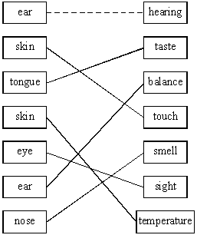
one correct 1 mark
two correct 2 marks
three correct 3 marks
four correct 4 marks
five or six correct 5 marks
(• for 6th correct mark)
both skin boxes can be connected to either touch or temperature
do not credit where more than one link goes to or from any box (except for skin, touch and temperature)
[5]

M2.(a) (i) receptor cells
1
(ii) eye(s)
accept retina
1

(b) (i) any one from:
• gender / sex
• quality of eyesight
eg wearing glasses
• eg of factor that might affect reaction times
eg alcohol consumption / distractions / tiredness / health / time of day / amount of practice (at this test)
do not allow time / age
1

(ii) 182
allow 182.0
1

(iii) Any anomalies can be identified.
1

(iv) reaction time (too) long or reactions (too) slow
1
allow reaction time (too) slow
allow examples of data quoted or derived from the table, eg (mean) reaction time for 90 year olds is 162 ms longer than for 75 year olds
(so) more likely to have / cause an accident
1
[7]
﻿
M3. (a) (i) receptor
allow named receptor eg light receptor
ignore sensory neurone
allow sense organ / named sensory organ eg skin / eye
1
(ii) sensory (neurone)
allow afferent
1
(iii) motor (neurone)
allow efferent
1
(iv) effector / muscle / gland / named
1

(b) any two from:
• impulse / information passes from one neurone to another
or impulse / information passes across gap
• chemical / transmitter involved
• diffusion (across gap)
2

(c) brain / person not aware of pain / stimulus / can’t feel
allow brain/ person doesn’t know / realise / unable to coordinate
ignore reflex
ignore information
1
possibility of (permanent / serious) damage / eg burning
ignore danger
1
[8]

M4.(a) (i) sensory neurone
1
a synapse
1

(ii) contract
1

(iii) not connected to brain / coordinated only by spinal cord
1

(iv) automatic / rapid (response)
allow no thinking / faster / less time
1
protects body from danger / from damage / from burning
1

(b) (i) caffeine decreases reaction time
accept caffeine speeds up / quicker reactions
1

(ii) the two sets of results overlap (considerably)
allow use of appropriate numbers – eg 5 of the ‘after’ results overlap with the ‘before’ results
allow ‘wide spread of results’
allow ‘it was just one person’ or ‘it was a small sample’
accept use of one pair of results only – if meaning is clear
accept use of one pair of overlapping results
1

(iii) any two sensible suggestions: eg
• more repetitions
• perform investigation on several other people
• use other (measured) amounts of coffee
• use different / more time intervals
• other suggested measure of reaction time – eg computer-generated light flash + time measurement
• use pure caffeine or caffeine tablets
2
[10]

M5.(a) receptors detect / sense stimuli / change in surroundings or convert stimulus into an impulse
ignore send impulses to brain / spinal cord
1
example of a receptor
allow any appropriate organ or part of an organ, eg eye / retina or named type of receptor eg light receptor
1
effectors allow / make response or convert an impulse to an action
ignore receive impulses from brain / spinal cord
1
(effector) muscle / gland
allow an example
ignore eg arm / leg
1

(b) (i) junction
allow idea of a (small) gap / space
do not allow if implication is that the neurones move
1
between neuron(e)s
allow named types of neurones
1

(ii) chemical
allow answers in terms of specific types of neurone
allow neurotransmitter / named neurotransmitter released
1
any one from:
• (chemical released) from one neurone
ignore produced
• (chemical) passes (across synapse) to next neurone to stimulate / cause (electrical) impulse
allow diffuses for passes (across)
1

(c) (i) skin
ignore hand / leg
1

(ii) 1.6 (cm per millisecond)
allow 2 if evidence of rounding up of 1.6
1

(iii) any two from:
ignore length of neurones
• synapses slow down transmission / impulse
allow idea of movement of chemical being slower than electrical impulse
• fewer synapses (via brain)
allow one synapse compared to two or only one synapse
• (therefore) fewer delays
allow impulse travels more slowly in relay neurones
2
[12]

M6. (a) 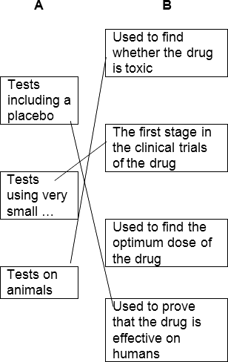
1 mark for each correct line
mark each line from left hand box
two lines from left hand box cancels mark for that box
3

(b) any three from:
Students have been informed that the headline is not justified
• reference to reliability, eg only a small number of mice tested
or trial too short
or investigation not repeated
• reference to control, eg mice given caffeine not coffee
or 6 cups (equivalence) is more than 1 dose
• (and) the effect on mice might not be same as on humans
allow only tested on mice
• (also) text suggests that the treatment improves memory loss (rather than delays it)
accept text suggests disease cured
or mice already have memory loss or experiment only showed improvement in memory
or does not show delays Alzheimer’s
or experiment not done on old mice
allow reference to the fact that mice engineered to have it
3
[6]

