2.3.2 Liquidity

Starter
- You owe some people money, this is your financial liability
- Which one item that you own do you think would be the quickest to sell if you needed to raise cash in a hurry? _________________________
- This is your most liquid item; it is an asset to you
- You can turn your assets into cash to pay your liabilities

Write a definition of liquidity here:
____________________________________________________________________________________________________________________________________________________________________
Liquidity – turning assets into cash
________________________________________________________________________________________________________________________________________________________________________________________________________________________________________________________________________________________________________________________________________
Write a definition of the statement of financial position here:
________________________________________________________________________________________________________________________________________________________________________________________________________________________________________________________________________________________________________________________________________

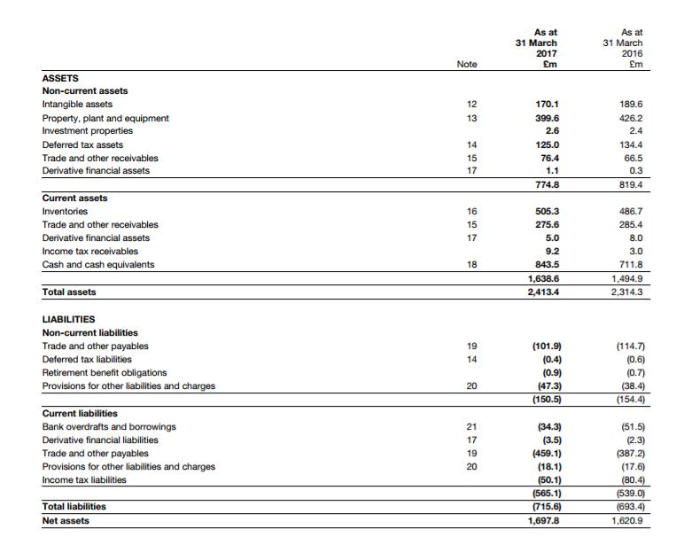

Measuring liquidity
________________________________________________________________________________________________________________________________________________________________________________________________________________________________________________________________________________________________________________________________________
Write the current ratio formula here:

2016
2017

________________________________________________________________________________________________________________________________________________________________________________________________________________________________________________________________________________________________________________________________________

Write the acid test ratio formula here:

2016
2017

________________________________________________________________________________________________________________________________________________________________________________________________________________________________________________________________________________________________________________________________________
Ways liquidity can be improved
________________________________________________________________________________________________________________________________________________________________________________________________________________________________________________________________________________________________________________________________________

Working capital and its management: the importance of cash
Write a definition of working capital here:
________________________________________________________________________________________________________________________________________________________________________________________________________________________________________________________________________________________________________________________________________
Working capital cycle:
