Taxation, PED and calculations
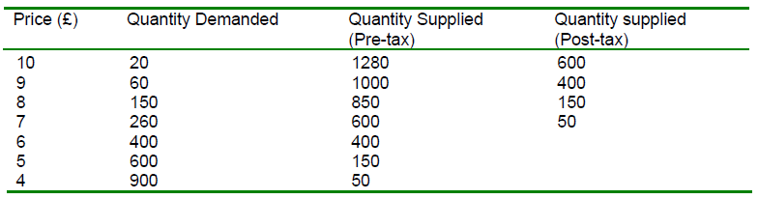
- What is the initial (pre-tax) equilibrium price and quantity?

- The government imposes a tax of £3 per unit. The new supply schedule is shown in the right hand column of the table – less is now supplied at each and every market price. Identify the new equilibrium price after the tax has been imposed:

- Explain why the new equilibrium (market) price is not simply £3 more than the old equilibrium price (before the tax was introduced).

- Calculate the total tax revenue going to the government

- Calculate how much of the total tax revenue is being paid by the consumer?

- Calculate how much of the total tax revenue is being paid by the producer?

- How have consumers been affected by this tax? Refer to consumer surplus/welfare in your answer.

Now let’s analyse the impact of PED upon the incidence of tax
- Draw and comment upon the incidence of taxation for a product with an inelastic demand curve

Explain what might cause the incidence of tax to look like this for a product with an inelastic demand curve.

- Draw and comment upon the incidence of taxation for a product with an elastic demand curve

Explain what might cause the incidence of tax to look like this for a product with an elastic demand curve.

A-Level past paper question
The specification requires students to calculate revenue and the incidence of tax…
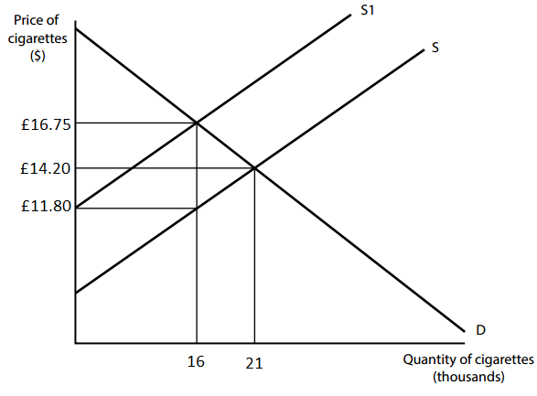

Calculate the total incidence of tax on consumers. You are advised to show your working. (2)

Calculate the total tax revenue. You are advised to show your working. (2)

Mr Wilson’s Thinking Further Challenge… Calculate total revenue before and after the tax. What does your answer suggest about this section of the demand curve, in terms of elasticity?

