Q1.Microorganisms can cause disease.
(a) Draw one line from each disease to the correct description.
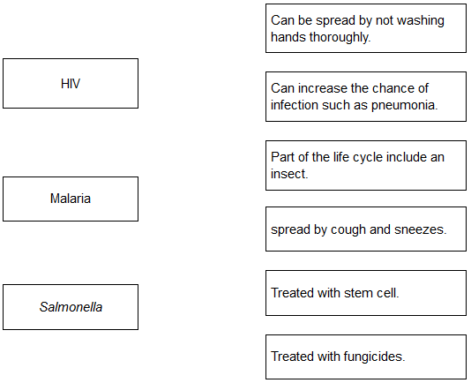
(3)

(b) Gonorrhoea is a sexually transmitted disease.
A bacterium causes gonorrhoea.
What are the symptoms of gonorrhoea?

Tick two boxes.
Headache
Pain when urinating
Rash
Vomiting
Yellow discharge

(2)

(c) The table below shows the number of people in the UK diagnosed with gonorrhoea in different years.

Number of people diagnosed
with gonorrhoea in thousands
 | Year | Female | Male
 | 2005 | 5.0 | 12.5
 | 2007 | 5.0 | 12.5
 | 2009 | 5.5 | 12.0
 | 2011 | 6.0 | 14.0
 | 2013 | 7.5 | 22.0

Use the data in the table to complete the graph below.
• The numbers for males have already been plotted.
• Only some of the numbers for females have been plotted.
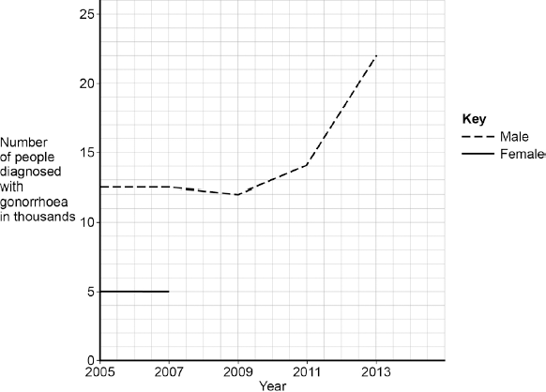
(3)

(d) Describe the patterns in the numbers of males and females with gonorrhoea from 2005 to 2013.
Use the data in the graph.
........................................................................................................................
........................................................................................................................
........................................................................................................................
........................................................................................................................
........................................................................................................................
(3)

(e) Gonorrhoea is treated with an antibiotic.
HIV is another sexually transmitted disease.
Explain why prescribing an antibiotic will not cure HIV.
........................................................................................................................
........................................................................................................................
........................................................................................................................
........................................................................................................................
(2)
(Total 13 marks)

Q2.Microorganisms cause infections.
The human body has many ways of defending itself against microorganisms.
(a) Describe two ways the body prevents the entry of microorganisms.
1 .....................................................................................................................
........................................................................................................................
2 .....................................................................................................................
........................................................................................................................
(2)

(b) In 2014 the Ebola virus killed almost 8000 people in Africa.
Drug companies have developed a new drug to treat Ebola.
Explain what testing must be done before this new drug can be used to treat people.
........................................................................................................................
........................................................................................................................
........................................................................................................................
........................................................................................................................
........................................................................................................................
........................................................................................................................
........................................................................................................................
........................................................................................................................
........................................................................................................................
........................................................................................................................
(6)
(Total 8 marks)

Q3. Read the article.

Parents all over the world advise children to ‘wrap up warm or you’ll catch a cold’.
Scientists at Cardiff University recruited 180 volunteers to take part in an investigation to find out if the advice was true. The investigation took place during the city’s common cold season.
Half of the volunteers put their feet in bowls of ice cold water for 20 minutes. The other volunteers sat with their feet in empty bowls.
Over the next few days, almost a third of the volunteers who put their feet into cold water developed colds. Fewer than one in ten of the other volunteers developed colds.

(a) Draw a ring around the correct answer to complete the sentence.

 | hearsay.
The advice ‘wrap up warm or you’ll catch a cold’ is an example of | a hypothesis.
 | a prediction.

(1)

(b) What was the experimental control in the investigation?
........................................................................................................................
(1)

(c) The scientists did not prove that the advice ‘wrap up warm or you’ll catch a cold’ is true.
Explain why.
........................................................................................................................
........................................................................................................................
........................................................................................................................
........................................................................................................................
........................................................................................................................
........................................................................................................................
(3)
(Total 5 marks)

Q4.White blood cells protect the body against pathogens such as bacteria and viruses.
(a) (i) Pathogens make us feel ill.
Give one reason why.
...............................................................................................................
...............................................................................................................
(1)

(ii) White blood cells produce antibodies. This is one way white blood cells protect us against pathogens.
Give two other ways that white blood cells protect us against pathogens.
1.............................................................................................................
...............................................................................................................
2.............................................................................................................
...............................................................................................................
(2)

(b) Vaccination can protect us from the diseases pathogens cause.
(i) One type of virus causes measles.
A doctor vaccinates a child against measles.
What does the doctor inject into the child to make the child immune to measles?
...............................................................................................................
...............................................................................................................
...............................................................................................................
...............................................................................................................
(2)

(ii) A few weeks after the vaccination, the child becomes infected with measles viruses from another person.
The graph shows the number of measles antibodies in the child’s blood from before the vaccination until after the infection.
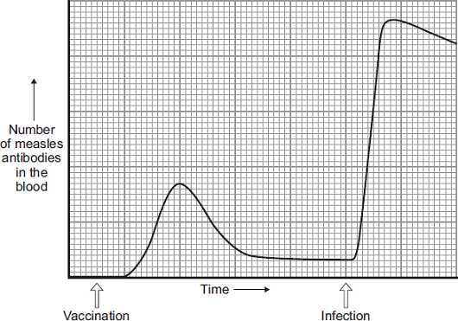
More measles antibodies are produced after the infection than after the vaccination.
Describe other differences in antibody production after infection compared with after vaccination.
...............................................................................................................
...............................................................................................................
...............................................................................................................
...............................................................................................................
...............................................................................................................
...............................................................................................................
(3)

(iii) Vaccination against the measles virus will not protect the child against the rubella virus.
Why?
...............................................................................................................
(1)

(c) What is the advantage of vaccinating a large proportion of the population against measles?
........................................................................................................................
(1)
(Total 10 marks)

Q5. People may be immunised against diseases using vaccines.
(a) (i) Which part of the vaccine stimulates the body’s defence system?
...............................................................................................................
...............................................................................................................
...............................................................................................................
...............................................................................................................
(2)

(ii) A person has been vaccinated against measles. The person comes in contact with the measles pathogen. The person does not catch measles.
Explain why.
...............................................................................................................
...............................................................................................................
...............................................................................................................
...............................................................................................................
...............................................................................................................
...............................................................................................................
(3)

(b) A man catches a disease. The man has not been immunised against this disease. A doctor gives the man a course of antibiotics.
The graph shows how the number of live disease bacteria in the body changes when the man is taking the antibiotics.
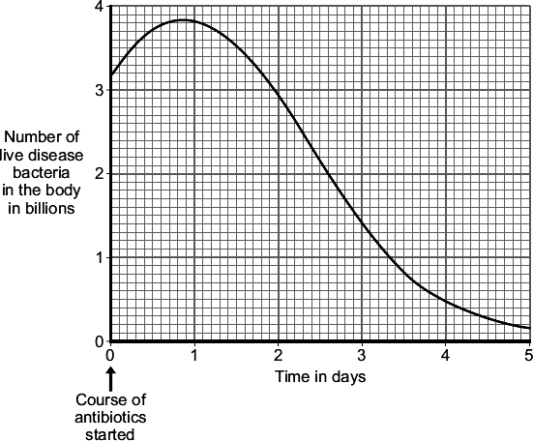

(i) Four days after starting the course of antibiotics the man feels well again.
It is important that the man does not stop taking the antibiotics.
Explain why.
Use information from the graph.
...............................................................................................................
...............................................................................................................
...............................................................................................................
...............................................................................................................
(2)

(ii) Occasionally a new, resistant strain of a pathogen appears.
The new strain may spread rapidly.
Explain why.
...............................................................................................................
...............................................................................................................
...............................................................................................................
...............................................................................................................

...............................................................................................................
...............................................................................................................
(3)
(Total 10 marks)

M1.
(a)
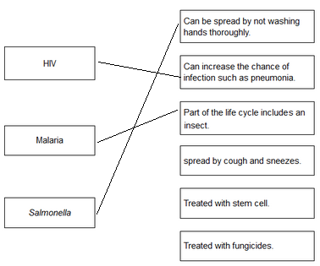
each extra line negates a mark
4

1

1

(b) pain when urinating
1

yellow discharge
1

(c) three correct plots
allow 1 mark for two correct plots
2

correctly drawn line
1

(d) any three from:
• (fairly) level / steady up to 2009
allow numbers of males fall (slightly) and females rise (slightly) up to 2009
• (there is a) rise after 2009
• males are (always) higher than females
• males rising faster than females
allow overall increase (from 2005 to 2013)
3

(e) HIV is a virus
1

(and) antibiotics are only effective against bacteria
or
antibiotics do not kill viruses
allow viruses live inside cells
1
[13]

M2.(a) any two from:
• acid in the stomach kills pathogens in food
• skin forms a barrier / produces antimicrobial secretions
• hairs in the nose trap (particles which may contain) pathogens
• trachea / bronchi has mucus which traps pathogens
or
bronchi have cilia which waft mucus to throat to be swallowed
2

(b) Level 3 (5–6 marks):
A clear, logical and coherent answer, with no significant redundancy. The student understands the process and links this to reasons for clinical trials.
Level 2 (3–4 marks):
A partial answer with errors and ineffective reasoning or linkage.
Level 1 (1–2 marks):
One or two relevant points but little linkage of points or logical reasoning.
0 marks:
No relevant content.
Indicative content
• pre-clinical trials of the new drug on cells / tissues / live animals
• to test toxicity, dosage and efficacy
• clinical trials / test on healthy volunteers and Ebola patients at very low doses
• so that you can monitor for safety / side effects
• and only then do trials to find the optimum dosage and test for efficacy
• double blind trial / use of placebo
• which does not contain the new drug
• random allocation of Ebola patients to groups
• so no one knows who has placebo / the new drug
• peer review of data
• to help prevent false claims
6
[8]

M3. (a) hearsay
1

(b) (volunteers with feet in) empty bowls
accept bowl with no (iced) water
do not accept mention of bowl with iced water
1

(c) any three from:
ignore control variables, eg age, gender
• only some of those whose feet were in cold water caught colds
• some controls caught colds
• only feet were cold in experimental group
allow (control) not wrapped up warm
• only kept feet in cold water for 20 minutes
• insufficient evidence for ‘proof’ / only showed increased risk
allow small sample size
• don’t know activities of individuals before / after the investigation
(eg exposure to cold virus) / reference to immune system
allow investigation done in ‘cold season’
3
[5]

M4.(a) (i) any one from:
• (produce) toxins / poisons
• (cause) damage to cells
kill / destroy cells
allow kills white blood cells
1

(ii) produce antitoxins
1

engulf / ingest / digest pathogens / viruses / bacteria / microorganisms
accept phagocytosis or description
ignore eat / consume / absorb for engulf
ignore references to memory cells
1

(b) (i) dead / inactive / weakened
accept idea of antigen / protein
1

(measles) pathogen / virus
ignore bacteria
1

(ii) (after infection)
accept converse if clearly referring to before vaccination
1

rise begins sooner / less lag time
steeper / faster rise (in number)
1

longer lasting or doesn’t drop so quickly
idea of staying high for longer
ignore reference to higher starting point
1

(iii) antibodies are specific or needs different antibodies
accept antigens are different or white blood cells do not recognise virus
1

(c) reduces spread of infection / less likely to get an epidemic
accept idea of eradicating measles
1
[10]

M5. (a) (i) dead / inactive / weakened
allow antigen / protein
ignore ref to other components
ignore small amount
1

pathogen / bacterium / virus / microorganism
ignore germs / disease
1

(ii) antigen / antibiotic instead of antibody = max 2
white blood cells produce / release antibodies
accept lymphocytes / leucocytes / memory cells produce antibodies
do not accept phagocytes
1

antibodies produced quickly
1

(these) antibodies destroy the pathogen
allow kill
do not accept antibodies engulf pathogens
1

(b) (i) (live) bacteria still in body
ignore numbers
1

would reproduce
ignore mutation / growth
1

(ii) antibiotics / treatment ineffective or resistant pathogens survive
accept resistant out compete non-resistant
1

these reproduce
1

population of resistant pathogens increases
allow (resistant pathogens reproduce) rapidly
1
[10]

