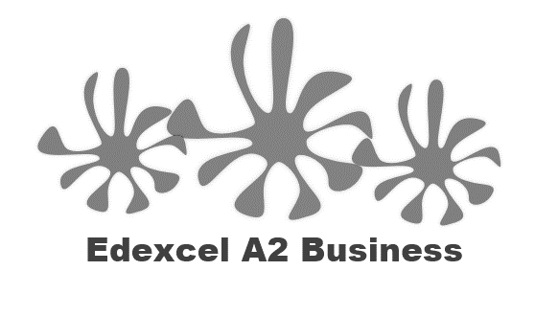
3.5.1 Interpretation of financial statements

Write the definition of the statement of comprehensive income (profit and loss)

________________________________________________________________________________________________________________________________________________________________________________________________________________________________________________________________________________________________________________________________________
Key information on a profit and loss? (SOCI)

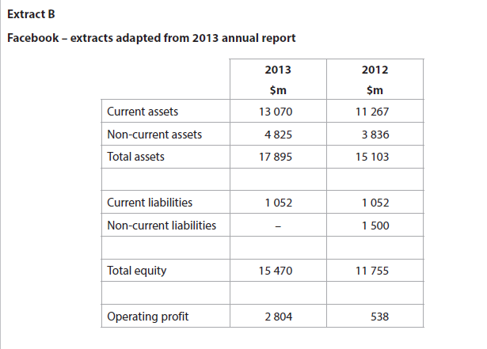
R____________________________ G________________________________________
E___________________________ O_________________________________________
Revenue
Formula:
________________________________________________________________________________________________________________________________________________________________________________________________________________________________________________________________________________________________________________________________________

Gross profit
Formula:

________________________________________________________________________________________________________________________________________________________________________________________________________________________________________________________________________________________________________________________________________
Expenses
________________________________________________________________________________________________________________________________________________________________________________________________________________________________________________________________________________________________________________________________________
Operating profit
Formula:

________________________________________________________________________________________________________________________________________________________________________________________________________________________________________________________________________________________________________________________________________
Examples
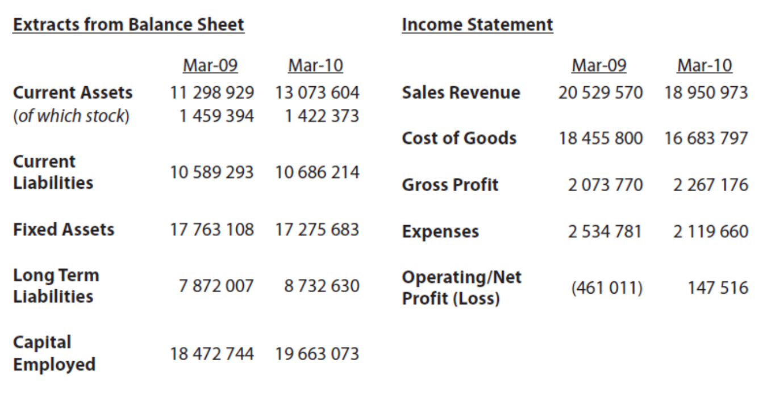

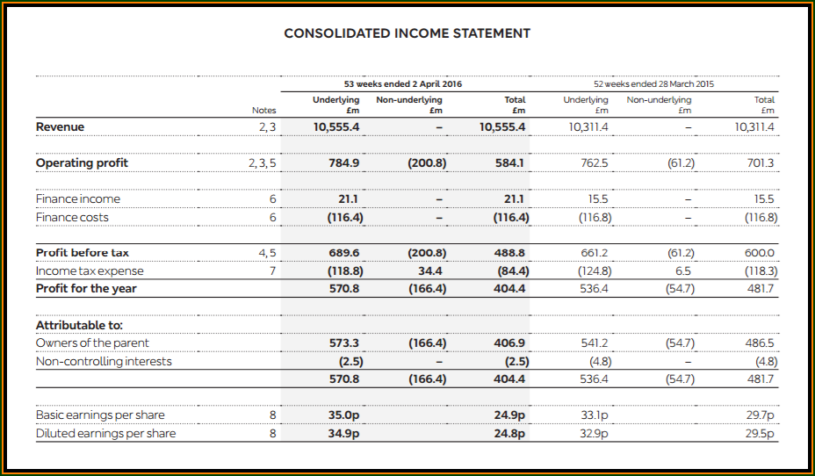

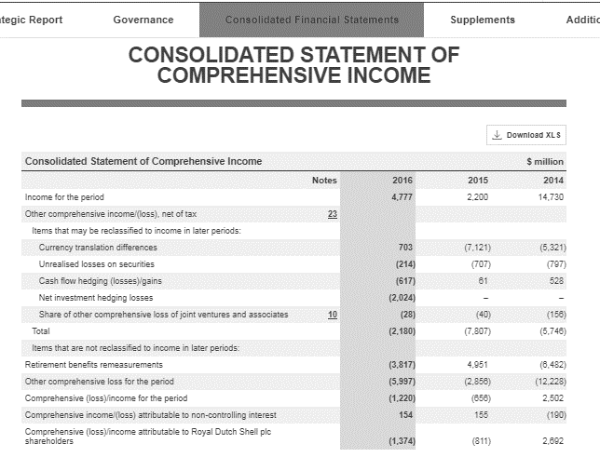
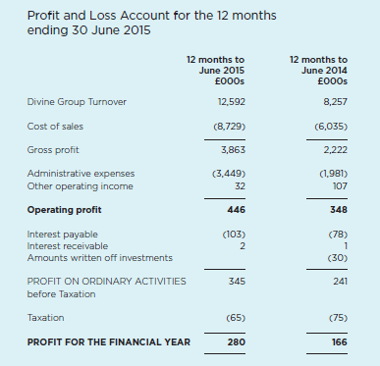
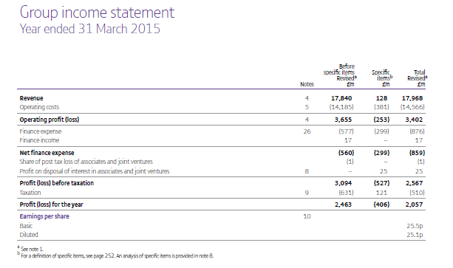
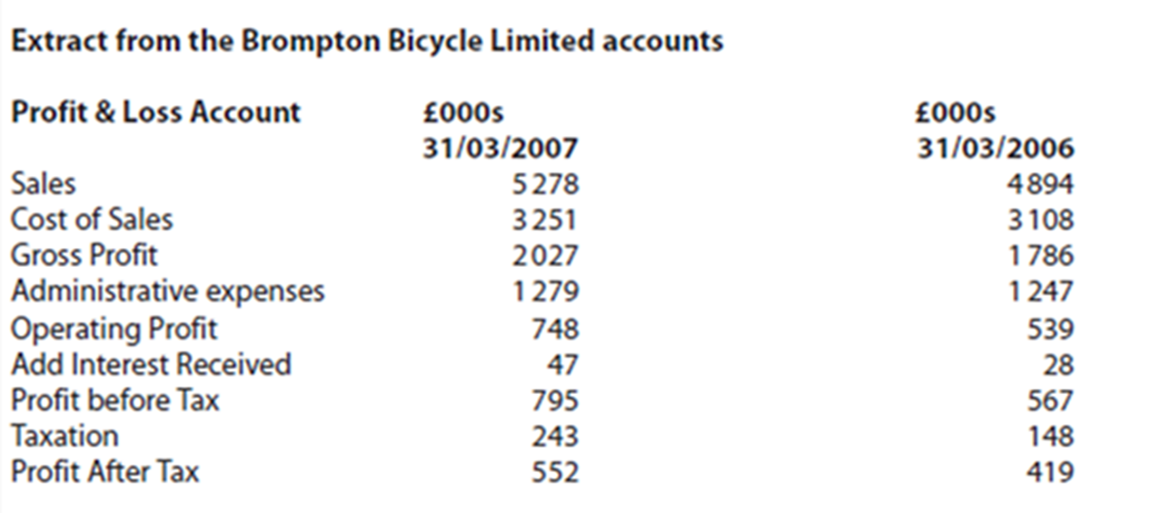

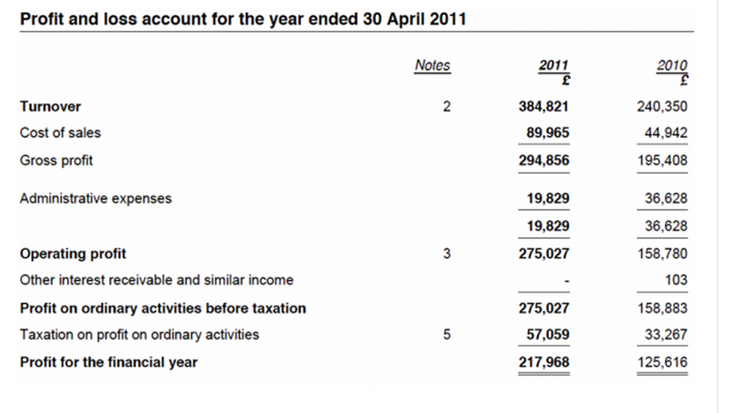

Sales
Cost of sales
Gross profit
Admin expenses
Operating profit
Add Interest received
Profit before tax
Taxation
Profit after tax

Stakeholder interest

________________________________________________________________________________________________________________________________________________________________________________________________________________________________________________________________________________________________________________________________________
A word of caution:
____________________________________________________________________________________________________________________________________________________________________
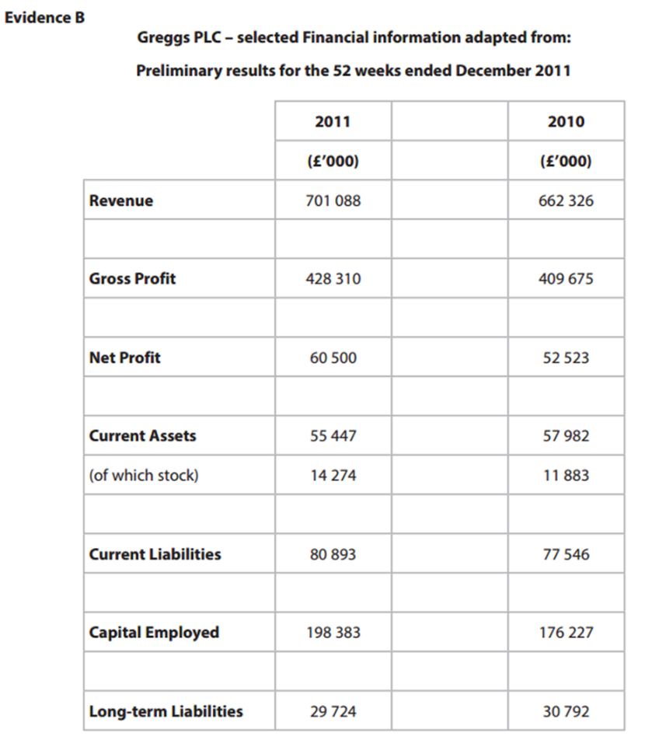

Statement of financial position - (balance sheet)

Write a definition of the statement of financial position here:
________________________________________________________________________________________________________________________________________________________________________________________________________________________________________________________________________________________________________________________________________
Key information on a balance sheet (SOFP)

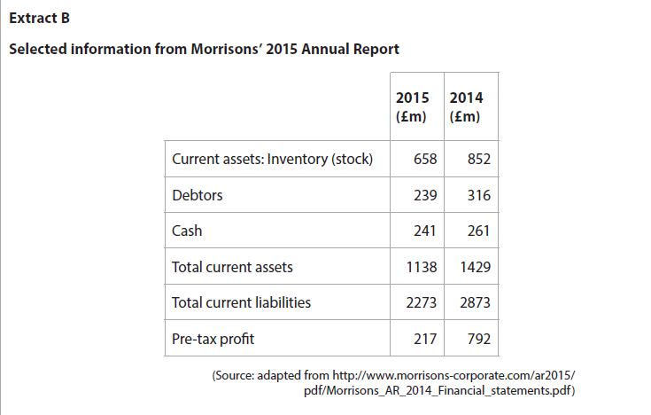
C___________________________________________
N__________________________________________
C__________________________________________
L__________________________________________

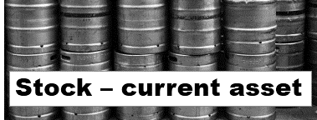
Current assets

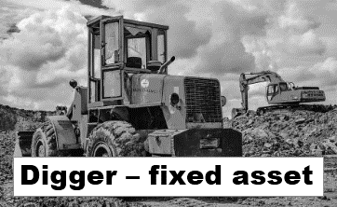
________________________________________________________________________________________________________________________________________________________________________________________________________________________________________________________________________________________________________________________________________
Non-current assets (fixed assets)

________________________________________________________________________________________________________________________________________________________________________________________________________________________________________________________________________________________________________________________________________
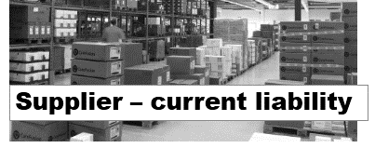
Current liabilities

________________________________________________________________________________________________________________________________________________________________________________________________________________________________________________________________________________________________________________________________________

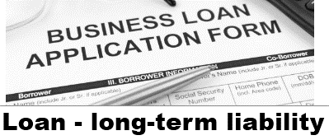
Long-term liabilities

________________________________________________________________________________________________________________________________________________________________________________________________________________________________________________________________________________________________________________________________________
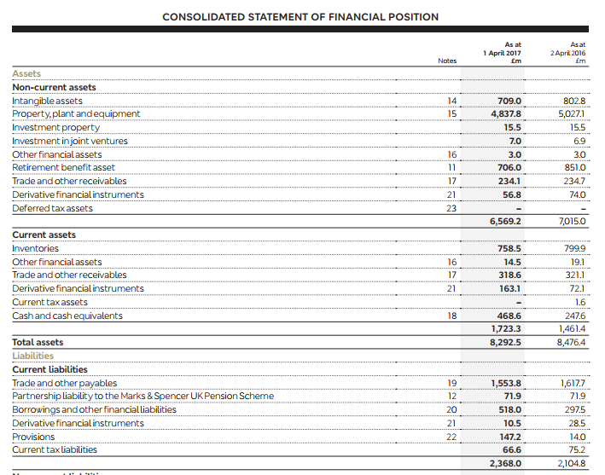

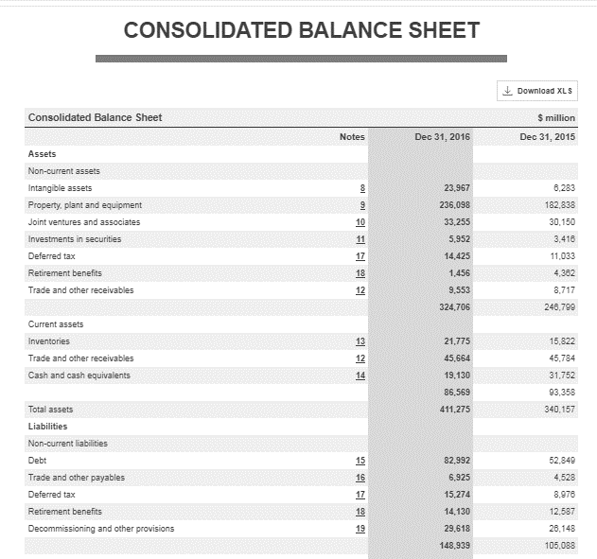

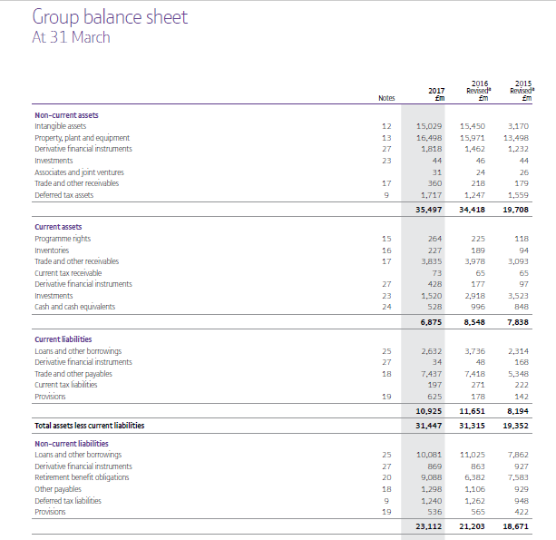

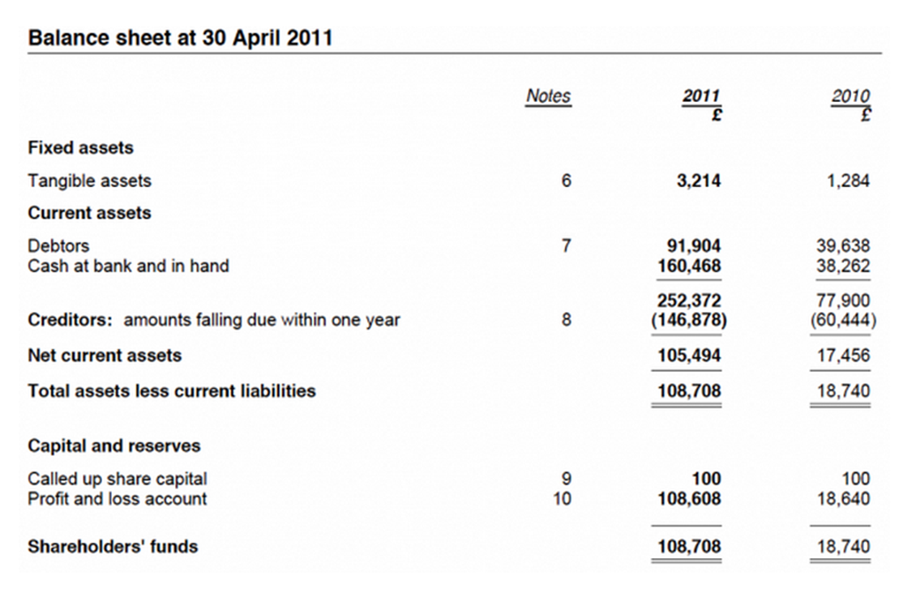
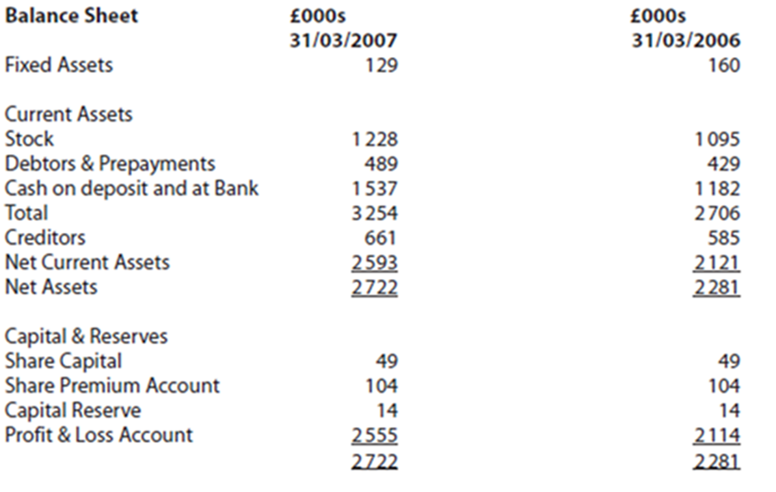
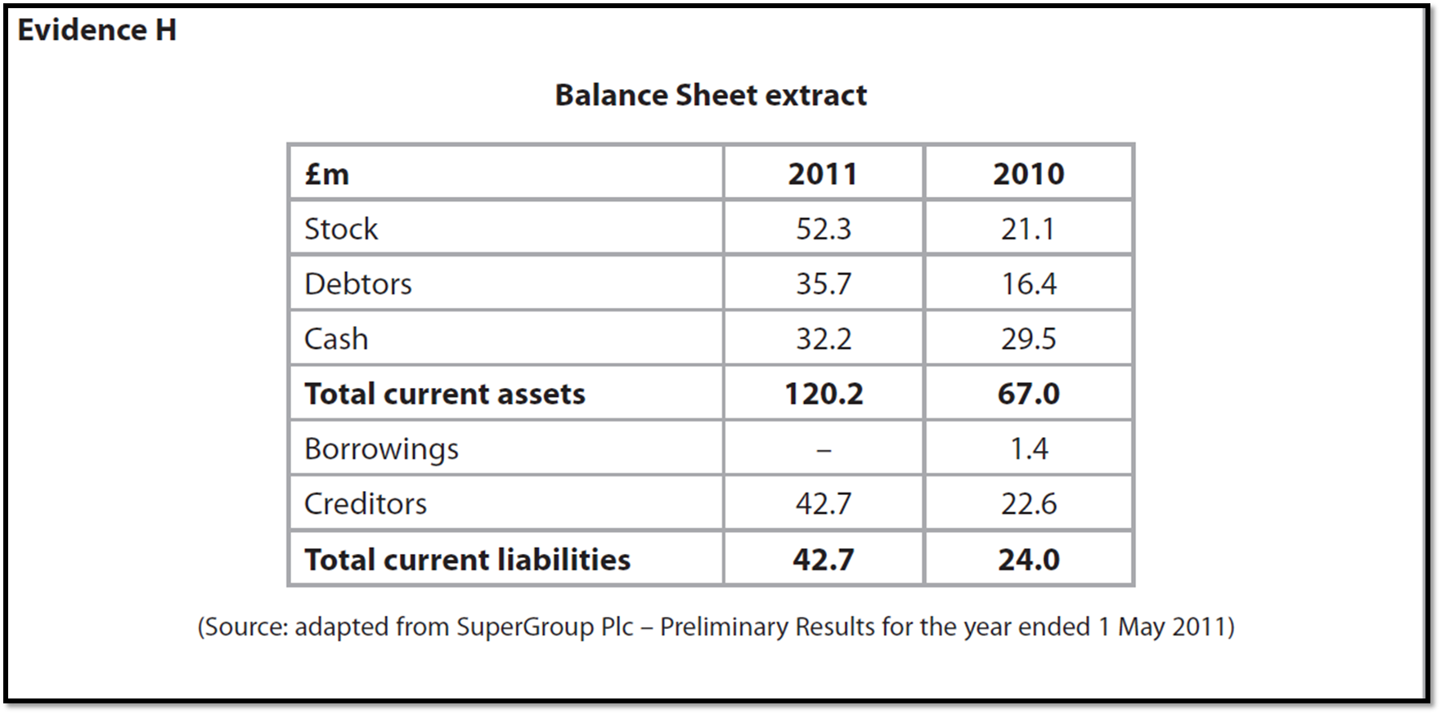

Fixed assets
Current assets
Stock
Debtors and Prepayments
Creditors
Capital reserves and share capital
Share premium account
Stakeholder interest:

Government
Shareholders
Directors
Potential investors
Creditors

