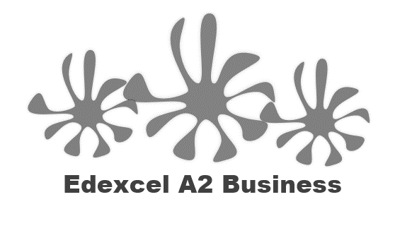
4.1.4 Protectionism

Imports banned or not banned?

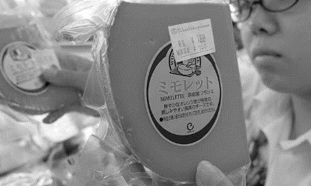  A | 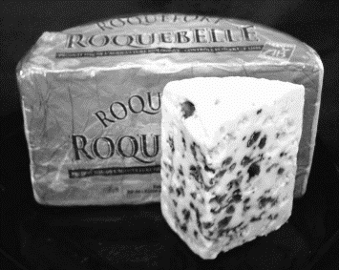  B | 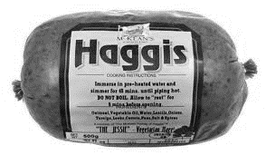  C
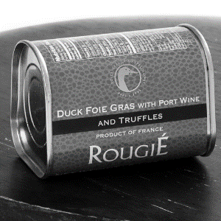  D | 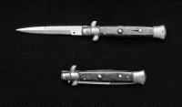  E | 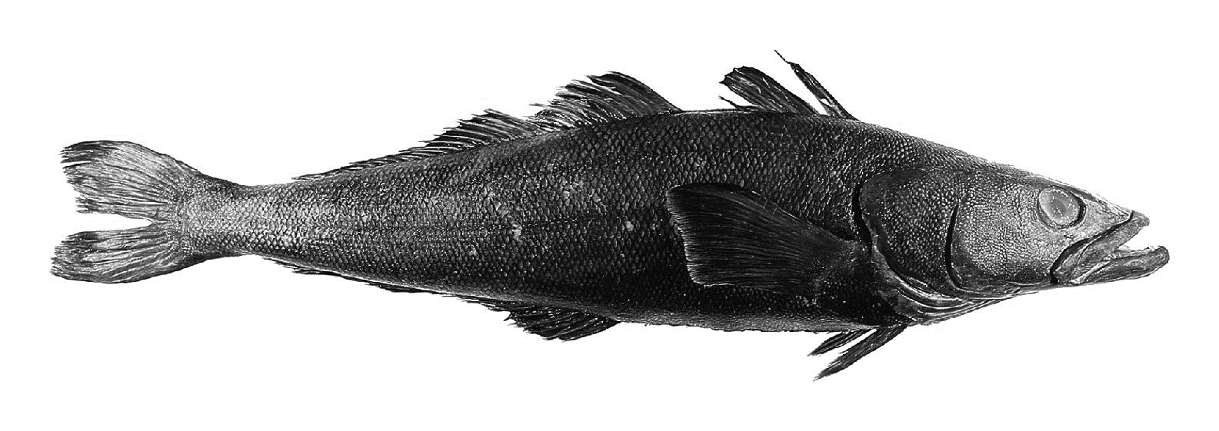  F

Write a definition of protectionism here:

________________________________________________________________________________________________________________________________________________________________________________________________________________________________________________________________________________________________________________________________________

Tariffs
What is a tariff?
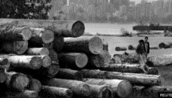
________________________________________________________________________________________________________________________________________________________________________________________________________________________________________________________________________________________________________________________________________

Tariffs – impact on business

________________________________________________________________________________________________________________________________________________________________________________________________________________________________________________________________________________________________________________________________________

Tariffs – 3 reasons they are imposed
1
2
3

Advantages and disadvantages of tariffs:

Advantages | Disadvantages

Import quotas
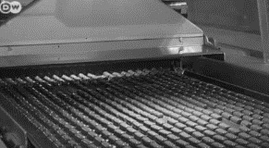
What is an import quota?

_______________________________________________________________________________________________________________________________________________________________________________________________________________________________________________________________________________________________________________________________________

Why are quotas imposed?

_______________________________________________________________________________________________________________________________________________________________________________________________________________________________________________________________________________________________________________________________________
Uses of import quotas

_______________________________________________________________________________________________________________________________________________________________________________________________________________________________________________________________________________________________________________________________________

Advantages and disadvantages of quotas:

Advantages | Disadvantages

Other trade barriers
Government legislation
_______________________________________________________________________________________________________________________________________________________________________________________________________________________________________________________________________________________________________________________________________

Advantages and disadvantages of government legislation:

Advantages | Disadvantages

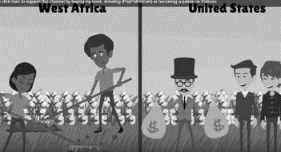
Domestic subsidies
_______________________________________________________________________________________________________________________________________________________________________________________________________________________________________________________________________________________________________________________________________

Subsidy example - CAP

_______________________________________________________________________________________________________________________________________________________________________________________________________________________________________________________________________________________________________________________________________
Advantages and disadvantages of domestic subsidies:

Advantages | Disadvantages

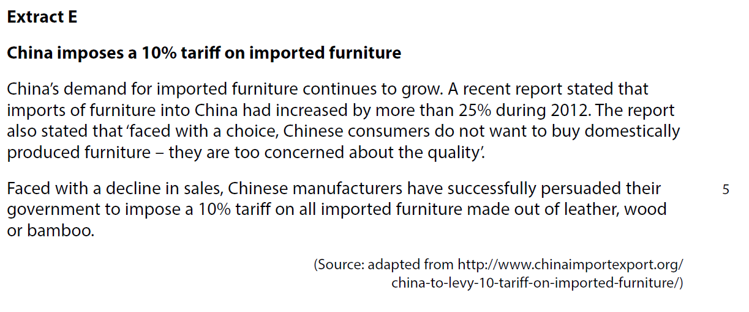
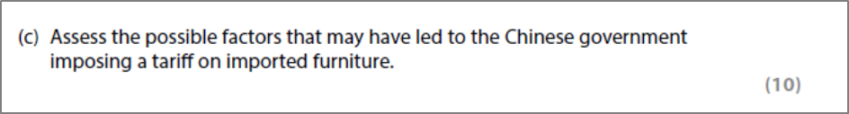

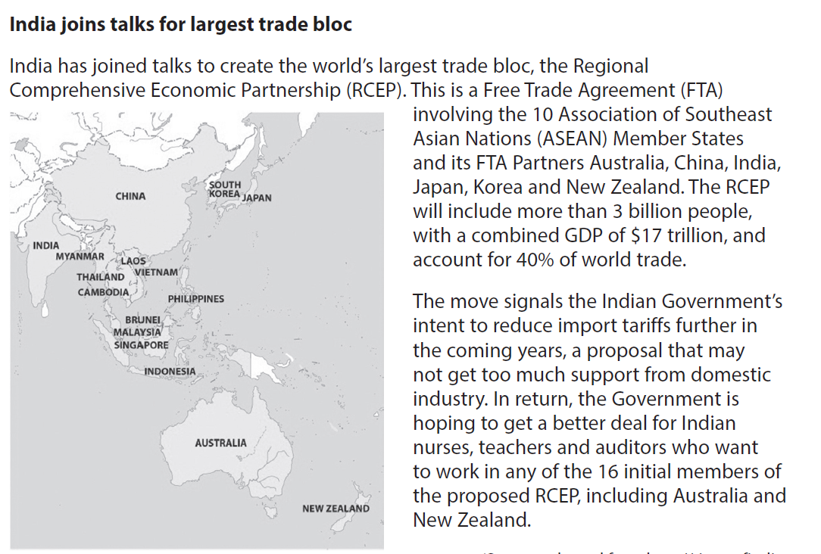

[6]

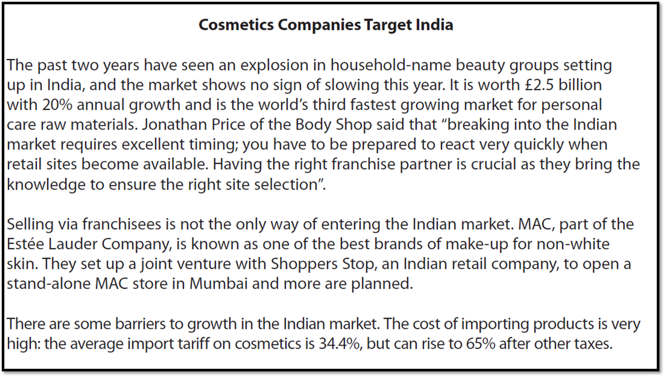
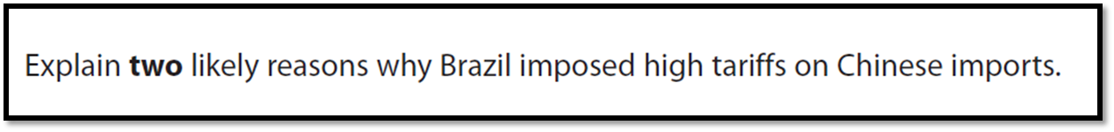
[6]

