Q1.The digestive system breaks down food into small molecules.
The small molecules can be absorbed into the blood.
The diagram below shows the human digestive system.
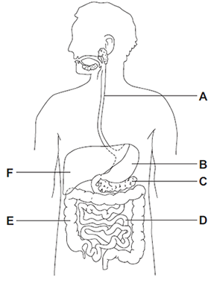
(a) (i) Which letter, A, B, C, D, E or F, shows each of the following organs?

Write one letter in each box.
large intestine
small intestine
stomach

(3)

(ii) Different organs in the digestive system have different functions.
Draw one line from each function to the organ with that function.
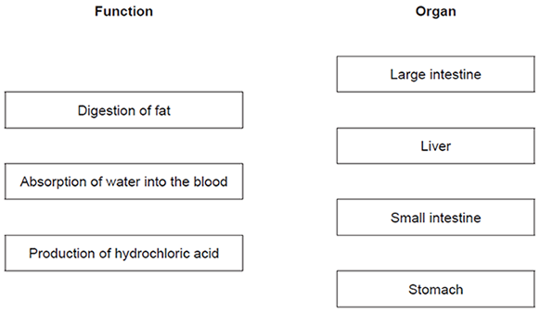
(3)

(b) Glucose is absorbed into the blood in the small intestine.
Most of the glucose is absorbed by diffusion.
How does the glucose concentration in the blood compare to the glucose concentration in the small intestine?

Tick (✔) one box.
The concentration in the blood is higher.
The concentration in the blood is lower.
The concentration in the blood is the same.

(1)
(Total 7 marks)

Q2.The diagram below shows an alveolus from a healthy lung and an alveolus from a damaged lung.
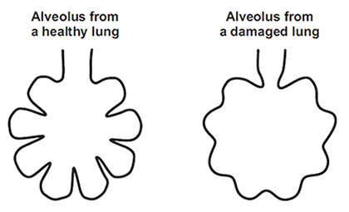
(a) Which one of the following is a difference between the alveolus from the damaged lung and the alveolus from the healthy lung?

Tick (✔) one box.
The damaged alveolus has a smaller surface area.
The damaged alveolus has a shorter diffusion pathway.
The damaged alveolus has a better blood supply.

(1)

(b) A person with damaged alveoli finds exercising difficult.
Which one of the following is the reason why the damaged alveoli will make exercising difficult?

Tick (✔) one box.
Less carbon dioxide is taken in.
Less energy is needed for exercise.
Less oxygen is taken in.

(1)
(Total 2 marks)

Q3.(a) Enzymes are used in body cells.
(i) What is an enzyme?
Draw a ring around the correct answer.

 | an antibody | a catalyst | a hormone

(1)

(ii) All enzymes are made of the same type of substance.
What is this substance?
Draw a ring around the correct answer.

 | carbohydrate | fat | protein

(1)

(iii) Where is the enzyme amylase produced in the human body?
Draw a ring around the correct answer.

 | liver | salivary glands | stomach

(1)

(b) Enzymes are sometimes used in industry.
Draw one line from each enzyme to the correct industrial use of that enzyme.

 | Enzyme |  | Industrial use
 |  |  | Changes starch into sugars
 | Carbohydrase
Removes grease stains from
clothes
 | Isomerase
Pre-digests proteins in some
baby foods
 | Protease
Changes glucose syrup into
fructose syrup

(3)
(Total 6 marks)

Q4.Scientists investigated the effect of different factors on health.
(a) People who are not active may have health problems.
The graph shows the percentage of 16-year-olds in some countries who are not active.
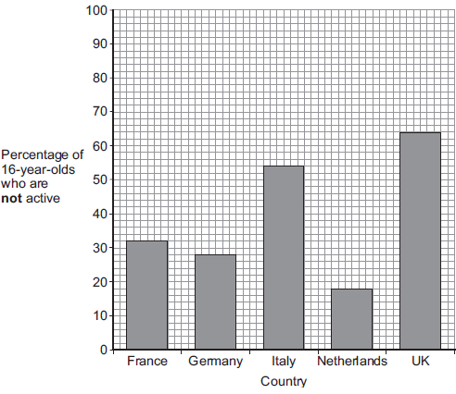
(i) What percentage of 16-year-olds in the UK are not active?
.......................... %
(1)
(ii) What percentage of 16-year-olds in the UK are active?
.......................... %
(1)
(iii) A newspaper headline states:
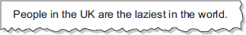
Information in Figure 1 does not support the newspaper headline.
Suggest one reason why the newspaper headline may be wrong.
...............................................................................................................
...............................................................................................................
(1)

(b) Doctors gave a percentage rating to the health of 16-year-olds.
100% is perfect health.
The table shows the amount of exercise 16-year-olds do and their health rating.

 | Amount of exercise done in minutes every week | Health rating as %
 | Less than 30 | 72
 | 90 | 76
 | 180 | 82
 | 300 | 92

What conclusion can be made about the effect of exercise on health?
Use information from the table.
........................................................................................................................
........................................................................................................................
(1)

(c) Inherited factors can also affect health.
Give one health problem that may be affected by the genes someone inherits.
Draw a ring around the correct answer.

 | being  malnourished | having a high  cholesterol level | having a  deficiency disease

(1)

(d) White blood cells are part of the immune system.
Use the correct answer from the box to complete each sentence.

 | antibiotics | antibodies | pathogens | vaccines

(i) When we are ill, white blood cells produce .............................................. to kill microorganisms.
(1)
(ii) Many strains of bacteria, including MRSA, have developed resistance to drugs called
...............................................................................................................
(1)
(Total 7 marks)

Q5.Lipase is an enzyme that digests fat.
(a) (i) Complete the equation to show the digestion of fat.
Use the correct answer from the box.

 | glucose | glycerol | glycogen

fat fatty acids + ..................................
(1)
(ii) Name one organ that makes lipase.
...............................................................................................................
(1)

(b) Some students investigated the effect of bile on the digestion of fat by lipase.
The students:
1 mixed milk and bile in a beaker
2 put the pH sensor of a pH meter into the beaker
3 added lipase solution
4 recorded the pH at 2-minute intervals
5 repeated steps 1 to 4, but used water instead of bile.
Suggest two variables that the students should have controlled in this investigation.
1......................................................................................................................
........................................................................................................................
2......................................................................................................................
........................................................................................................................
(2)

(c) The graph shows the students’ results.
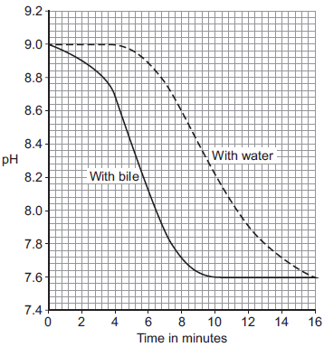
(i) Why did the pH decrease in both investigations?
...............................................................................................................
...............................................................................................................
(1)

(ii) Bile helps lipase to digest fat.
What evidence is there in the graph to support this conclusion?
...............................................................................................................
...............................................................................................................
(1)

(iii) Suggest one reason why the contents of both beakers had the same pH at the end of the investigations.
...............................................................................................................
...............................................................................................................
(1)
(Total 7 marks)

Q6.The heart pumps the blood around the body. This causes blood to leave the heart at
high pressure.
The graph shows blood pressure measurements for a person at rest.
The blood pressure was measured in an artery and in a vein.
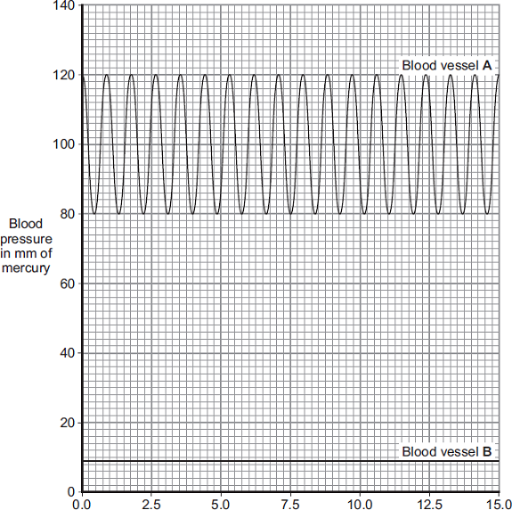
Time in seconds
(a) Which blood vessel, A or B, is the artery?
Blood vessel ....................
Give two reasons for your answer.
Reason 1 .......................................................................................................
........................................................................................................................
Reason 2 .......................................................................................................
........................................................................................................................
(2)

(b) Use information from the graph to answer these questions.
(i) How many times did the heart beat in 15 seconds? .............................
(1)

(ii) Use your answer from part (b)(i) to calculate the person’s heart rate per minute.
...............................................................................................................
...............................................................................................................
Heart rate = .................... beats per minute
(1)

(c) During exercise, the heart rate increases.
The increased heart rate supplies useful substances to the muscles at a faster rate.
Name two useful substances that must be supplied to the muscles at a faster rate
during exercise.
1 ........................................................................................................................
2 ........................................................................................................................
(2)
(Total 6 marks)

Q7.Drugs are used to treat cardiovascular diseases (diseases of the heart and blood vessels).
(a) What is a drug?
........................................................................................................................
........................................................................................................................
(1)

(b) People can be treated for cardiovascular diseases with statins or aspirin.
Information about these two drugs is given in the table.

 | STATINS | ASPIRIN
 | Statins are only available on prescription from doctors. | Aspirin can be bought over the counter.  Treatment with aspirin costs up to £15 per year.
 | In studies, 30 000 patients were monitored  over several years. Statins were found to reduce the rate of non-fatal heart attacks by about 30%. | In a study of 1000 patients, aspirin was found to cause bleeding of the stomach in around 0.5% of patients and there was a slightly increased risk of poor blood clotting at cuts.
 | Approximately 0.1% of the patients suffered serious muscle damage and 0.01% suffered kidney failure. | There was a slightly increased risk of damage to the blood vessels in the brain in older patients.
 | Statins reduce blood cholesterol which builds up in the walls of blood vessels. The cost of treating patients with statins can vary between £150 and £500 per year, depending on the type of cardiovascular disease being treated. | Aspirin was found to reduce the risk of non-fatal heart attacks by 31%.

Would you recommend statins or aspirin for the treatment of cardiovascular diseases?
In your answer you should:
• give your recommendation
• use information from the table to support your recommendation by making comparisons of the two drugs.
...............................................................................................................
...............................................................................................................
...............................................................................................................
...............................................................................................................
...............................................................................................................
...............................................................................................................
...............................................................................................................
...............................................................................................................
...............................................................................................................
...............................................................................................................
...............................................................................................................
...............................................................................................................
...............................................................................................................
...............................................................................................................
(5)
(Total 6 marks)

M1.(a) (i) large intestine = E
1
small intestine = D
1
stomach = B
1

(ii) 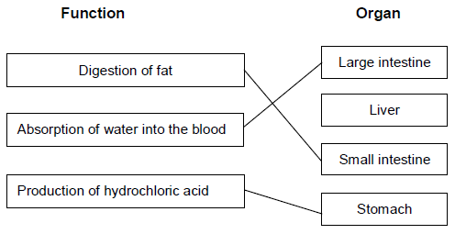
extra lines cancel
3

(b) The concentration in the blood is lower.
1
[7]

M2.(a) The damaged alveolus has a smaller surface area.
1

(b) Less oxygen is taken in.
1
[2]

M3.(a) (i) a catalyst
1
(ii) protein
1
(iii) salivary glands
1

(b)
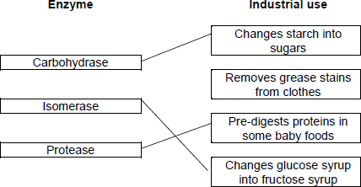
extra lines from any enzyme cancels that mark
3
[6]

M4.(a) (i) 64
1
(ii) 36
allow e.c.f from (i) i.e. 100 − answer given in (a)(i)
1
(iii) any one from:
• only considers 16-year-olds
ignore lack of evidence
allow does not refer to all ages
• only about some / 5 countries
allow does not refer to all countries.
1

(b) the more exercise done the healthier a person is
allow the more exercise done the higher the health rating
allow the less exercise done the lower the health rating
1

(c) having a high cholesterol level
1
(d) (i) antibodies
1
(ii) antibiotics
1
[7]

M5.(a) (i) glycerol
1
(ii) pancreas / small intestine
accept duodenum / ileum
ignore intestine unqualified
1

(b) any two from:
• type of milk
• volume / amount of milk
• vol. bile equals vol. water
• volume of lipase
• concentration of lipase
• temperature
ignore time interval
ignore solution unqualified
do not allow pH
ignore starting pH
ignore volume / amount of bile / water
ignore concentration of bile
accept amount of lipase if neither volume nor concentration given
2

(c) (i) fatty acid (production)
1
(ii) faster reaction / digestion (with bile)
or
pH decreases faster (with bile)
or
takes less time (with bile)
or
steeper fall / line (with bile)
allow use of data
ignore easier
1
(iii) all fat / milk digested
or
same amount of fatty acids present
or
(lower pH) denatures the enzyme / lipase
allow all reactants used up
ignore reference to neutralisation
allow enzyme won’t work at low pH
do not allow enzyme killed
1
[7]

M6.(a) A
no mark - can be specified in reason part
if B given - no marks throughout
if unspecified + 2 good reasons = 1 mark
high(er) pressure in A
allow opposite for B
do not accept ‘zero pressure’ for B
pulse / described in A
accept fluctuates / ‘changes’
allow reference to beats / beating
ignore reference to artery pumping
2

(b) (i) 17
1

(ii) 68
accept correct answer from student’s (b)(i) × 4
1

(c) oxygen / oxygenated blood
allow adrenaline
ignore air
glucose / sugar
extra wrong answer cancels - eg sucrose / starch / glycogen / glucagon / water
allow fructose
ignore energy
ignore food
2
[6]

M7.(a) (substance / chemical) that affects body chemistry / chemical reactions in the body
1

(b) statin / aspirin / neither recommended
no mark, may be implied. If no recommendation or implication, max 4 marks
answers should be comparative
any five from:
• argued evaluation in favour of aspirin or statin or neither
answers could include reference to
accept converse for statins / aspirin but not as advantage of one and disadvantage of other
for statins:
• more people in studies
• so data / findings more repeatable
accept reliable for repeatable
ignore accurate / precise
• reduces cholesterol but aspirin doesn’t
allow reduces cholesterol but no evidence about aspirin
• aspirin (may) causes bleeding / poor clotting but statins do not
allow aspirin causes bleeding / poor clotting but no evidence about statins
• smaller (total) percentage suffer side-effects
• monitored by doctor, aspirins not
for aspirin:
• cheaper
• can be bought over the counter rather than prescribed
• statins cause serious damage / muscle damage / kidney failure but aspirins do not
similarities:
• both have similar effect on reducing (non-fatal) heart attacks
• incidence of side-effects low in both
allow (for aspirin) higher reduction of risk of heart attack
5
[6]

