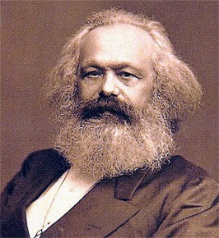
Economic Thinkers – Marx, Smith and Hayek
1.1.6 Free market economies, mixed economy and command economy
a) The distinction between free market, mixed and command economies: reference to Adam Smith, Friedrich Hayek and Karl Marx
b) The advantages and disadvantages of a free market economy and a command economy
c) The role of the state in a mixed economy
Students should have an awareness of the perspective of Smith, Hayek and Marx.
There is no requirement for detailed consideration of the work of each economist.
