1.2.3 Markets

Starter:
B
A
Question 1

Question 2
A
B
Question 3

Definition of supply:
Price
Quantity
S
Supply

______________________________________________________________________________________________________________________________________________________________________________________________________________________________________________________

Definition of demand:
Demand
Price
Quantity
D

_____________________________________________________________________________________________________________________________________________________________________________________________________________________________________________________
Market clearing price – explain that here:
________________________________________________________________________________________________________________________________________________________________________________________________________________________________________________________________________________________________________________________________________

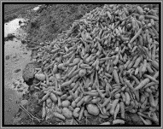
Surplus – explain that here:

________________________________________________________________________________________________________________________________________________________________________________________________________________________________________________________________________________________________________________________________________
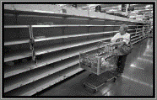
Shortage – explain that here:

________________________________________________________________________________________________________________________________________________________________________________________________________________________________________________________________________________________________________________________________________
Supply

How a price increase affects the supply curve:

Supply
How a price decrease affects the supply curve:

Non-price factors that affect supply
Supply
1
2
3
4
5
Supply
How non-price factors can affect the supply curve –
increase in supply (surplus)

Supply
How non-price factors can affect the supply curve –
decrease in supply (shortage)

Demand
How a price increase affects the demand curve:

How a price decrease affects the demand curve:
Demand

#

Non price factors that affect demand:
1
2
3
4
5
6
7
8
9
10
How non-price factors can affect the demand curve: increase in demand
Demand

How non-price factors can affect the demand curve: –
decrease in demand
Demand

