1.5.5 Business Choices

Starter:
- James is an entrepreneur. He sells hats at festivals on a stall. He now wants to grow his business.
- He has a decision to make:
  - OPTION A: he can rent another stall
  - OPTION B: he could sell his hats, on another stall through another trader, who will charge him commission for every hat sold
  - He cannot do both – which should he choose?

- Justify your decision

- Possible answer to starter

Write a definition of opportunity cost here:
________________________________________________________________________________________________________________________________________________________________________________________________________________________________________________________________________________________________________________________________________
Opportunity cost – the problem
________________________________________________________________________________________________________________________________________________________________________________________________________________________________________________________________________________________________________________________________________

Choices and potential trade-offs
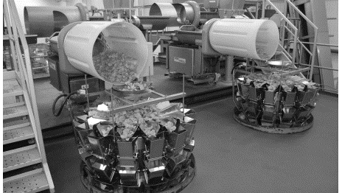
Trade-off defined

________________________________________________________________________________________________________________________________________________________________________________________________________________________________________________________________________________________________________________________________________

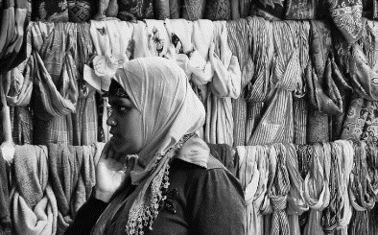
Trade-off example – scarves

________________________________________________________________________________________________________________________________________________________________________________________________________________________________________________________________________________________________________________________________________
Trade-off________________________________________________________________________
Opportunity cost_______________________________________________________________
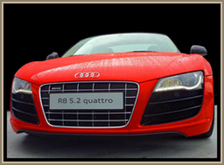
Cars Vs Vans

________________________________________________________________________________________________________________________________________________________________________________________________________________________________________________________________________________________________________________________________________
Trade-off________________________________________________________________________
Opportunity cost_______________________________________________________________

