1.4.5 Leadership

Starter
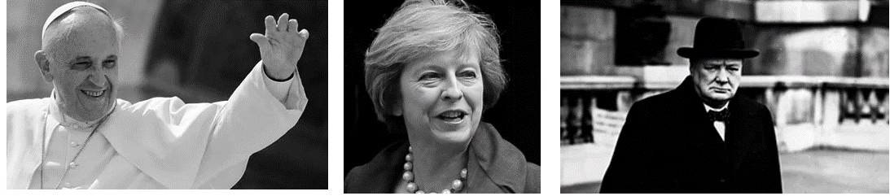
- Which of these would you consider to be the greatest leader?
__________________________________________________________________
- What are the qualities of a great leader?
__________________________________________________________________
- Is there anyone missing in your opinion?
__________________________________________________________________

Write a definition of leadership here:
____________________________________________________________________________________________________________________________________________________________________
Write a definition of management here:
____________________________________________________________________________________________________________________________________________________________________

Leadership vs management
Leadership | Management

Types of leadership style

Autocratic leadership
________________________________________________________________________________________________________________________________________________________________________________________________________________________________________________________________________________________________________________________________________
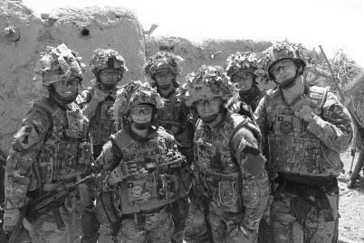
Autocratic continued

________________________________________________________________________________________________________________________________________________________________________________________________________________________________________________________________________________________________________________________________________
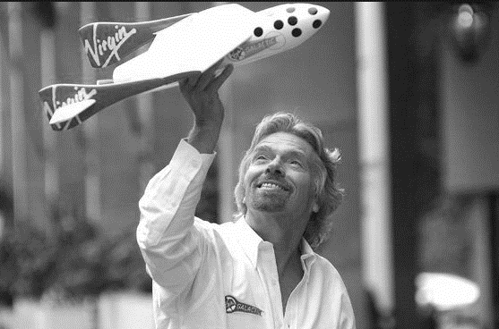
Democratic Leadership

________________________________________________________________________________________________________________________________________________________________________________________________________________________________________________________________________________________________________________________________________
Democratic continued

________________________________________________________________________________________________________________________________________________________________________________________________________________________________________________________________________________________________________________________________________
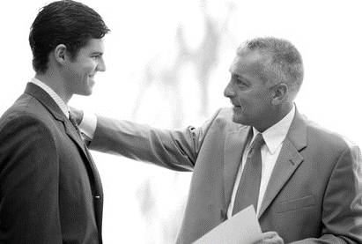
Paternalistic continued

________________________________________________________________________________________________________________________________________________________________________________________________________________________________________________________________________________________________________________________________________
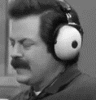
Laissez-faire

________________________________________________________________________________________________________________________________________________________________________________________________________________________________________________________________________________________________________________________________________
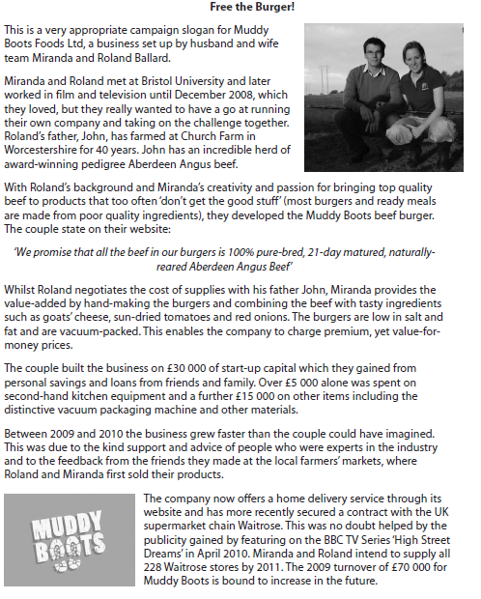
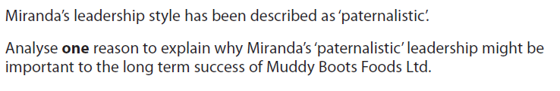

[4]

