Data response

British clothing manufacturer Superdry is considering building a brand new factory as part of a strategy to boost market share in the USA. This will be the company's first factory on the other side of the Atlantic and the choice has been narrowed down to two possible options.

Option A - Mexico
Following a path that many European firms have followed, Mexico will offer a relatively stable political environment and a large pool of suitably skilled labour. With transport costs to the US market relatively low, Superdry would also benefit from Mexico's membership of NAFTA. The availability of highly skilled workers means that factory defect rates should be no more than 1 per cent.

Option B - Venezuela
With a growing clothing manufacturing sector, the current Venezuelan government is keen to offer incentives to foreign manufacturers to locate there. Some Superdry staff has noted the ease with which this location would allow the firm to enter the huge Brazilian market in the future. However, the greater distance to the US market would add five days to delivery times. The availability of skilled workers means that factory defect rates should be no more than 4 per cent.

Financial data for the two options is shown in Table 34.4.
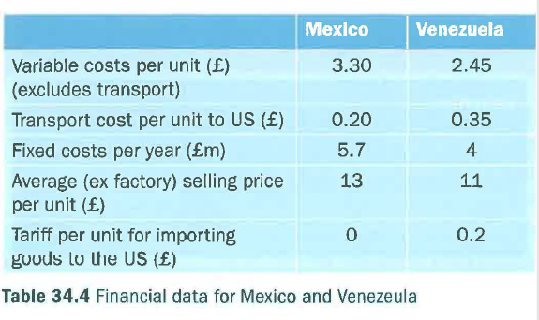
Questions (40 marks; 45 minutes)

1 Calculate the break-even point for both factories. (10)

2 Assess the main factors other than costs that should be considered when making the decision. (10)

3 Based on all the information available, evaluate which site the directors of Superdry should choose. (20)

