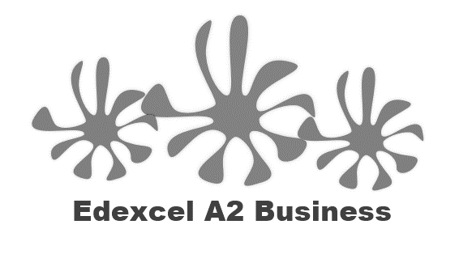
2.2.2 Sales, revenues and costs

Starter
- If you were going to start a business selling products at a festival – what would you sell?

Your festival business
_______________________________________________________________________________________________________________________________________________________________________________________________________________________________________________________________________________________________________________________________________

Basic terms:

Sales revenue
Variable cost
Fixed costs
Profit

Sales volume formula – write that here:

 | SR | SP | SV
Hats | £100,000 | 40p
Sunglasses | £60,000 | £1.20
Wellies | £80,000 | £4.60

Sales revenue formula – write that here:

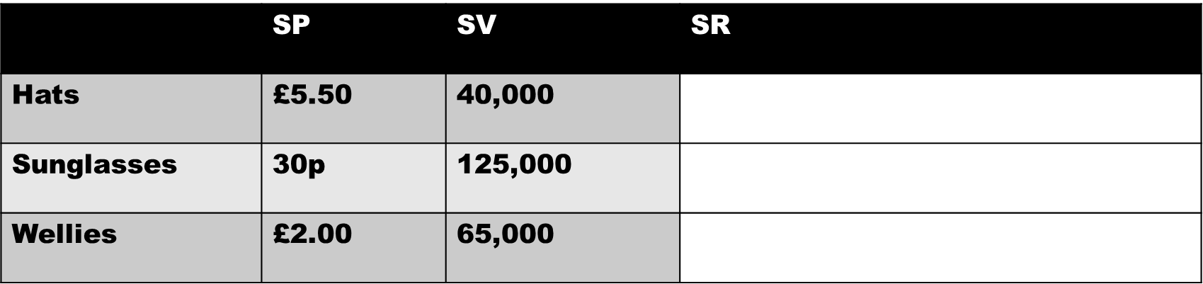

Write a definition of fixed costs here:
________________________________________________________________________________________________________________________________________________________________________________________________________________________________________________________________________________________________________________________________________
Examples of fixed costs
________________________________________________________________________________________________________________________________________________________________________________________________________________________________________________________________________________________________________________________________________

Fixed costs of a festival business
________________________________________________________________________________________________________________________________________________________________________________________________________________________________________________________________________________________________________________________________________

Calculation of fixed costs

Fixed costs on a bank loan
- For example, a loan of £5,000 at 9.9% over 3 years would be:
  - Monthly repayments £_____________________________
  - Total amount repayable £___________________________
  - APR 9.9%Total cost of credit £______________________
Step 1
Step 2
Step 3

Bank loan calculation examples:
 | Example A | Example B | Example C | Example D
Number of years loan is over | £30,000 | £10,500 | £4,500 | £9,000
Percentage rate of the loan | 5 | 10 | 3 | 4
Total cost of credit | 7% | 5.5% | 6% | 8.25%
Total amount repayable
Monthly repayments
Definition of variable costs
________________________________________________________________________________________________________________________________________________________________________________________________________________________________________________________________________________________________________________________________________

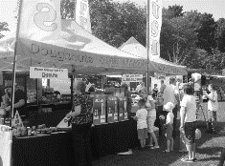
Variable costs

________________________________________________________________________________________________________________________________________________________________________________________________________________________________________________________________________________________________________________________________________
Variable costs of a festival business
________________________________________________________________________________________________________________________________________________________________________________________________________________________________________________________________________________________________________________________________________

Total variable cost formula

 | AVC | Q | TVC
A | £2.25 | 40,000
B | 40p | 125,000
C | £6.50 | 65,000

Total costs formula

 | AVC | Q | TVC
A | £30,000 | £66,000
B | £42,000 | £52,400
C | £127,000 | £170,000
Formula to calculate changes:

