Ethical Teaching: Kamma, Karuna & Metta Summary Sheet
(Pages 64-69 in the Buddhism textbook)
This summary sheet is to help you learn about Buddhist ethical teaching on kamma, compassion (karuna) and loving-kindness (metta). According to the AQA specification you need to know the following things:
‘Ethical teaching:
• kamma (karma) and rebirth
• compassion (karuna)
• loving kindness (metta).’
Terminology
benevolent - wishing good for others, e.g., wanting to help them
compassion - feeling concerned for the suffering of other people
Dhamma - the teaching of the Buddha
ethics - the study of right & wrong behaviour/good & bad behaviour
ethical - to do with right/wrong behaviour
equanimity - accepting good things and bad things with an equal level calmness
the Four Sublime States - the four qualities of love, compassion, sympathetic joy and equanimity
kamma (karma) - 1. a person’s actions; 2. the idea that skilful actions result in happiness and unskilful actions result in suffering.
karuna - compassion
metta - loving-kindness; showing a kind, friendly, benevolent attitude toward others
moksha - release from the cycle of rebirth
rebirth - Buddhist belief that the kammic energy of a person’s/animal’s life continues after death and is born into a new body. There is no continuing identity and no soul therefore it is not the same as reincarnation in Hinduism and Sikhism.
samsara - the cycle of rebirth
skilful - good, ethical actions or behaviour
Sutta Nipata - one of the Buddhist holy books
unskilful - bad, unethical actions or behaviour
vihara - a Buddhist monastery
Kamma (karma in Sanskrit language)
Kamma is the Pali language version of the word. Kamma strictly means one’s actions. However, in Buddhism it refers to the idea that a person’s good or bad ethical desires lead that person in the direction of happiness or suffering. People who feel like doing good kamma are likely to be led in the direction of happiness. People who follow the desires of greed, hatred & ignorance are being led in the direction of the suffering of themselves as well as others.
An example is a person who is often angry. Anger is unpleasant and the angry person suffers because of his anger. He will also behave in ways that bring him and others suffering, such as getting into fights. Other people will not want to be around the angry person and he will be left alone and isolated.
People are not punished for their actions, they are punished by their actions. The Christian idea of sin does not quite exist in Buddhism. Buddhists talk about skilful (good) and unskilful (harmful) actions.
Rebirth
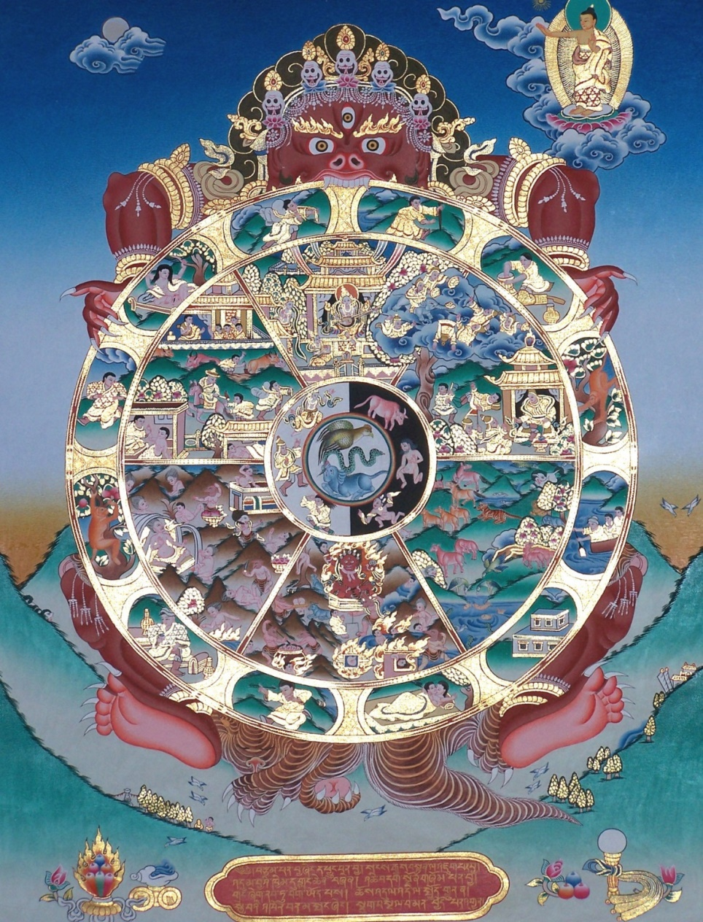
A person’s kamma affects their rebirth. At death, the kammic energy of the dying person/animal is reborn into one of the Six Realms:
- the realm of the devas (gods/goddesses);
- the realm of the asuras (angry warrior beings);
- the realm of the animals;
- the realm of the tormented beings (hell);
- the realm of the pretas (hungry ghosts);
- the realm of the humans (come on, you know what this means!).
The human realm is the best one for achieving enlightenment and moksha.
The belief in anatta means that there is no self or soul; no continuing identity. There is only a constantly changing personality, the kamma of which continues into the rebirth. A being may pass from a god to a human to an animal in different lives or the other ways around and may change gender. Buddhists believe that there are many lives before someone achieves enlightenment and release from this cycle of samsara. Until they let go of all greed, hatred and ignorance they cannot be freed from suffering. Therefore, Buddhists aim to use skilful, compassionate actions to gain a better rebirth. (See also the PowerPoint buddhist_crime TES on the VLE in the Y10/Y11 section of RE under Crime & Punishment.)
Karuna
This means compassion or caring about the suffering of others. The best example of this for Buddhists is when Buddha had become enlightened he chose to share what he discovered with others rather than keep it to himself. This was because he saw the suffering of the people and wanted to help them be free. Karuna may be shown to oneself and it recognises that one cannot be truly happy when others are unhappy.
Karuna is important because:
- it is one of the Four Sublime States:
  - metta (loving-kindness);
  - karuna (compassion);
  - sympathetic joy (being happy for others);
  - equanimity (stability/calmness in the face of suffering or happiness);
- Buddha told his followers to develop these states;
- in Mahayana it is needed in order to become a Bodhisattva.
It is important to develop wisdom along with karuna in order to have the intelligence to help those in need. An example of compassion in action is the charity ROKPA. This provides free education to poor children and orphans in Tibet, Nepal and Zimbabwe.
Metta
This means loving-kindness and is also one of the Four Sublime States. Buddhists aim to cultivate a kind and friendly attitude towards all other beings including those whose actions are unskilful.
‘Just as a mother would protect with her life her own son, her only son, so one should cultivate an unbounded mind towards all beings, and loving-kindness towards all the world.’
The Sutta Nipata verses 149-150
Metta is different from karuna because metta is the desire for others to be happy but karuna is what happens when metta meets suffering. An example is desiring a friend to be happy (metta) but being upset when the friend has an accident (karuna). The goodwill transforms into compassion.
Metta is important because:
- by concentrating on the good of others it removes jealousy, greed and hatred;
- people will be less likely to be angry;
- it helps lead to enlightenment.
Loving-kindness meditation is a way of increasing one’s metta. It has five parts to it. The meditator focusses on having metta towards:
- oneself;
- a good friend;
- a neutral person (someone who is not a friend but not disliked);
- a difficult person whom one dislikes;
- all four of these people followed gradually by everyone else in the world.
They will say words to wish happiness and wellbeing to each of these people.

Possible Exam Questions
Explain two ways in which believing in kamma might affect the way a Buddhist lives. (4 marks)
Explain two ways in which metta is different from karuna. In your answer you must refer to scripture. (5 marks)
Explain two ways in which practising metta can affect oneself and others. In your answer you must refer to scripture. (5 marks)
‘Metta is impossible to show towards everyone in the world.’ (12 marks)
‘The motivation behind an action is more important than the consequences.’ (12 marks)
‘Wisdom is more important than compassion.’ (12 marks)
‘We need to view anybody we meet in whatever circumstances as a brother or sister with compassion.’ (12 marks)
‘Being kind to others in order to gain enlightenment is selfish.’ (12 marks)

