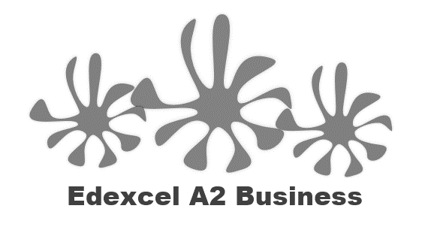
3.6.1 Causes and effects of change

Causes of change in a business:
#1 Changes in organisational size

#2 Poor business performance

#3 New ownership

#4 transformational leadership

#5 PESTLE

Possible effects of change on a business

#1 Competitiveness

#2 Productivity

#3 Financial performance

#4 stakeholders - internal

#4 stakeholders - external

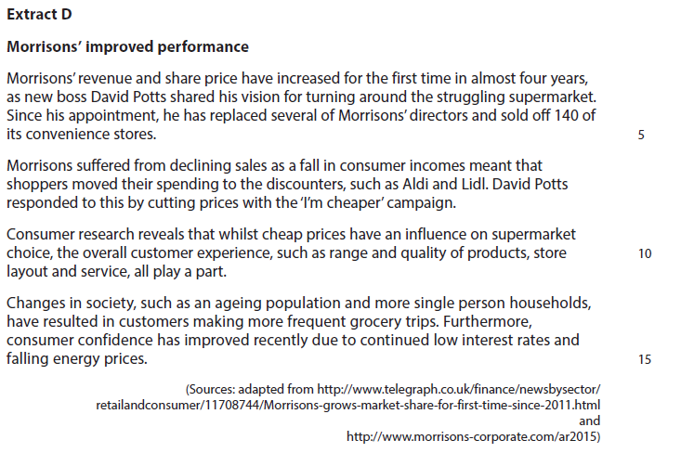

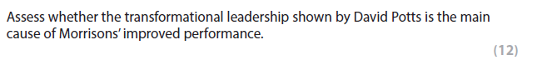

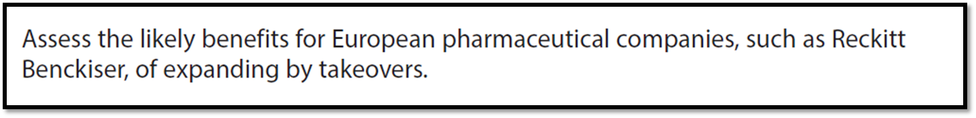
[8]

