3.3.3 Decision trees

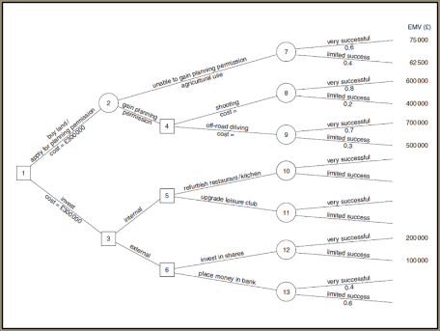
Write the definition of decision trees here:

________________________________________________________________________________________________________________________________________________________________________________________________________________________________________________________________________________________________________________________________________
Step 1: How the decision tree works
A decision tree traces an _________________________ outcome of a decision, the results can be compared and the business can decide which _____________________ would be the most _____________________________
This is a _____________________________________ approach (means it uses numbers) it is pictorial as it’s in the shape of a tree and it predicts the best bet _________________________ so a business knows what to spend its money on
The data is usually based on ___________________________ data from the business, for example they would know the probability of success of launching a new product would be 20% based on previous ________________ launches and how _______________ they had turned out

Step by step how to draw a decision tree

Example 1 – complete the tree
Launch a new product
Start a marketing campaign on the old product
A
B
Success
Success
Failure
Failure
0.2
0.8
0.4
0.6

Example 2 complete the tree
Launch a new product £1 million
Start a marketing campaign on the old product
£0.7 million
A
B
Success
Failure
Failure
0.2
0.8
0.4
0.6
£20 million
£1 million
£7 million
£1 million
Success

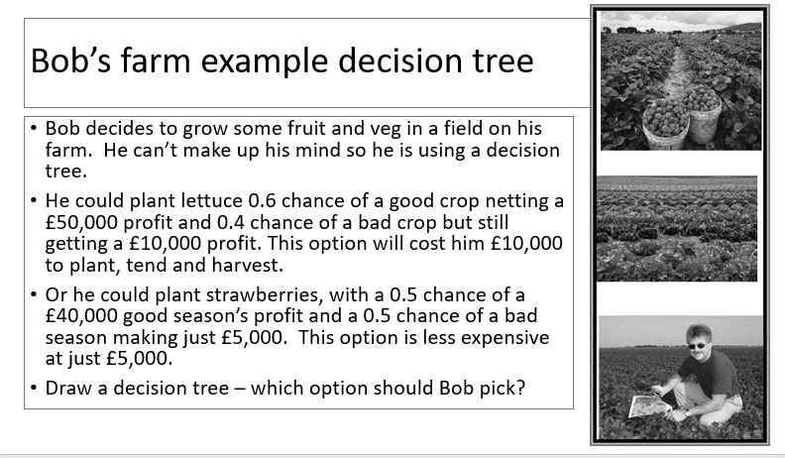

Bob’s farm example decision tree - can you complete the tree?

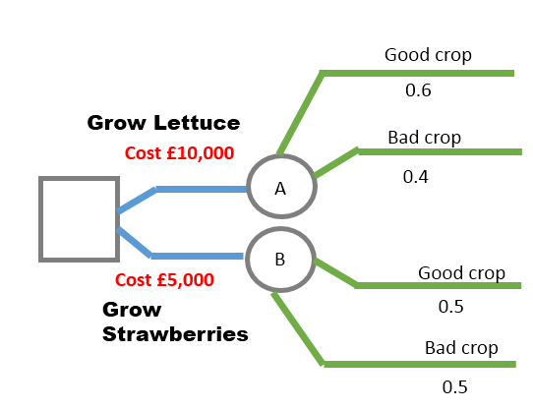

Limitations
1
2
3
4
5

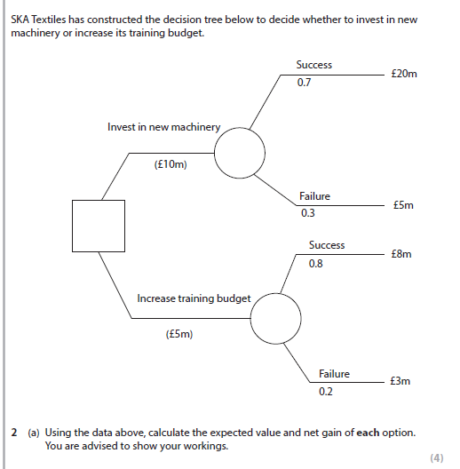

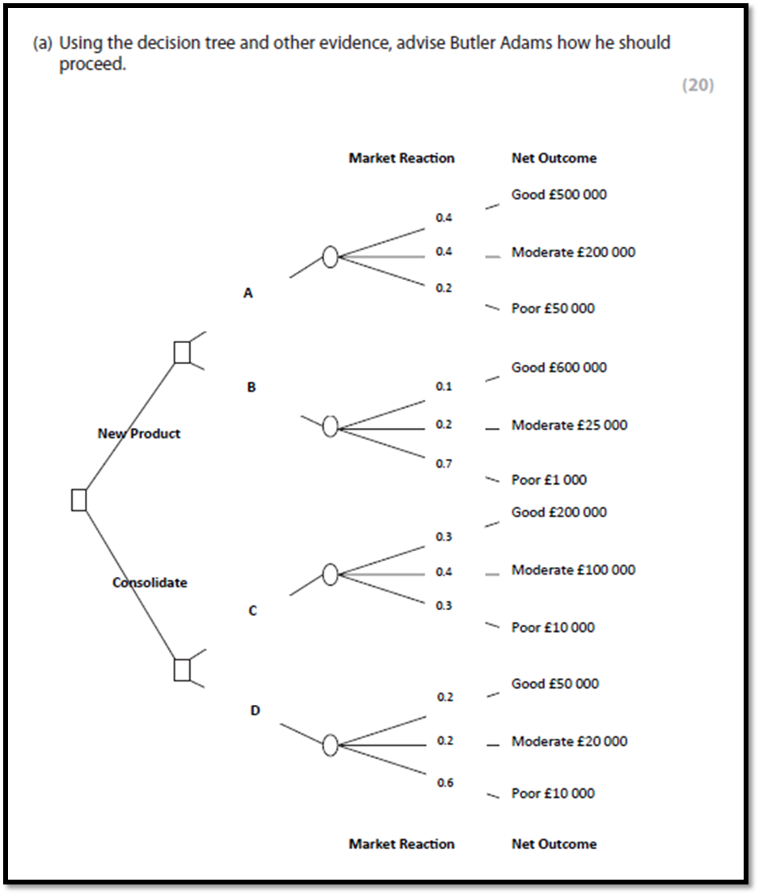
Just complete the calculation on this question as you don’t have the full case study.

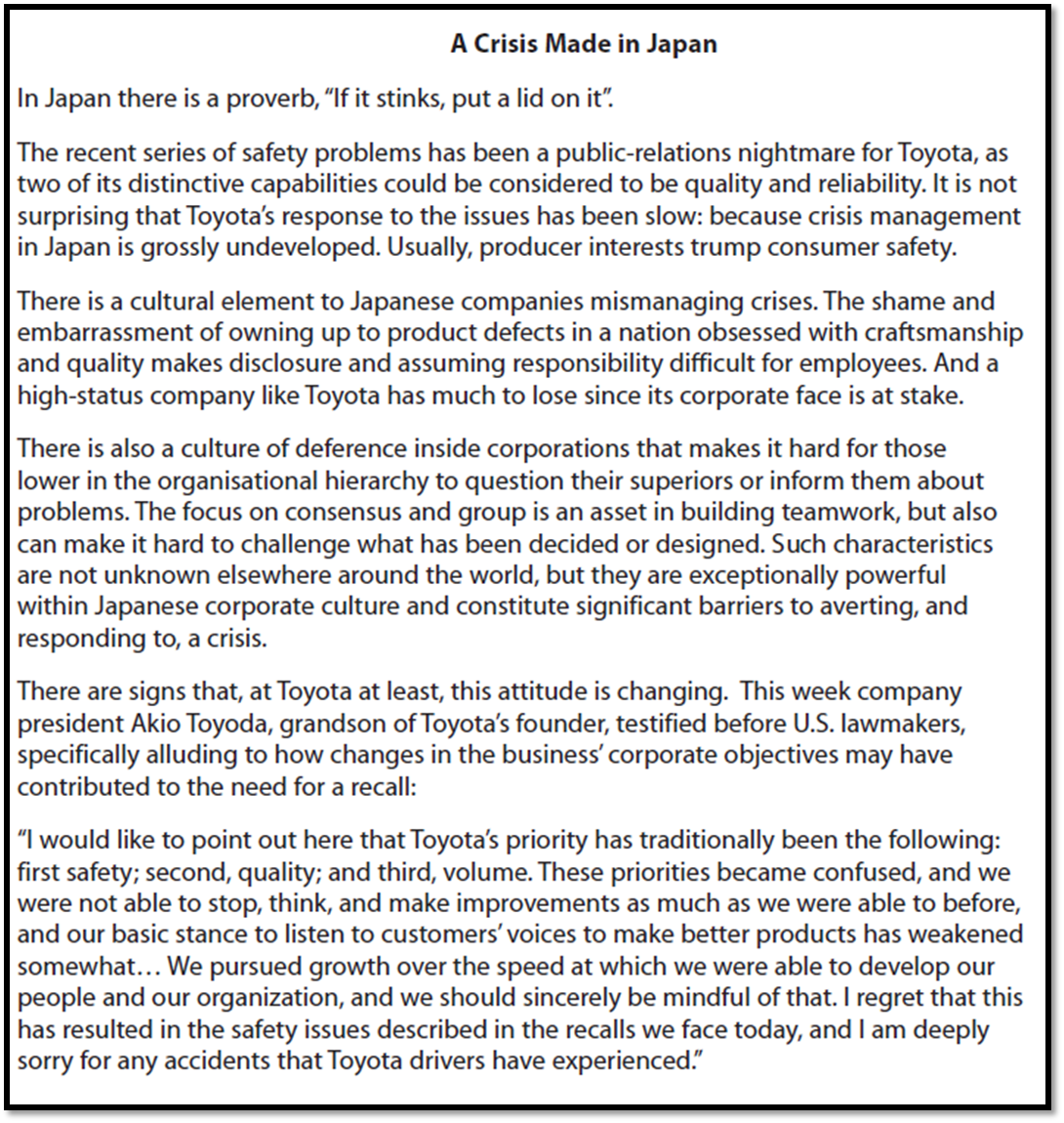
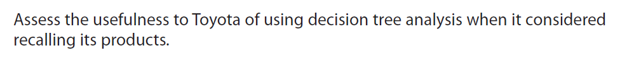
[10]

