One in five cigarettes smoked in Britain avoids UK tax as holidaymakers stock up abroad

Potential tax revenues up in smoke as use of foreign and smuggled cigarettes rises amid hikes in duty
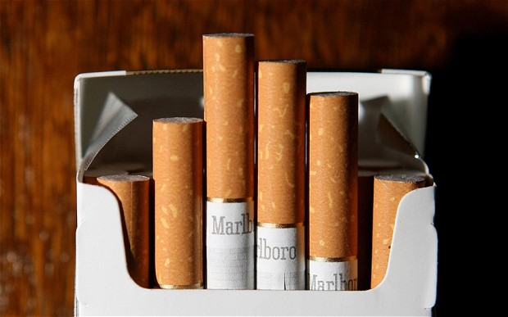
One in five cigarettes smoked in the UK is now bought or smuggled from abroad as increasing numbers of travellers bring boxes back from holidays and gap years to avoid soaring taxes, new research suggests.
The proportion of cigarettes used in Britain without paying UK duty leapt by more than 40 per cent in the last year, the latest findings from an annual study compiled for tobacco manufacturers claims.
It suggests that duty has risen so much that the Treasury risks missing out on millions of pounds of potential revenue because more smokers are stockpiling on trips abroad.
There is a continuing concern over plans to force manufacturers to sell cigarettes in so-called plan packaging – unbranded packets, likely to carry large graphic health warnings.
Polls suggest more than six out of 10 people in Britain would support a change in the law.
But studies in Australia, which introduced plain packaging recently, suggest a regulation like this could lead to a rise in smuggling without reducing overall smoking. In part due to reducing the difficulty of producing counterfeit cigarette packets.
The price of a packet of cigarettes in Britain has doubled in 10 years and almost quadrupled in two decades.
A pack of 20 cigarettes rose from an average of £4.51 for the most popular brands in 2003 to £7.98 last year – 77 per cent of which was tax. The most recent budget added another 28 pence to the price.
As part of the tobacco industry’s annual Market Survey Report, researchers collect almost 13,000 empty and discarded packets a year from more than 100 towns and cities in the UK to monitor counterfeit activities.
In the most recent study 21.4 per cent of boxes collected either: carried a foreign duty stamp OR had been illegally smuggled – up from 15 per cent a year earlier.
A spokesman for Philip Morris, whose brands include Marlboro and Chesterfield, said: "Non-duty paid cigarettes are a serious problem in the UK.
“Coupled with other forms of illegal cigarettes they cost the UK Government nearly three billion pounds in lost revenue. Those who think that it is a victimless crime to bring back a few cartons of cigarettes to sell to their friends are wrong.
“Selling fake and non-duty paid tobacco in this way affects legitimate retailers and undermines the efforts to tackle this illicit trade.
“As this study shows the market in illegal cigarettes is booming with up to one in five cigarettes smoked in Britain being fake, smuggled or non-duty paid. The black market in illegal cigarettes is increasingly controlled by organised criminal gangs. Anything that boosts it must be stopped.”
QUESTIONS:
What examples of government intervention are mentioned in the article?

Outline the examples of government failure (unintended consequenes) mentioned.

What could the government do to increase their government revenue?

Draw the Laffer Curve below to highlight the impact of high tax rates:

