3.6.3 Scenario planning

Write a definition of scenario planning here:

________________________________________________________________________________________________________________________________________________________________________________________________________________________________________________________________________________________________________________________________________
Create your own scenario planning diagram here:

Scenario planning process
________________________________________________________________________________________________________________________________________________________________________________________________________________________________________________________________________________________________________________________________________
Write about the Shell energy scenario in 2050 video here:

Risk assessment
#1 Natural disasters
- A __________________________ can strike any organisation, large or small. It can arrive in the shape of storm, flood, fire, earthquake and even ____________________
- It may take some time for the business to return to ____________________________ operation after an incident.
- ______________________________ change means UK businesses must plan for extremes of weather
#2 IT systems failure
- IT systems often contain ___________________ about: Customers details including; e-mails, phone numbers, addresses, supplier’s details, stock control information, how much __________________ is in the warehouse, location etc.
- Human resources ___________________________, sensitive information on contract, pay rates, health __________________________ and personal circumstances
- If this information is lost it could be __________________________________ for the business (and possibly the customers)
- Scenario planning means that adequate __________________________, backups and alternatives are planned for and in place
#3 Loss of key staff
- When a key figure leaves whether it’s a band or a business, it can have serious repercussions on that organisation’s __________________________________________.
- It is important to plan for the loss of key staff so that when it happens the business ________________________________ as normal
Who am I and what band did I leave?

A

B

C

D

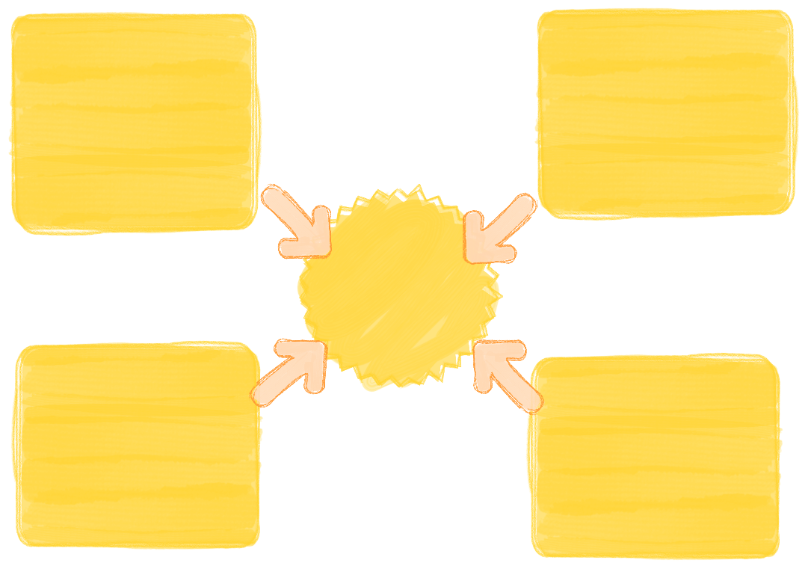
Degrees of risk mitigation

Planning for risk mitigation
Business continuity planning

Succession planning

Succession planning

Potential

Performance

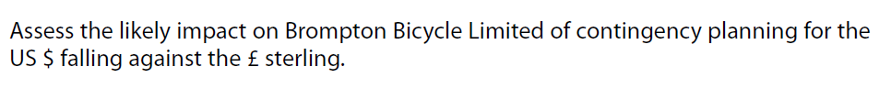

[9]

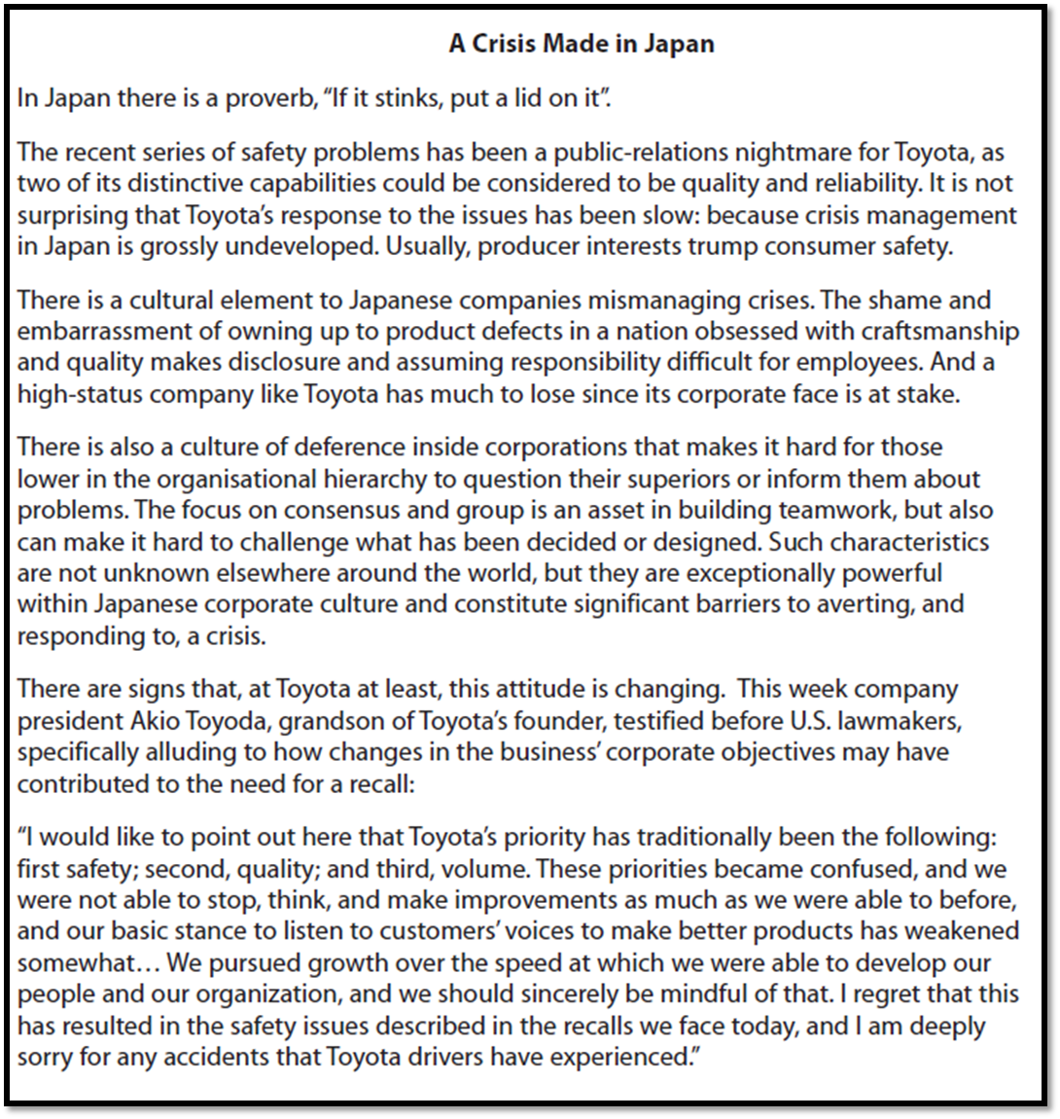
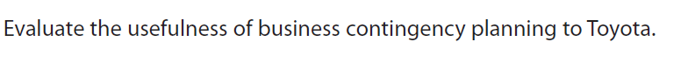

[20]

