2.5.2 Legislation

Starter
Have you ever had anything that you had to take back to a shop?

Write a definition of legislation here:
____________________________________________________________________________________________________________________________________________________________________
Legislation introduction

#1 Consumer Protection Law
________________________________________________________________________________________________________________________________________________________________________________________________________________________________________________________________________________________________________________________________________
#1 Consumer protection effect on business

________________________________________________________________________________________________________________________________________________________________________________________________________________________________________________________________________________________________________________________________________
#2 Employee protection
Employment __________________ Act __________________
Minimum ____________________________Act _______________
Working _________________________ Regulations_____________
Pensions Act _______________________
Equality Act _________________________
#2 Employee protection: Employment Rights Act

________________________________________________________________________________________________________________________________________________________________________________________________________________________________________________________________________________________________________________________________________
#2 Employee protection: National Minimum Wage Act

________________________________________________________________________________________________________________________________________________________________________________________________________________________________________________________________________________________________________________________________________
#2 Employee protection: National living wage

________________________________________________________________________________________________________________________________________________________________________________________________________________________________________________________________________________________________________________________________________

#2 Employee protection: Working Time Regulations 1998

________________________________________________________________________________________________________________________________________________________________________________________________________________________________________________________________________________________________________________________________________
#2 Employee protection: Pensions Act 2008

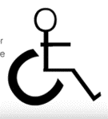
________________________________________________________________________________________________________________________________________________________________________________________________________________________________________________________________________________________________________________________________________
#2 Employee protection: Equality Act 2010

________________________________________________________________________________________________________________________________________________________________________________________________________________________________________________________________________________________________________________________________________
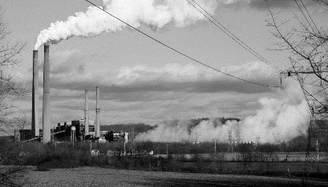
#3 Environmental protection

________________________________________________________________________________________________________________________________________________________________________________________________________________________________________________________________________________________________________________________________________
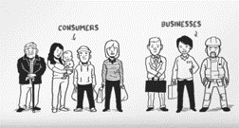
#4 Competition policy

________________________________________________________________________________________________________________________________________________________________________________________________________________________________________________________________________________________________________________________________________

#5 Health and Safety at Work Act: workplace hazard

#5 Health and Safety at Work Act: employer duties

#5 Health and Safety at Work Act

Impact of legislation on business cost
Impact of legislation on business training needs
Impact of legislation on business recruitment

