The Factors of Production
Sometimes also known as the factors of supply.
Economic resources are scarce relative to the infinite needs and wants of people and businesses operating in the economy. It is important to use these resources efficiently in order to maximise the output that can be produced from them.
Economists make a distinction between three types of resources - land, labour and capital. Also enterprise, but this one is not as important from our point of view – but just be aware that it exists.
- CAPITAL
- ENTERPRISE
- LAND
- LABOUR
You can remember the factors of supply by using the acronym CELL.
LAND
Land is the natural resources available for production. Some nations are endowed with natural resources and exploit this by specialising in the extraction and production of these resources - for example - the development of the North Sea Oil and Gas.
Only one major resource is for the most part free - the air we breathe. The rest are scarce, because there are not enough natural resources in the world to satisfy the demands of consumers and producers. Air is classified as a free good since consumption by one person does not reduce the air available for others - a free good does not have an opportunity cost
LABOUR
Labour is the human input into the production process.
In the UK, of about 60 million inhabitants only approximately 35 million are of working age (16-64 years for men and 16-59 for women), and of those about 28 million have paid jobs. The employment level for people in the Uk economy is shown in the chart below. Over recent years there has been a sustained increase (expansion) in the employed labour force.
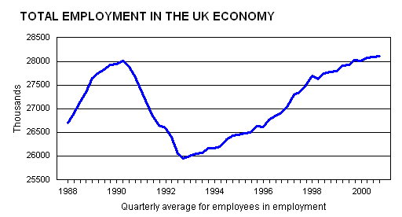
Two important points need to be remembered about labour as a resource:
A housewife, a keen gardener and a DIY enthusiast all produce goods and services, but they do not get paid for them. They are producing non-marketed output and the output of these people is not included in Gross Domestic Product.
Not all labour is of the same quality. Some workers are more productive than others because of the education, training and experience they have received
Human capital refers to the quality of labour resources, which can be improved through investments in education, training, and health

CAPITAL
To an economist, capital has several meanings - including the finance raised to operate a business. But normally the term capital means investment in goods that can produce other goods in the future.
Capital refers to the machines, roads, factories, schools and office blocks which human beings have produced in order to produce other goods and services. A modern industrialized economy possesses a large amount of capital, and it is continually increasing. Increases to the capital stock of a nation are called investment. Investment is important if the economy is to achieve economic growth in the long run.

ENTERPRISE
This is one you should be aware of, but is not as important as the other three.
Enterprise refers to the people who organize other productive resources to make goods and services. Some economists regard entrepreneurs as a specialist form of labour input. Others believe that they deserve recognition as a separate factor of production in their own right.
The success and/or failure of a business often depend critically on the quality of entrepreneurship.

