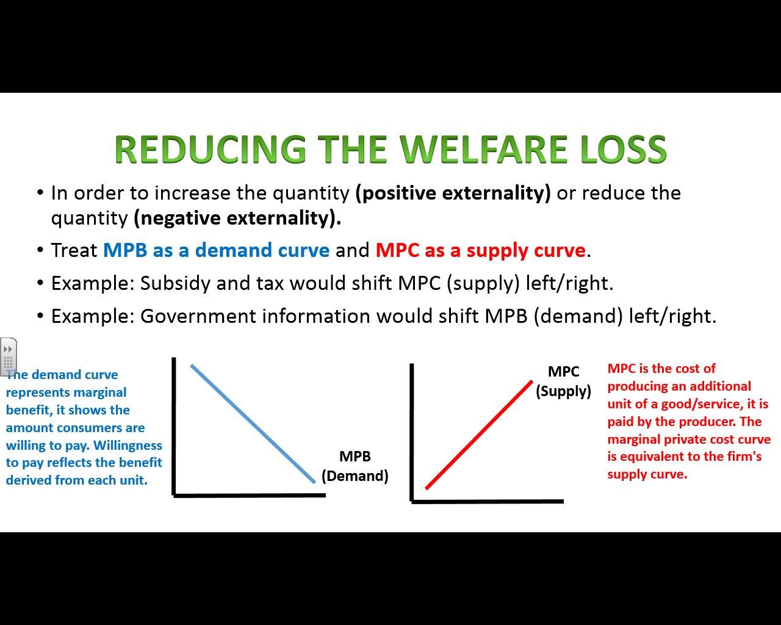

Government Intervention to reduce externalities
Using the information on the reverse of this page, try and draw the following diagram:
- Start by drawing a negative externality diagram on the axes below:
- Now adapt the diagram to illustrate what would happen to the welfare loss triangle if taxation was placed upon this particular good. (Do not eliminate the triangle entirely.)

Explain what has happened to the welfare loss, how is this an example of government failure?

What does the government need to do in order to eliminate the externality totally?

Mr Wilson’s Thinking Further Challenge… Now solve the same negative externality scenario by having the government try to close the information gap with an advert campaign. Draw what this would look like.

