1.3.5 Marketing Strategy

Starter
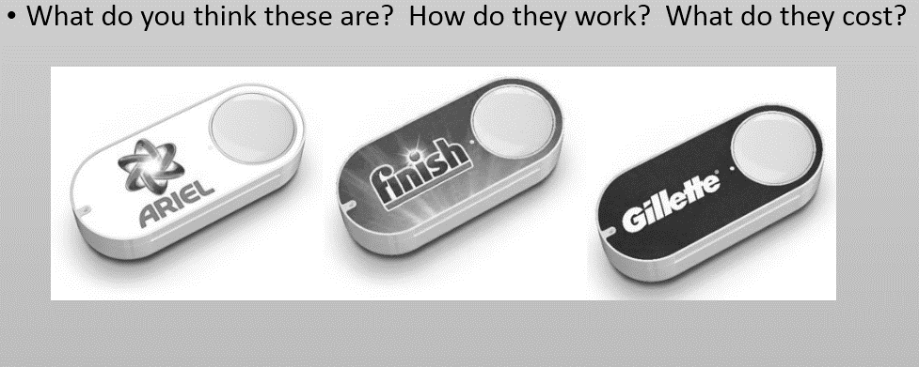

____________________________________________________________________________________________________________________________________________________________________
Write a definition of marketing here:
____________________________________________________________________________________________________________________________________________________________________
Write a definition of marketing strategy here:
____________________________________________________________________________________________________________________________________________________________________
Product lifecycles
________________________________________________________________________________________________________________________________________________________________________________________________________________________________________________________________________________________________________________________________________

Draw the product lifecycle diagram

Time
Revenue £

Product lifecycle explained
Product development
Introduction of product to market
Growth phase
Maturity phase
Decline phase

Product lifecycle extension strategies

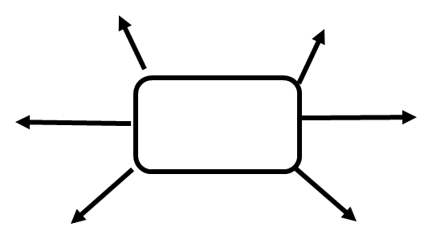

- There are ways that a business can extend the lifecycle of the product, the most popular ways are:

Draw the product lifecycle diagram with the extension strategy marked on

Time
Revenue £

Product lifecycle extension strategies
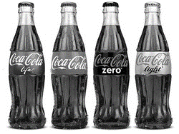
__________________________________________________________________________________________________________________________________________________________________________________________________________________________________________________________________________________________________________________________________________________________________________________________
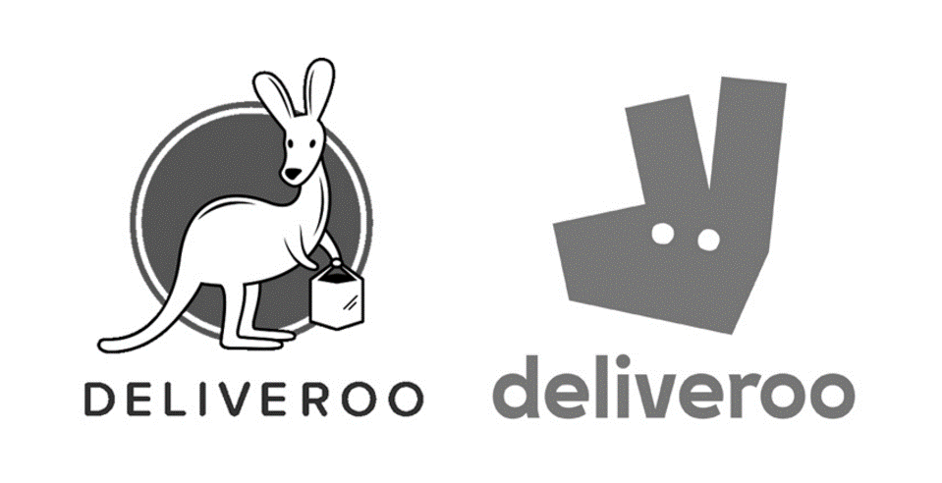
__________________________________________________________________________________________________________________________________________________________________________________________________________________________________________________________________________________________________________________________________________________________________________________________

Product lifecycle extension– modification of the product
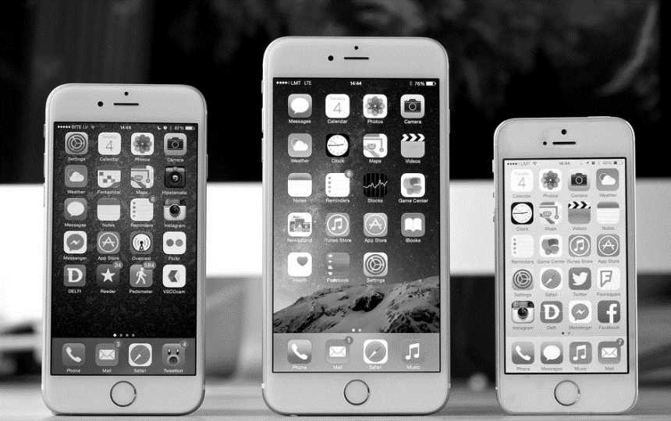
__________________________________________________________________________________________________________________________________________________________________________________________________________________________________________________________________________________________________________________________________________________________________________________________

__________________________________________________________________________________________________________________________________________________________________________________________________________________________________________________________________________________________________________________________________________________________________________________________
Product lifecycle extension - rebranding
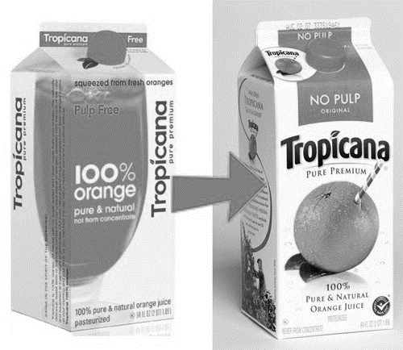
__________________________________________________________________________________________________________________________________________________________________________________________________________________________________________________________________________________________________________________________________________________________________________________________
Product lifecycle extension – relaunching product
__________________________________________________________________________________________________________________________________________________________________________________________________________________________________________________________________________________________________________________________________________________________________________________________
Product lifecycle extension - promotion
__________________________________________________________________________________________________________________________________________________________________________________________________________________________________________________________________________________________________________________________________________________________________________________________
Boston Matrix and the product portfolio

Write a definition of the Boston Matrix here:

__________________________________________________________________________________________________________________________________________________________________________________________________________________________________________________________________________________________________________________________________________________________________________________________

Boston Matrix explained

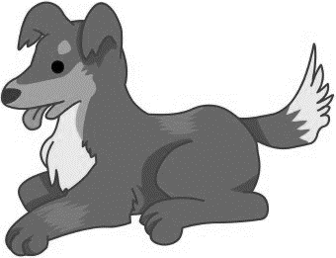

Uses and limitations of the Boston Matrix

Uses | Limitations

Marketing strategies appropriate for different types of market

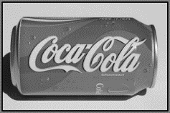Mass market strategies
________________________________________________________________________________________________________________________________________________________________________________________________________________________________________________________________________________________________________________________________________

Niche market strategies

________________________________________________________________________________________________________________________________________________________________________________________________________________________________________________________________________________________________________________________________________

B2B marketing

________________________________________________________________________________________________________________________________________________________________________________________________________________________________________________________________________________________________________________________________________

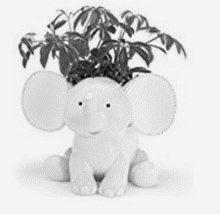B2C Marketing

________________________________________________________________________________________________________________________________________________________________________________________________________________________________________________________________________________________________________________________________________

Consumer behaviour – how businesses develop customer loyalty
- Businesses have discovered that it is much ______________________ to keep a _________________ customer than to gain new customers through marketing
- The expression “______________________ the leaky bucket” is used – where business owners should focus on keeping their existing customers with loyalty _______________________, discounts and extras rather than continually trying to _____________________________ new customers
- Customer loyalty is creating a product or service that ensures ______________________ purchases

Effective customer service

________________________________________________________________________________________________________________________________________________________________________________________________________________________________________________________________________________________________________________________________________
________________________________________________________________________________________________________________________________________________________________________________________________________________________________________________________________________________________________________________________________________

________________________________________________________________________________________________________________________________________________________________________________________________________________________________________________________________________________________________________________________________________

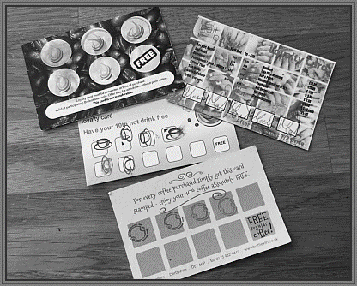Loyalty cards
________________________________________________________________________________________________________________________________________________________________________________________________________________________________________________________________________________________________________________________________________

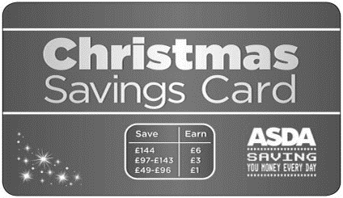Saver schemes

________________________________________________________________________________________________________________________________________________________________________________________________________________________________________________________________________________________________________________________________________

