1.2.5 Income Elasticity of Demand (YED)

Starter
Read these statements and have a go at the question.
- We know that an inferior good is a good whose demand decreases when consumer income increases
- We also know that a normal good (necessity good) is any good for which demand increases when income increases
- We also know that a luxury good is a good for which demand increases more than proportionally as income rises

Define Income Elasticity of Demand here:
________________________________________________________________________________________________________________________________________________________________________________________________________________________________________________________________________________________________________________________________________

Normal goods
________________________________________________________________________________________________________________________________________________________________________________________________________________________________________________________________________________________________________________________________________
Inferior goods
________________________________________________________________________________________________________________________________________________________________________________________________________________________________________________________________________________________________________________________________________

________________________________________________________________________________________________________________________________________________________________________________________________________________________________________________________________________________________________________________________________________

ED formula, write that in here:

% change in price or quantity demanded formula, write that in here:

Interpretation of numerical values

Inferior | Normal | Luxury

Example YED Calculations
Question 1: Calculate YED if demand has increased from 20,000 units to 25,000 units following an average income increase of 15%.

Question 2: Calculate YED if demand has increased from 52,476 units to 702,003 units following an average income increase of 4%.

Question 3: Calculate YED if demand has increased from 6,438 units to 6,489 units following an average income increase of 12%.

 | Question 1 | Question 2 | Question 3
Your answers
YED negative or positive?
Inferior or normal good?
The factors influencing income elasticity of demand

Expectations of changes of income

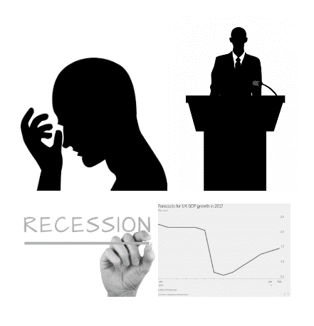

The significance of income elasticity of demand to businesses






