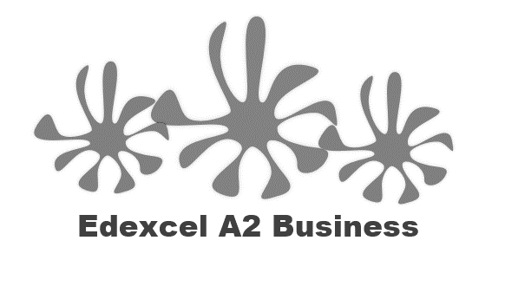
4.1.1 Growing economies

Starter quiz – what do you think the country names are?
B |  | M
R |  | I
I |  | N
C |  | T
BRIC economies:

________________________________________________________________________________________________________________________________________________________________________________________________________________________________________________________________________________________________________________________________________
MINT economies

________________________________________________________________________________________________________________________________________________________________________________________________________________________________________________________________________________________________________________________________________
Write a definition of economy here:

________________________________________________________________________________________________________________________________________________________________________________________________________________________________________________________________________________________________________________________________________
Comparison of growth rates

Current GDP growth rate
UK
Brazil
Russia
India
China

Implications of economic growth for individuals and businesses
Economic growth

- Growing economies start to see changes in employment _________________________; working women, migration, the rise of the ______________ job, home working and the search for a better ___________________ balance.
- The countries that manage to pull themselves out of ______________________ and get richer are those that are able to ______________________ away from agriculture and other traditional products.
- As labour and other resources move from agriculture into modern economic activities, overall productivity rises and ___________________ expand.

What does all this growth mean for business?

- All these new growing and emerging economies have increasing _______________________ of their __________________________
- This means opportunities to increase ___________________ and profit for MNCs by moving into new ________________________
- Increased incomes combined with low labour costs and __________________ to market make these growing economies very ______________________

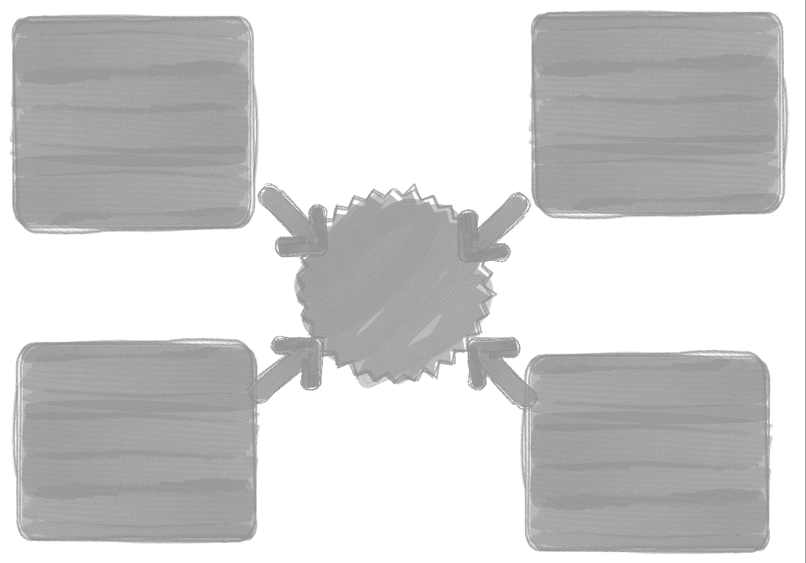
Indicators of growth

Comparison of indicators of growth

Country | GDP of nations | Literacy | Health | HDI
UK
Brazil
Russia
India
China
Mexico
Indonesia
Nigeria
Turkey

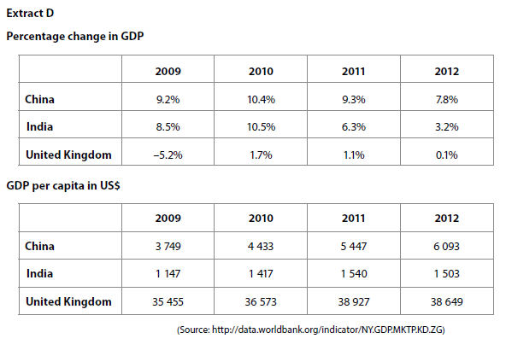

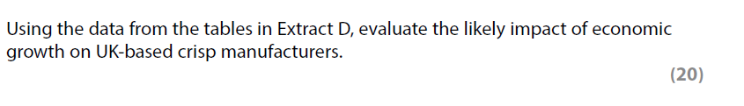

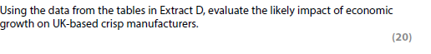
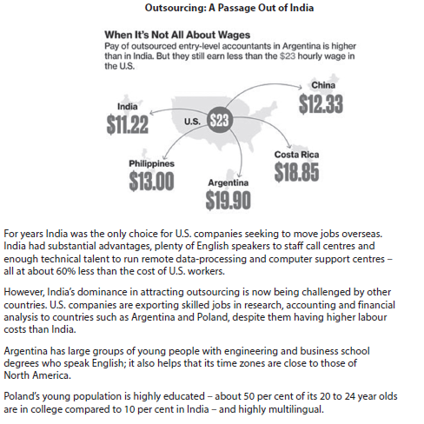

[15]

