What is a competitive market?

Markets used to be physical places where buyers and sellers met in person to exchange goods or to haggle over price. Street markets are still like that. In online or digital markets, there is no face-to-face negotiation, but the potentially huge number of buyers and sellers makes transactions highly competitive.

A competitive market features intense rivalry between producers of a similar good or service. The number of firms operating within a market influences the intensity of competition; the more firms there are, the greater the level of competition. However, the respective size of the firms operating in the market should also be taken into account. A market consisting of 50 firms may not be particularly competitive, if one of the firms holds a 60 per cent market share and the 40 per cent is shared between the other 49. Similarly, a market composed of just four firms could be quite competitive if they are of a similar size.

Consumers benefit from competitive markets. Not so the firms themselves. In competitive markets, prices and profit margins tend to be squeezed. As a result, firms operating in competitive markets try hard to minimise competition, perhaps by creating a unique selling point (USP) or using predatory pricing.

It could be argued that marketing is vital no matter what the level of competition. Firms that fail to produce goods and services that satisfy the needs of their target consumers will find it hard to succeed in the long term. Ultimately, consumers will not waste their hard-earned cash on products that disappoint.

The degree of competition within a market

One dominant business some markets are dominated by one large business. Economists use the word 'monopoly' to describe a market where there is a single supplier, and therefore no competition. In practice, pure textbook monopolies rarely exist; even Microsoft does not have a 100 per cent share of the office software market (though it does have a 90 per cent share). The UK government's definition of a monopoly is somewhat looser. According to the Competition and Markets Authority, a monopoly is a firm that has a market share of25 per cent and above.

Monopolies are bad for consumers. They restrict choice, and tend to drive prices upwards. For that reason, most governments regulate against monopolies and near monopolies that exploit consumers by abusing their dominant market position.

Deciding whether a firm has, or does not have, a monopoly is far from being a straightforward task. First, the market itself has to be accurately defined. For example, Camelot has been granted a monopoly to run the National Lottery. However, it could be argued that Camelot does not have a dominant market position because there are other forms of gambling, such as horseracing and football 'in-play' betting, available to consumers in the UK. Second, national market share figures should not be used in isolation because some firms enjoy local monopolies. A good example of a dominant local market position was the airport operator BAA. The company used to own three of London's four airports. Acting on complaints made by airlines, the government forced BAA to sell off Gatwick airport in December 2009 and Stansted in 2013. Increased competition should lead to improved customer service and lower landing fees (and therefore airfares).

Companies work hard to try to create monopoly positions for themselves. This might be achieved by technical innovations that make it harder for new entrants to break into the market. Apple spends millions of dollars on research and development in order to produce innovative products. Apple's 14-year-old iPod is still the market leader in MP3s with a 70 per cent share of the massive US market. In 2014, Apple sold $14 billion of iPods. To ensure that Apple maintains its dominant market position, new product launches involve innovations that make it hard for competitors to keep up.

Competition among a few giants
The UK supermarket industry is a good example of a market that is dominated by a handful of very large companies. Economists call markets like these oligopolies. The rivalry that exists within such markets can be very intense. Firms know that any gains in market share will be at the expense of their rivals. The actions taken by one firm affect the profits made by the other firms that compete within the same market.

In markets made up of a few giants, firms tend to focus on non-price competition when designing the marketing mix. Firms in these markets are reluctant to compete by cutting price. They fear that the other firms in the industry will respond by cutting their prices too, creating a costly price war in which no firm wins.

The fiercely competitive market
Fiercely competitive markets tend to be fragmented; made up of hundreds of relatively small firms who each compete actively against other. In some of these markets, competition is amplified by the fact that firms sell near-identical products called commodities; these are products such as flour, sugar or blank DVDs, which are hard to differentiate. Rivalry in commodity markets tends to be intense. In such markets, firms have to manage their production costs very carefully because the retail price is the most important factor in determining whether the firm's product sells or not. If a firm cannot cut its costs, it will not be able to cut its prices without cutting into profit margins. Without price cuts, market share is likely to be lost. In fiercely competitive markets, firms will try, where possible, to create product differentiation. For example, the restaurant market in Croydon, Surrey, is extremely competitive. There are over 70 outlets within a two-mile radius of the town centre. To survive without having to compete solely on price, firms in markets like this must find new innovations regularly because points of differentiation are quickly copied.

Competition and market size

Big markets

In 2014, British consumers spent £2,700 million on 'bagged snacks'. Walkers regular crisps was the market leader, with sales of £475 million. More money was spent on Walkers crisps in the UK than the entire worldwide revenues of Manchester United football club. But even though brand owner PepsiCo had 14 of the 25 top sellers in the market for bagged snacks (think Doritos, Quavers, Sensations and many more), it still faced serious competition. Although the market number two (Pringles) had sales of 'just' £180 million, Pringles gives Walkers serious competition, forcing the market leader to have to keep innovating in order to stay at number one. Walkers also faces competition from niche brands such as Kettle Chips. Started in 1988, it took the brand until 2004 to reach £35 million of annual sales. In 2014, its sales had nearly trebled to £98 million. A market share of 3.6 per cent may seem trivial, but Kettle's adult niche allows it to be one of the most profitable brands in bagged snacks.

Small markets
The market for dishwasher powder is less than a tenth of that for bagged snacks. At £250 million a year,
there is only room for two brands: Finish, which once dominated this sector and still has a 52 per cent market
share, and Fairy, with 25 per cent of the market. The remainder consists of other brands and supermarket own
labels. In such a market, it would be hugely difficult for any other brand to break in. Both Finish and Fairy are
backed by generous advertising budgets, which act as a barrier to others entering the market.

Changes in the competitive environment
The number of firms operating within a market can change over time. If new competitors enter, a market will become more competitive. New entrants are usually attracted into a new market by the high profits or the rapid growth achieved by the existing firms. After the Europe-wide success of airlines such as easy Jet and Ryanair, a huge number of imitators came into the airline business, including Air Berlin and Wizz Air. Although most of these have struggled to be profitable, their lower prices have unquestionably benefited the traveller.

In markets that are suffering from low or negative profitability, firms tend to exit, leaving the market less competitive than it was. In 2014, many UK 'payday' lenders withdrew from the market after the Financial Conduct Authority placed restrictions on the level of interest rates they were allowed to charge.

Quotes
People of the same trade seldom meet together, even for merriment and diversion, but the conversation ends in a conspiracy against the public, or in some contrivance to raise prices.'
Adam Smith, The Wealth of Nations, 1776

'Competition is not only the basis of protection to the consumer, but is the incentive to progress.'
Herbert Hoover, US President, 1929-1933

'Like many businessmen of genius he learned that free competition was wasteful, monopoly efficient. And so he simply set about achieving that efficient monopoly.'
Mario Puzo, The Godfather, 1969

Responses of businesses to a changing competitive environment
In a market that has become more competitive, firms may be forced into the following actions in order to defend market share.

Price cutting

Many firms attempt to fight off a competitor by cutting price. If the competition can be under-cut, consumers will hopefully remain loyal to the company that has cut its prices. Firms that use price-cutting as a way of fighting off the competition will normally try to cut their costs in line with the price cut in an attempt to preserve profit margins. If profit margins are already tight and costs have already been cut as much as possible, it probably will not be possible to respond to a new competitor by cutting prices.

Increase product differentiation
Product differentiation is the degree to which consumers perceive a brand to be different from, and in some way superior to, other brands of the same type of product. Some firms may be apprehensive about responding to a competitive threat by cutting price because the long-term result could be a deteriorating brand image that could hinder, rather than help, sales. Many consumers still associate price with product quality. If product differentiation can be increased, consumers will be less likely to switch to products supplied by the competition. To a degree, differentiation helps a firm to insulate itself from competitive pressure. Firms that want to increase differentiation can do so in the following ways.

Design
An eye-catching design that is aesthetically pleasing can help a firm to survive in a competitive market. By using design as a unique selling point, British manufacturers can compete on quality rather than on price, making them less vulnerable to competition from China and India. Goodlooking design can add value to a product. For example, the BMW Mini relies upon its retro 1960s styling to command its price premium within the small car market.

Unique product features
In markets that are highly competitive, some firms react by redesigning their products to ensure that they possess the latest must-have feature. For example, in the car market, Toyota's hybrid drive technology has appealed to consumers who are interested in buying an environmentally friendly car with very low emissions.

Collusion
If faced with a real threat to the survival of the business, some management take the apparently easy way out and try to do deals with their supposed competitors. In other words, they get in touch to fix prices, cut promotional expenditures or find any other way to boost profitability. If two or more companies feel equally threatened by the level of competition, there is every reason to agree to this in the short term. With much tougher legislation these days, it has become more difficult to make this work in the longer term, because there are strong incentives for one cheating firm to whistleblow ('rat') on the others. The first one to whistleblow gets 100 per cent immunity and therefore no fines or any other form of punishment.

Five whys and a how
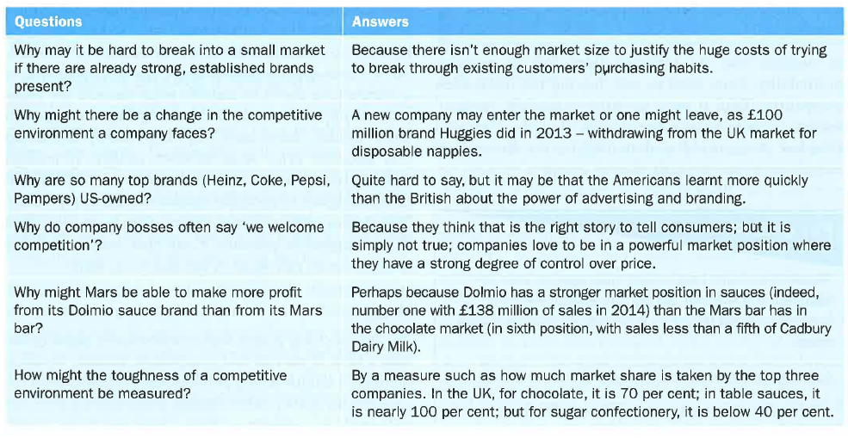
The competitive environment – evaluation

The best way a business can ensure its survival in a competitive world is to find something it is good at, and stick with it. Cadbury is great when it concentrates on making chocolate; Heinz is brilliant at making and marketing baked beans or ketchup. Even if the massive Hershey Corporation brings its chocolate from America, Cadbury need not fear.

The hard thing is to get to the stage at which customers are subconsciously looking for your brand on the shelf, and buying it without thinking too much about price and quality. They want Nike on their feet and Apple in their hand. In 2014, in the UK, Pepsi added £33 million of sales while Coca-Cola suffered a £25 million sales decline - despite the huge and expensive launch of Coke Life. That is a reminder that 'do nothing' can sometimes be the right course of action. Instead of panicking about the possible impact of Coke Life upon Pepsi Max, Pepsi stayed confident in its product range. Clever stuff.

Key terms

Collusion: when managers from different firms get together to discuss ways to work together to restrict supply and/or raise prices.

Oligopolies: markets dominated by a few large companies.

Predatory pricing: pricing low with the deliberate intention of driving a competitor out of business

Non-price competition: anti-competitive strategies other than price, such as branding, product design and technological innovation.

