Price Elasticity of Supply – Worksheet 2
The capacity at the Madejski Stadium is 24,161. There is a fixed supply of seats. If demand for a particularly match is very high (in excess of 24,161) Reading FC cannot simply install additional seats in the short-term to cover the demand. The supply is therefore fixed. In the long run the owners could expand the existing stadium and increase the number of seats, or build a completely new stadium, which they did in 1998.
- On the axes below - draw and label a diagram showing the fixed supply of seats at the Madejski Stadium. Label it as S1.

- John Madejski has planning permission to expand the stadium to around 36,900 seats (below). Draw a new supply curve (labelled S2) to demonstrate the outcome of such an expansion.
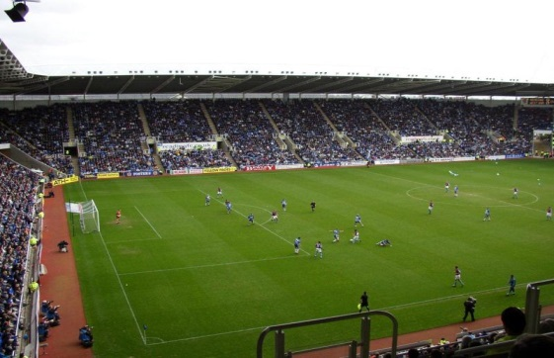
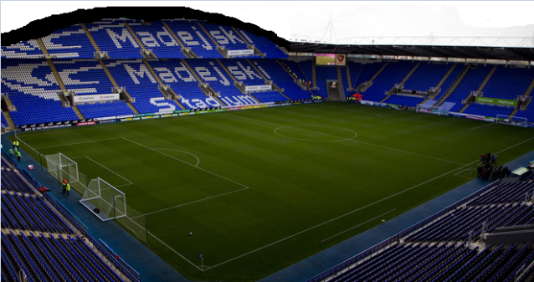

- Explain what is meant by short-run and long-run in Economics:

- What is it about the Madejski Stadium that causes supply to be fixed in the short-run?
5) Draw how the think the supply curve for the Madejski stadium would look in the long-run:

- Average house prices in an area have increased from £145,000 to £170,000 and supply increases from 40,000 to 44,000. PES is:

- With reference to the factors that we discussed previously; briefly explain two reasons why the PES value for housing (from the previous question) does not come as a surprise.

For each of the following goods, identify the arguments for being inelastic/elastic or elements of both.
Good | Inelastic/Elastic? | Justification for your answer (which factors impact this good)
Milk
Wheat
Gold

