Extract 1: Karen Armstrong, ‘Enlightenment’, (2002) Taken from: Karen Armstrong, Lives: Buddha (Phoenix press, 2002), Chapter 3, Enlightenment, pp 60-88

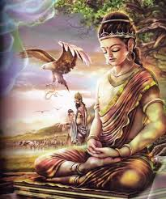
The legends indicate that Gotama’s childhood had been spent in an unawakened state, locked away from that knowledge of suffering which alone can bring us to spiritual maturity, but in later years he recalled that there had been one moment which had given him intimations of another mode of being. His father had taken him to watch the ceremonial ploughing of the fields before the planting of the next year’s crop. All the men of the villages and townships took part in this annual event, so Suddhodana had left his small son in the care of his nurses under the shade of a rose-apple tree while he went to work. But the nurses decided to go and watch the ploughing, and, finding himself alone, Gotama sat up.

In one version of this story, we are told that when he looked at the field that was being ploughed, he noticed that the young grass had been torn up and that insects and the eggs they had laid in these new shoots had been destroyed. The little boy gazed at the carnage and felt a strange sorrow, as though it were his own relatives that had been killed. But it was a beautiful day, and a feeling of pure joy rose up unbidden in his heart.

We have all experienced such moments, which come upon us unexpectedly and without any striving on our part. Indeed, as soon as we start to reflect upon our happiness, ask why we are so joyful and become self-conscious, the experience fades. When we bring self into it, this unpremeditated joy cannot last: it is essentially a moment of ecstasy, a rapture which takes us outside the body and beyond the prism of our own egotism. Such ecstasis, a word that literally means “to stand outside the self,” has nothing to do with the craving and greed that characterize so much of our waking lives. As Gotama reflected later, it ‘existed apart from objects that awaken tanhā’. The child had been taken out of himself by a moment of spontaneous compassion, when he had allowed the pain of creatures that had nothing to do with him personally to pierce him to the heart. This surge of selfless empathy had brought him a moment of spiritual release. Instinctively, the boy composed himself and sat in the āsana position, with straight back and crossed legs. A natural yogi, he entered into the first jhāna, a trance in which the meditator feels a calm happiness but is still able to think and reflect. Nobody had taught him the techniques of yoga, but for a few moments, the child had a taste of what it might be like to leave himself behind.

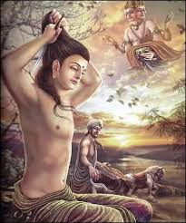
The commentary tells us that the natural world recognized the spiritual potential of the young Gotama. As the day wore on, the shadows of the other trees moved, but not the shade of the rose-apple tree, which continued to shield the boy from the blazing sun. When the nurses came back, they were stunned by the miracle and fetched Suddhodana, who paid homage to the little boy. These last elements are certainly fictional, but the story of the trance, historical or not, is important in the Pāli legend and is said to have played a crucial role in Gotama’s enlightenment. Years later, just after he had cried, with mingled optimism and despair, “Surely there must be another way to enlightenment!”, Gotama recalled this childhood experience. At that moment – again, unpremeditated and unsought – the memory of that childhood ecstasy rose to the surface of his mind.

Emaciated, exhausted and dangerously ill, Gotama remembered the ‘cool shade of the rose-apple tree,’ which, inevitably, brought to mind the ‘coolness’ of Nibbāna. Most yogis could only achieve the first jhāna after years of study and hard work, but it had come to him without any effort on his part and given him a foretaste of Nibbāna. Ever since he had left Kapilavatthu, he had shunned all happiness as part of his campaign against desire. During his years as an ascetic, he had almost destroyed his body, hoping that he could thereby force himself into the sacred world that was the inverse of humanity’s usual suffering existence. Yet as a child he had attained that yogic ecstasy without any trouble at all, after an experience of pure joy. As he reflected on the coolness of the rose-apple tree, he imagined, in his weakened state, the relief of being convalescent (nibbuta), after a lifetime of fever. Then he was struck by an extraordinary idea. ‘Could this,’ he asked himself, ‘possibly be the way to enlightenment?’ Had the other teachers been wrong? Instead of torturing our reluctant selves into the final release, we might be able to achieve it effortlessly and spontaneously. Could Nibbāna be built into the structure of our humanity? If an untrained child could reach the first jhāna and have intimations of Nibbāna without even trying, then yogic insight must be profoundly natural to human beings. Instead of making yoga an assault upon humanity, perhaps it could be used to cultivate innate tendencies that led to ceto-vimutti, the ‘release of the mind’ that was a synonym for the supreme enlightenment? As soon as he had mulled over the details of that childhood experience, Gotama became convinced that his hunch was correct. This was indeed the way to Nibbāna. Now all he had to do was prove it. What had produced that mood of calm happiness that had modulated so easily into the first jhāna?

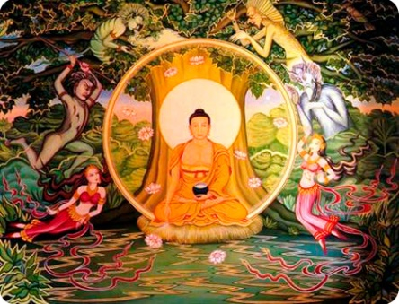
An essential element had been what Gotama called ‘seclusion.’ He had been left alone; he could never have entered the ecstatic state if his nurses had distracted him with their chatter. Meditation required privacy and silence. But this seclusion went beyond physical solitude. Sitting under the rose-apple tree, his mind had been separated from desire for material things and from anything unwholesome and unprofitable. Since he had left home six years before, Gotama had been fighting his human nature and crushing its every impulse. He had come to distrust any kind of pleasure. But he now asked himself, why should he be afraid of the type of joy he had experienced on that long-ago afternoon? That pure delight had had nothing to do with greedy craving or sensual desire. Some joyful experiences could actually lead to an abandonment of egotism and to the achievement of an exalted yogic state. Again, as soon as he had posed the question to himself, Gotama responded with his usual, confident decisiveness: ‘I am not afraid of such pleasures,’ he said. The secret was to reproduce the seclusion that had led to his trance, and foster such wholesome states of mind as the disinterested compassion that had made him grieve for the insects and the shoots of young grass.

At the same time, he would carefully avoid any state of mind that would not be helpful or would impede his enlightenment. He had, of course, already been behaving along these lines by observing the ‘five prohibitions’ which had forbidden such ‘unhelpful’ activities as violence, lying, stealing, intoxication and sex. But now, he realized, this was not enough. He must cultivate the positive attitudes that were the opposite of these five restraints. Later, he would say that a person seeking enlightenment must be ‘energetic, resolute and persevering’ in pursuing those ‘helpful,’ ‘wholesome’ or ‘skillful’ states that would promote spiritual health.

Ahimsā (harmlessness) could only take one part of the way: instead of simply avoiding violence, an aspirant must behave gently and kindly to everything and everybody; he must cultivate thoughts of loving-kindness to counter any incipient feelings of ill will. It was very important not to tell lies, but it was also crucial to engage in ‘right talk’ and make sure that whatever you said was worth saying: ‘reasoned, accurate, clear, and beneficial.’ Besides refraining from stealing, a bhikkhu should positively rejoice in taking whatever alms he was given, expressing no personal preference, and should take delight in possessing the bare minimum. The yogis had always maintained that avoiding the five prohibitions would lead to ‘infinite happiness,’ but by deliberately cultivating these positive states of mind, such ecstasis could surely be redoubled. Once this ‘skillful’ behavior became so habitual that it was second nature, the aspirant, Gotama believed, would ‘feel within himself a pure joy,’ similar to if not identical with the bliss that he had felt as a boy under the roseapple tree. This recollection was, according to the texts, a turning point for Gotama. He resolved from then on to work with human nature and not fight against it – amplifying states of mind that were conducive to enlightenment and turning his back on anything that would stunt his potential.

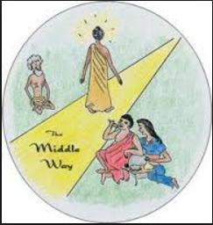
Gotama was developing what he called a ‘Middle Way,’ which shunned physical and emotional selfindulgence on the one hand, and extreme asceticism (which could be just as destructive) on the other. He decided that he must immediately abandon the punitive regime that he had followed with his five companions, which had made him so ill that there was no way he could experience the ‘pure joy’ that was a prelude to liberation. For the first time in months, he took solid food, starting with what the texts call kummāsa, a soothing milky junket or rice pudding. When the five bhikkhus saw him eating, they were horrified and walked away in disgust, convinced that Gotama had abandoned the struggle for enlightenment. But this, of course, was not the case. Gotama must have nursed himself slowly back to health, and during this time he probably started to develop his own special kind of yoga.

He was no longer hoping to discover his eternal Self, since he was beginning to think that this Self was just another one of the delusions that held people back from enlightenment. His yoga was designed to help him become better acquainted with his human nature, so that he could make it work for him in the attainment of Nibbāna. First, as a preliminary to meditation, came the practice that he called ‘mindfulness’ (sati), in which he scrutinized his behaviour at every moment of the day. He noted the ebb and flow of his feelings and sensations, together with the fluctuations of his consciousness. If sensual desire arose, instead of simply crushing it, he took note of what had given rise to it and how soon it faded away. He observed the way his senses and thoughts interacted with the external world, and made himself conscious of his every bodily action. He would become aware of the way he walked, bent down or stretched his limbs, and of his behaviour while ‘eating, drinking, chewing, and tasting, in defecating, walking, standing, sitting, sleeping, waking, speaking and keeping silent.’ He noticed the way ideas coursed through his mind and the constant stream of desires and irritations that could plague him in a brief half-hour. He became ‘mindful’ of the way he responded to a sudden noise or a change in the temperature, and saw how quickly even a tiny thing disturbed his peace of mind. This ‘mindfulness’ was not cultivated in a spirit of neurotic introspection.

Gotama had not put his humanity under the microscope in this way in order to castigate himself for his ‘sins.’ Sin had no place in his system, since any guilt would simply be ‘unhelpful’: it would imbed an aspirant in the ego that he was trying to transcend. Gotama’s use of the words kusala (skilful) and akusala (unskilful) are significant. Sex, for example, was not listed among the five yama because it was sinful, but because it would not help a person reach Nibbāna; sex was emblematic of the desire that imprisoned human beings in samsara; it expended energy that would be better employed in yoga. A bhikkhu refrained from sex as an athlete might abstain from certain foods before an important competition. Sex had its uses, but it was not ‘helpful’ to one engaged in the ‘noble quest.’

Gotama was not observing his human nature in order to pounce on his failings, but was becoming acquainted with the way it worked in order to exploit its capacities. He had become convinced that the solution to the problem of suffering lay within himself, in what he called ‘this fathom-long carcass, this body and mind.’ Deliverance would come from the refinement of his own mundane nature, and so he must investigate it and get to know it as intimately as an equestrian learns to know the horse he is training. But the practice of mindfulness also made him more acutely aware than ever of the pervasiveness of both suffering and the desire that gave rise to it.

All these thoughts and longings that crowded into his consciousness were of such short duration. Everything was impermanent (anicca). However intense a craving might be, it soon petered out and was replaced by something quite different. Nothing lasted long, not even the bliss of meditation. The transitory nature of life was one of the chief causes of suffering, and as he recorded his feelings, moment by moment, Gotama also became aware that the dukkha of life was not confined to the major traumas of sickness, old age and death. It happened on a daily, even hourly basis, in all the little disappointments, rejections, frustrations and failures that befall us in the course of a single day: ‘Pain, grief and despair are dukkha,’ he would explain later, ‘being forced into proximity with what we hate is suffering, being separated from what we love is suffering, not getting what we want is suffering.’ True, there was pleasure in life, but once Gotama had subjected this to the merciless scrutiny of mindfulness, he noticed how often our satisfaction meant suffering for others. The prosperity of one person usually depends upon the poverty or exclusion of somebody else; when we get something that makes us happy, we immediately start to worry about losing it; we pursue an object of desire, even when we know in our heart of hearts that it will make us unhappy in the long run.

Mindfulness also made Gotama highly sensitive to the prevalence of the desire or craving that is the cause of this suffering. The ego is voracious and continually wants to gobble up other things and people. We almost never see things as they are in themselves, but our vision is coloured by whether we want them or not, how we can get them, or how they can bring us profit. Our view of the world is, therefore, distorted by our greed, and this often leads to ill will and enmity, when our desires clash with the cravings of others. Henceforth, Gotama would usually couple ‘desire’ (tanhā) with ‘hatred’ (dosa). When we say ‘I want,’ we often find ourselves filled with envy, jealousy and rage if other people block our desires or succeed where we have failed. Such states of mind are ‘unskillful’ because they make us more selfish than ever. Desire and hatred, its contaminant, are thus the joint cause of much of the misery and evil in the world. On the one hand, desire makes us ‘grab’ or ‘cling’ to things that can never give lasting satisfaction. On the other, it makes us constantly discontented with our present circumstances.

As Gotama observed the way one craving after another took possession of his mind and heart, he noticed how human beings were ceaselessly yearning to become something else, go somewhere else, and acquire something they do not have. It is as though they were continually seeking a form of rebirth, a new kind of existence. Craving (tanhā) manifests itself even in the desire to change our physical position, go into another room, have a snack or suddenly leave work and go find somebody to talk to. These petty cravings assail us hour by hour, minute by minute, so that we know no rest. We are consumed and distracted by the compulsion to become something different. ‘The world, whose very nature is to change, is constantly determined to become something else,’ Gotama concluded. ‘It is at the mercy of change, it is only happy when it is caught up in the process of change, but this love of change contains a measure of fear, and this fear itself is dukkha.’ But when Gotama reflected upon these truths, he was not doing so in an ordinary, discursive manner. He brought the techniques of yoga to bear upon them, so that they became more vivid and immediate than any conclusion arrived at by normal ratiocination.

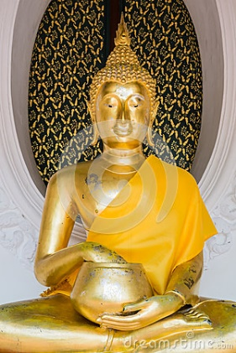
Every day, after he had collected enough alms for his daily meal, which he usually took before noon, Gotama would seek out a secluded spot, sit down in the āsana posture and begin the yogic exercises of ekāgratā or concentration. He would practice this mindfulness in a yogic context and, as a result, his insights gained a new clarity. He could see them ‘directly,’ enter into them and learn to observe them without the filter of self-protecting egotism that distorts them. Human beings do not usually want to realize the pervasiveness of pain, but now Gotama was learning, with the skill of a trained yogi, to ‘see things as they really are.’ He did not, however, stop at these more negative truths; he was also fostering the ‘skillful’ states with the same intensity. A person, he explained later, could purify his or her mind by cultivating these positive and helpful states while performing the yogic exercises, sitting cross-legged and, by means of the respiratory discipline of prānāyamā, inducing an alternative state of consciousness. Once he has banished malevolence and hatred from his mind, he lives without ill will and is also full of compassion, desiring the welfare of all living beings. . . . Once he has banished the mental habits of laziness and indolence, he is not only free of laziness and indolence but has a mind that is lucid, conscious of itself and completely alert; . . . Once he has banished anxiety and worry, he lives without anxiety and his mind becomes calm and still; . . . Once he has banished uncertainty, he lives with a mind that has outgrown debilitating doubt and is no longer plagued by unprofitable [akusala] mental states. … We do not know how long it took Gotama to recover his health after his years of asceticism.

The scriptures speed up the process to make it more dramatic, and give the impression that Gotama was ready for the final struggle with himself after one bowl of junket. This cannot have been true. The effects of mindfulness and the cultivation of skillful states take time. Gotama himself said that it could take at least seven years, and stressed that the new self developed imperceptibly over a long period. ‘Just as the ocean slopes gradually, falls away gradually, and shelves gradually with no sudden incline,’ he later warned his disciples, ‘so in this method, training, discipline and practice take effect by slow degrees, with no sudden perception of the ultimate truth.’

The texts show Gotama attaining his supreme enlightenment and becoming a Buddha in a single night, because they are less concerned with historical fact than with tracing the general contours of the process of achieving release and inner peace. Thus in one of the oldest portions of the scriptures, we read that after Gotama had been deserted by his five companions and had been nourished by his first meal, he set off toward Uruvelā, walking there by easy stages. When he reached Senānigāma beside the Nerañjarā river, he noticed ‘an agreeable plot of land, a pleasant grove, a sparkling river with delightful and smooth banks, and, nearby, a village whose inhabitants would feed him.’ This, Gotama thought, was just the place to undertake the final effort that would bring him enlightenment. If he was to reproduce the calm content that had modulated so easily into the first jhāna under the rose-apple tree, it was important to find a congenial spot for his meditation. He sat down, tradition has it, under a bodhi tree, and took up the āsana position, vowing that he would not leave this spot until he had attained Nibbāna.

This pleasant grove is now known as Bodh Gayā and is an important site of pilgrimage, because it is thought to be the place where Gotama experienced the yathabhuta, his enlightenment or awakening. It was in this spot that he became a Buddha. It was late spring. Scholars have traditionally dated the enlightenment of Gotama at about the year 528 B.C.E., though recently some have argued for a later date in the first half of the fifth century. The Pali texts give us some information about what happened that night, but nothing that makes much sense to an outsider who has not been through the Buddhist regimen. They say that Gotama mused upon the deeply conditional nature of all life as we know it, saw all his past lives, and recovered that ‘secluded’ and solitary state he had experienced as a child. He then slipped easily into the first jhāna, and progressed through ever higher states of consciousness until he gained an insight that forever transformed him and convinced him that he had freed himself from the round of samsāra and rebirth.

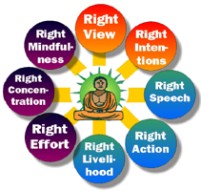
But there seems little new about this insight, traditionally known as the Four Noble Truths and regarded as the fundamental teaching of Buddhism. The first of these verities was the noble truth of suffering (dukkha) that informs the whole of human life. The second truth was that the cause of this suffering was desire (tanhā). In the third noble truth, Gotama asserted that Nibbana existed as a way out of this predicament and finally, he claimed that he had discovered the path that leads from suffering and pain to its cessation in the state of Nibbāna. There seems nothing strikingly original about these truths. Most of the monks and ascetics of North India would have agreed with the first three, and Gotama himself had been convinced of them since the very beginning of his quest. If there is anything novel, it was the fourth truth, in which Gotama proclaimed that he had found a way to enlightenment, a method which he called the Noble Eightfold Path. Its eight components have been rationalized still further into a three-fold plan of action, consisting of morality, meditation and wisdom:

- Morality (sila), which consists of right speech, right action and right livelihood. This essentially comprises the cultivation of the ‘skillful’ states in the way we have discussed.

- Meditation (sāmadhi), which comprises Gotama’s revised yoga disciplines, under the headings of right effort, mindfulness and concentration.

- Wisdom (paññā): the two virtues of right understanding and right resolve enable an aspirant, by means of morality and meditation, to understand the Buddha’s Dhamma, enter into it ‘directly’ and integrate it into his or her daily life in the way that we shall discuss in the following chapter.

If there is any truth to the story that Gotama gained enlightenment at Bodh Gayā in a single night, it could be that he acquired a sudden, absolute certainty that he really had discovered a method that would, if followed energetically, bring an earnest seeker to Nibbāna. He had not made this up; it was not a new creation or an invention of his own. On the contrary, he always insisted that he had simply discovered ‘a path of great antiquity, an ancient trail, travelled by human beings in a far-off, distant era.’ The other Buddhas, his predecessors, had taught this path an immeasurably long time ago, but this ancient knowledge had faded over the years and had been entirely forgotten. Gotama insisted that this insight was simply a statement of things ‘as they really are’; the path was written into the very structure of existence. It was, therefore, the Dhamma, par excellence, because it elucidated the fundamental principles that govern the life of the cosmos. If men, women, animals and gods kept to this path, they could all attain an enlightenment that would bring them peace and fulfilment, because they were no longer struggling against their deepest grain. But it must also be understood that the Four Noble Truths do not present a theory that can be judged by the rational intellect alone; they are not simply notional verities.
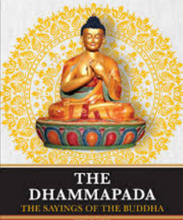
The Buddha’s Dhamma was essentially a method, and it stands or falls not by its metaphysical acuity or its scientific accuracy, but by the extent to which it works. The truths claim to bring suffering to an end, not because people subscribe to a salvific creed and to certain beliefs, but because they adopt Gotama’s program or way of life. Over the centuries, men and women have indeed found that this regimen has brought them a measure of peace and insight.

The Buddha’s claim, echoed by all the other great sages of the Axial Age, was that by reaching beyond themselves to a reality that transcends their rational understanding, men and women become fully human. The Buddha ever claimed that his knowledge of the Four Noble Truths was unique, but that he was the first person, in this present era, to have ‘realized’ them and made them a reality in his own life. He found that he had extinguished the craving, hatred and ignorance that hold humanity in thrall. He had attained Nibbāna, and even though he was still subject to physical ailments and other vicissitudes, nothing could touch his inner peace or cause him serious mental pain. His method had worked. ‘The holy life has been lived out to its conclusion!’ he cried out triumphantly at the end of that momentous night under the bodhi tree. ‘What had to be done has been accomplished; there is nothing else to do!’ Those of us who do not live according to the Buddhist program of morality and meditation have, therefore, no means of judging this claim.

The Buddha was always quite clear that his Dhamma could not be understood by rational thinking alone. It only revealed its true significance when it was apprehended ‘directly,’ according to yogic methods, and in the right ethical context. The Four Noble Truths do make logical sense, but they do not become compelling until an aspirant has learned to identify with them at a profound level and has integrated them with his own life. Then and only then will he experience the ‘exultation,’ ‘joy’ and ‘serenity’ which, according to the Pāli texts, come to us when we divest ourselves of egotism, liberate ourselves from the prison of self-centeredness, and see the Truths ‘as they really are.’ Without the meditation and morality prescribed by the Buddha, the Truths remain as abstract as a musical score, which for most of us cannot reveal its true beauty on the page but needs to be orchestrated and interpreted by a skilled performer.

Even though the Truths make rational sense, the texts emphasize that they did not come to Gotama by means of discursive reasoning. As he sat meditating under the Bodhi tree, they ‘rose up’ in him, as from the depths of his being. He apprehended them within himself by the kind of ‘direct knowledge’ acquired by a yogi who practices the disciplines of yoga with ‘diligence, ardor and self-control.’ Gotama was so absorbed in these Truths, the object of his contemplation, that nothing interposed itself between them and his own mind and heart. He had become their human embodiment. When people observed the way he behaved and responded to events, they could see what the Dhamma was like; they could see Nibbāna in human form.

In order to share Gotama’s experience, we have to approach the Truths in a spirit of total self-abandonment. We have to be prepared to leave our old unregenerate selves behind. The compassionate morality and yoga devised by Gotama only brought liberation if the aspirant was ready to lay aside all egotism. It is significant that at the moment he achieved Nibbāna under the bodhi tree, Gotama did not cry ‘I am liberated,’ but ‘It is liberated!’ He had transcended himself, achieved an exstasis, and discovered an enhanced ‘immeasurable’ dimension of his humanity that he had not known before.

What did the new Buddha mean when he claimed to have reached Nibbāna on that spring night? Had he himself, as the word implied, been ‘snuffed out,’ extinguished like a candle flame? During his six-year quest, Gotama had not masochistically courted annihilation but had sought enlightenment. He had wanted to wake up to his full potential as a human person, not to be wiped out. Nibbāna did not mean personal extinction: what had been snuffed out was not his personality but the fires of greed, hatred and delusion. As a result, he enjoyed a blessed ‘coolness’ and peace. By tamping out the ‘unhelpful’ states of mind, the Buddha had gained the peace which comes from selflessness; it is a condition that those of us who are still enmeshed in the cravings of egotism, which make us hostile toward others and distort our vision, cannot imagine.

That is why the Buddha always refused, in the years following his enlightenment, to define or describe Nibbāna: it would, he said, be ‘improper’ to do so, because there are no words to describe such a state to an unenlightened person. The attainment of Nibbāna did not mean that he Buddha would never experience any more suffering. He would grow old, get sick and die like everybody else and would experience pain while doing so. Nibbāna does not give an awakened person trancelike immunity, but an inner haven which enables a man or woman to live with pain, to take possession of it, affirm it, and experience a profound peace of mind in the midst of suffering. Nibbāna, therefore, is found within oneself, in the very heart of each person’s being. It is an entirely natural state; it is not bestowed by grace nor achieved for us by a supernatural savior; it can be reached by anybody who cultivates the path to enlightenment as assiduously as Gotama did. Nibbāna is a still center; it gives meaning to life.

People who lose touch with this quiet place and do not orient their lives toward it can fall apart. Artists, poets and musicians can only become fully creative if they work from this inner core of peace and integrity. Once a person has learned to access this nucleus of calm, he or she is no longer driven by conflicting fears and desires, and is able to face pain, sorrow and grief with equanimity. An enlightened or awakened human being has discovered a strength within that comes from being correctly centered, beyond the reach of selfishness. Once he had found this inner realm of calm, which is Nibbāna, Gotama had become a Buddha. He was convinced that, once egotism had been snuffed out, there would be no flames or fuel to spark a new existence, because the desire (tanhā) which bound him to samsāra had been finally quenched.

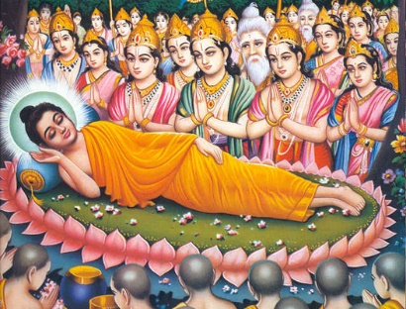
When he died, he would attain his paranibbāna, his final rest. Again, this did not mean total extinction, as Westerners sometimes assume. The paranibbāna was a mode of existence that; we cannot conceive unless we have become enlightened ourselves. There are no words or concepts for it, because our language is derived from the sense data of our unhappy, mundane existence; we cannot really imagine a life in which there is no egotism of any kind. But that does not mean that such an existence is impossible; it became a Buddhist heresy to maintain that an enlightened person would cease to exist after death. In the same way, monotheists have insisted that there are no words that can adequately describe the reality they call ‘God.’ ‘He who has gone to his final rest cannot be defined by any measure,’ the Buddha would tell his followers in later life. ‘There are no words capable of describing him. What thought might comprehend has been cancelled out, and so has every mode of speech.’

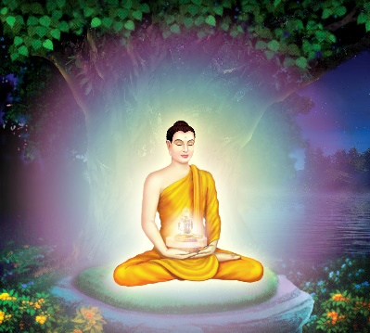
In purely mundane terms, Nibbāna was ‘nothing,’ not because it did not exist, but because it corresponded to nothing that we know. But those who had, by dint of the disciplines of yoga and compassionate morality, managed to access this still center within found that they enjoyed an immeasurably richer mode of being, because they had learned to live without the limitations of egotism.

The account of the Buddha’s attainment of enlightenment under the bodhi tree in the Pāli texts can leave the modern reader feeling baffled and frustrated. It is one of the places where these Theravādin scriptures become opaque to people who are not expert yogis, since they dwell in such detail on meditative technicalities. More helpful to an outsider is the story told in the later scripture, the Nidāna Kathā, which makes the notion of enlightenment more accessible to ordinary mortals. As with its version of Gotama’s ‘Going Forth,’ this story explores the psychological and spiritual implications of enlightenment in a way that a lay person or Buddhist beginner can understand, because it has no yogic jargon but gives us a wholly mythological account of the enlightenment.

The author is not attempting to write history in our sense, but draws instead on timeless imagery to show what is involved in the discovery of Nibbāna. He uses motifs common in mythology, which has been aptly described as a pre-modern form of psychology, tracing the inner paths of the psyche and making clearer the obscure world of the unconscious mind.

Buddhism is an essentially psychological religion, so it is not surprising that the early Buddhist authors made such skillful use of mythology. Again, we must recall that none of these texts is concerned with telling us what actually happened, but rather is intended to help the audience gain their own enlightenment. The Nidāna Kathā emphasizes the need for courage and determination: it shows Gotama engaged in a heroic struggle against all those forces within himself which militate against the achievement of Nibbāna.

We read that after Gotama had eaten his dish of junket, he strode as majestically as a lion toward the bodhi tree to make his last bid for liberation, determined to reach his goal that very night. First, he circled the tree, trying to find the place where all the previous Buddhas had sat when they had won through to Nibbāna, but wherever he stood, ‘the broad earth heaved and sunk, as though it was a huge cartwheel lying on its hub, and somebody was treading on its rim.’ Eventually, Gotama approached the eastern side of the tree, and when he stood there, the ground remained still. Gotama decided that this must be the ‘immovable spot’ on which all the previous Buddhas had positioned themselves, so he sat down in the āsana position facing the east, the region of the dawn, in the firm expectation that he was about to begin a new era in the history of humanity.

‘Let my skin and sinews and bones dry up, together with all the flesh and blood of my body! I will welcome it!’ Gotama vowed. ‘But I will not move from this spot until I have attained the supreme and final wisdom.’

The text emphasizes the fantastic shuddering of the earth as Gotama circled the bodhi tree to remind us not to read this story literally. This is not a physical location: the world-tree, standing at the axis of the cosmos, is a common feature of salvation mythology. It is the place where the divine energies pour into the world, where humanity encounters the Absolute and becomes more fully itself. We need only recall the cross of Jesus, which, according to Christian legend, stood on the same spot as the Tree of Knowledge of Good and Evil in the Garden of Eden. But in Buddhist myth, Gotama the man sits in this pivotal place, not a man-God, because human beings must save themselves without supernatural aid.

The texts make it clear that Gotama had come to this axis of the universe, the mythological center that holds the whole of the cosmos together. … But the struggle was not yet over. Gotama still had to fight those residual forces within himself which clung to the unregenerate life and did not want the ego to die.
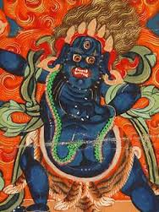
Māra, Gotama’s shadow-self, appeared before him, decked out like a cakkavatti, a World Ruler, with a massive army. Māra himself was mounted on an elephant that was 150 leagues high. He had sprouted 1,000 arms, each of which brandished a deadly weapon. Māra’s name means ‘delusion.’ He epitomized the ignorance which holds us back from enlightenment, since, as a cakkavatti, he could only envisage a victory achieved by physical force. Gotama was still not fully enlightened, so he tried to respond in kind, seeing the virtues he had acquired as defensive weapons, as a word or a shield that would destroy this deadly army. But, our author continues, despite Māra’s power, Gotama was sitting in the ‘unconquerable position,’ proof against such vulgar coercion. When Māra hurled nine fearful storms against him, Gotama remained unmoved. The gods, who had gathered around to witness Gotama’s attainment of Nibbāna, fled in terror, leaving him alone.

When men and women seek salvation, in the Buddhist view, they can expect no divine support. At this point, Māra approached Gotama and engaged him in a strange conversation. He told Gotama to ‘arise from this seat; it does not belong to you, but to me.’ Gotama, Māra thought, had transcended the world; he was invulnerable to all external opposition. But Māra was the Lord of this world, and it was he, the cakkavatti, who should sit at its pivotal center. He did not realize that the rage, hatred and violence that he had just exhibited disqualified him from taking up his position under the bodhi tree, which belongs only to the man who lives by compassion. Gotama pointed out that Māra was quite unprepared for enlightenment; he had never made any spiritual efforts, had never given alms, had never practiced yoga. So, Gotama concluded, ‘this seat does not belong to you but to me.’ He went on to add that in his previous lives he had given away all his possessions and had even laid down his life for others. What had Māra done? Could he produce witnesses to testify that he had performed such compassionate deeds? At once, Māra’s soldiers cried as one man: ‘I am his witness!’ And Māra turned triumphantly to Gotama and asked him to validate his own claims. But Gotama was alone; he had no human being or god on his side who could act as his witness to his long preparation for enlightenment. He therefore did something that no cakkavatti would ever do: he asked for help. Reaching out with his right hand to touch the ground, he begged the earth to testify to his past acts of compassion. With a shattering roar, the earth replied: ‘I bear you witness!’ In terror, Māra’s elephant fell to its knees and his soldiers deserted, running in fear in all directions.

The earth-witnessing posture, which shows the Buddha sitting in the cross-legged āsana position, touching the ground with his right hand, is a favorite icon in Buddhist art. It not only symbolizes Gotama’s rejection of Māra’s sterile machismo, but makes the profound point that a Buddha does indeed belong to the world. The Dhamma is exacting, but it is not against nature. There is a deep affinity between the earth and the selfless human being, something that Gotama had sensed when he recalled his trance under the rose-apple tree.

The man or woman who seeks enlightenment is in tune with the fundamental structure of the universe. Even though the world seems to be ruled by the violence of Māra and his army, it is the compassionate Buddha who is most truly in tune with the basic laws of existence. After this victory over Māra, which was really a victory over himself, there was nothing to hold Gotama back. The gods returned from the heavens and waited breathlessly for him to achieve his final release, for they needed his help as much as did any human being. Now Gotama entered the first jhāna and penetrated the inner world of his psyche; when he finally reached the peace of Nibbāna all the worlds of the Buddhist cosmos were convulsed, the heavens and hells shook, and the bodhi tree rained down red florets on the enlightened man.

Throughout all the worlds, the flowering trees bloomed; the fruit trees were weighed down by the burden of their fruit; the trunk lotuses bloomed on the trunks of trees . . . The system of ten thousand worlds was like a bouquet of flowers sent whirling through the air. The ocean lost its salty taste, the blind and the deaf were able to see and hear; cripples could walk and the fetters of prisoners fell to the ground. Everything suddenly glimpsed new freedom and potency; for a few moments, each form of life was able to become more fully itself. But the new Buddha could not save the world vicariously.
Every single creature would have to put Gotama’s program into practice to achieve its own enlightenment; he could not do it for them.

Yet at first, it seemed that the Buddha, as we must now call Gotama, had decided against preaching the Dhamma that alone could save his fellow creatures. He would often be known as Sakyamūni, the Silent One from the republic of Sakka, because the knowledge he had acquired was ineffable and could not be described in words. Yet throughout the Ganges region, people were longing for a new spiritual vision, especially in the cities. This became clear, the Pali texts tell us, almost immediately after the Buddha’s enlightenment, when two passing merchants, called Tapussa and Bhalluka, who had been informed of the great event by one of the gods, came to the Buddha and paid homage to him. They became his first lay followers.

Yet despite this initial success, the Buddha was still reluctant. His Dhamma was too difficult to explain, he told himself; the people would not be prepared to undergo the arduous yogic and moral disciplines that it required. Far from wishing to renounce their craving, most people positively relished their attachments and would not want to hear his message of selfabandonment. ‘If I taught the Dhamma,’ the Buddha decided, ‘people would not understand it and that would be exhausting and disappointing for me.’… But who should be first to hear the message? The Buddha thought at once of his former teachers Ālāra Kālāma and Uddaka Rāmaputta, but some gods, who were waiting nearby, told him that they had both recently died. This was a great grief. His teachers had been good men who would certainly have understood his Dhamma; now, through no fault of their own, they had missed their chance and were condemned to yet another life of pain.

This news could have given the Buddha a new sense of urgency. He next recalled the five bhikkhus who had practiced the penitential disciplines of tapas with him. They had fled from him in horror when he had taken his first meal, but he could not allow this rejection to cloud his judgment. He remembered how helpful and supportive they had been during their time together, and set out directly to find them. Hearing that they were now living in the Deer Park outside Vārānasī (the modern Benares), he began his journey, determined to set the Wheel of the Dhamma in motion and, as he put it, ‘to beat the drum of the deathless Nibbāna.’ He did not expect much.

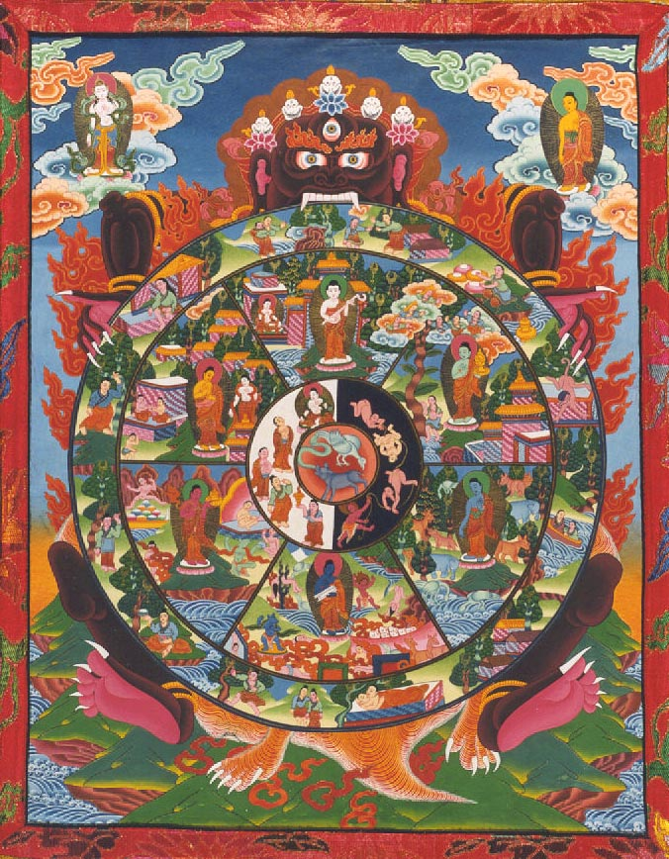
The Buddha mistakenly believed that his teaching would only be followed for a few hundred years. But people had to be rescued, and the Buddha was compelled, by the very nature of the enlightenment that he had achieved, to do what he could for them.

