Places of Worship in Buddhism Summary Sheet
(Pages 48-49 in the Buddhism textbook)
This summary sheet is to help you learn the different types of places of worship used in Buddhism and the various ways in which they are used. According to the AQA specification you need to know the following things:
‘• The nature, use and importance of Buddhist places of worship including temples, shrines, monasteries (viharas), halls for meditation or learning (gompas) and their key features including Buddha rupa, artefacts and offerings.’
Terminology
artefacts - objects (in this case ones used in worship)
Bodhisattva - an enlightened person who chooses to return from death and help others (in Mahayana Buddhism only)
Buddha rupa - a statue of Buddha of the type found in a place of worship
gompa - a hall or a building where Tibetan Buddhists meditate
incense - a substance that smells very sweet when it is burned
offerings - food, flowers, money, etc. given as part of worship
practice - mediation, worship, etc.
relics - special objects left over from a holy person e.g. their bones
shrine - an area which provides a focal point for worship and meditation
stupa - a building (often in a monastery) that often has holy relics
temple - In Buddhism, a place where people practise (worship, meditate etc.)
vihara (monastery) - a place where Buddhist monks and nuns live
Temples
There are many different types of building that are temples. A temple can be a single building or a group (complex) of buildings. A temple may include:
- a main hall where people practise; This will have a Buddha rupa (and statues of Bodhisattvas in a Mahayana temple).
- a meditation hall; In Tibetan Buddhism this is called a gompa.
- a study hall for lectures;
- shrines dedicated to Buddha (and Bodhisattvas in Mahayana temples);
- a pagoda or stupa which is often a tiered tower or a domed building that can contain relics which are holy items associated with Buddha himself.
Shrines
These can be found in a temple, monastery or home of a Buddhist. A shrine will have a Buddha rupa which is the main focus. Mahayana shrines may have a statue of a Bodhisattva.
Offerings are made in gratitude for the Buddha’s teachings. These may be:
- a candle, symbolising the light of wisdom driving away the darkness of ignorance;
- flowers, symbolising anicca or impermanence (they wither);
- incense, symbolising purity of thoughts, speech and actions.
Monasteries
Viharas are buildings where a community of monks or nuns live. These are people who have decided to dedicate themselves full time to Buddhist spiritual practice. They study, meditate, eat, sleep and worship in their community. They have very simple lifestyles and have given up many things. A vihara will also have a stupa which contains relics from Buddha (or a Bodhisattva in a Mahayana vihara). Stupas are therefore very important.
Artefacts in places of worship
Candles, flowers, incense (all offerings), relics, Buddha rupas, statues of Bodhisattvas, pictures
Pictures
temples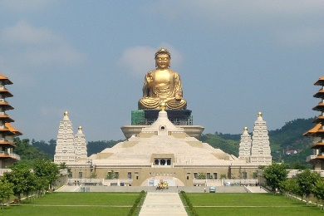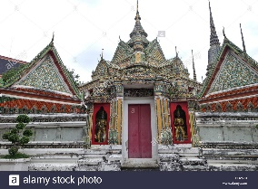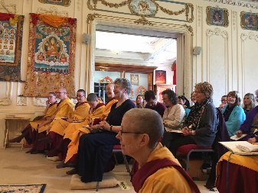
shrine 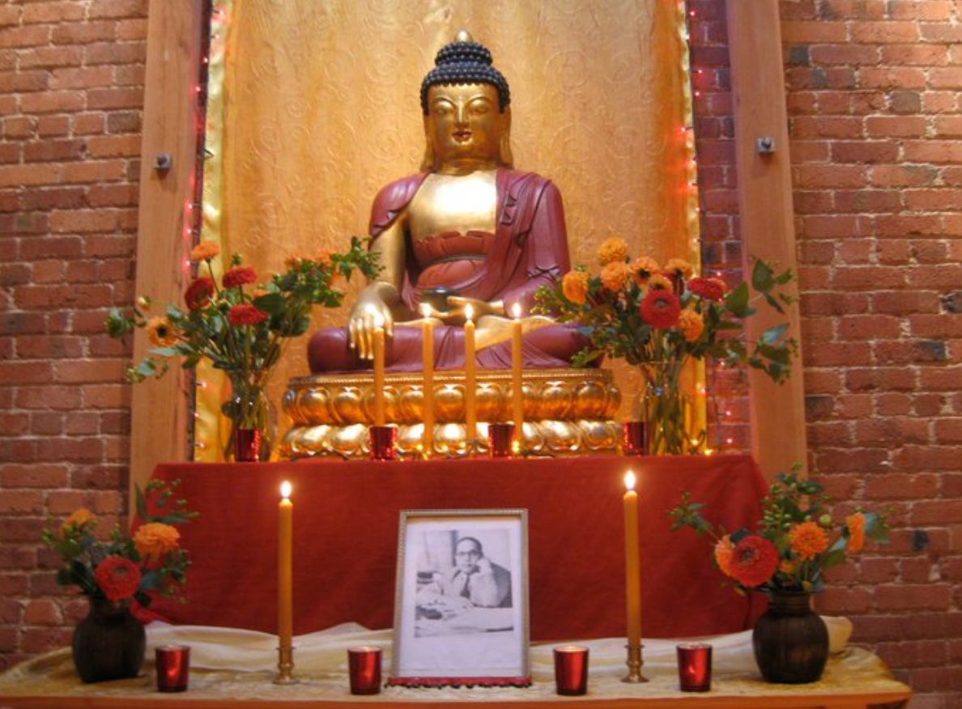 vihara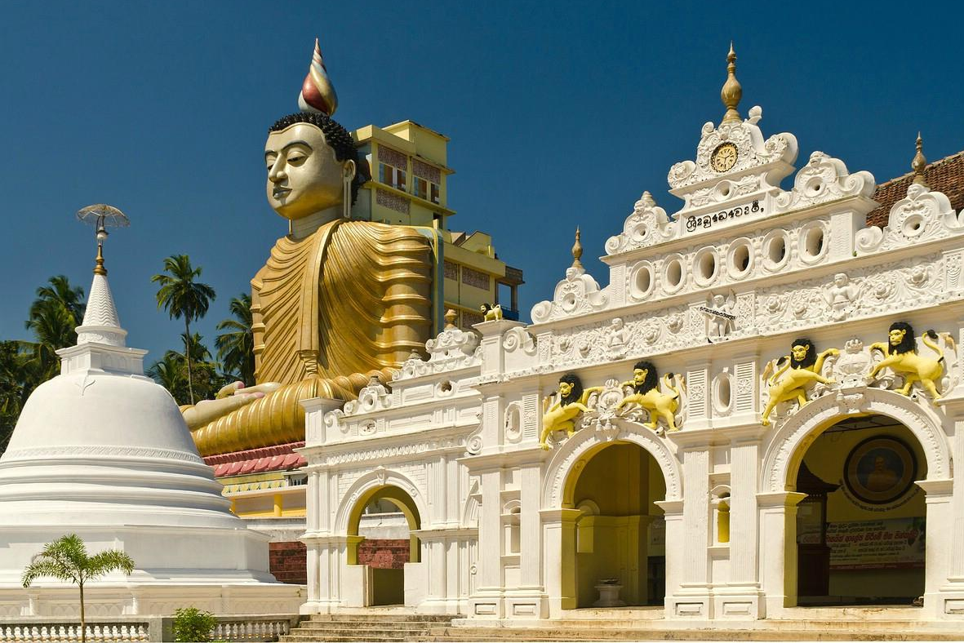 stupa
Buddha rupa gompa 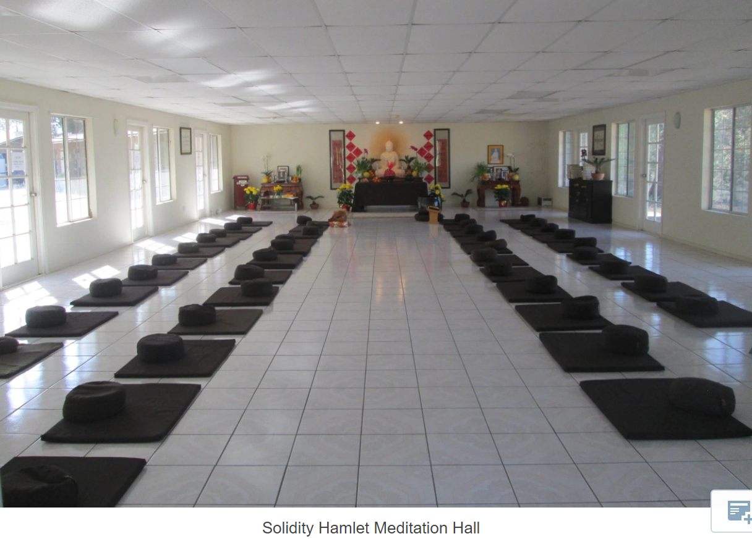
Possible exam questions:
- Explain two purposes of a Buddhist shrine. (4 marks)
- Explain two reasons why temples are important in Buddhist worship. In your answer you must refer to scripture. (5 marks) From the textbook p.75.
- Explain the purpose of two buildings in a Buddhist monastery. In your answer you must refer to scripture. (5 marks)
- Explain two Buddhist beliefs about Buddha reflected in worship practices. In your answer you must refer to scripture. (5 marks) [Note: Buddha is not a god.]
- ‘There is no need for temples; Buddhists can just worship at home.’ Do you agree? (12 marks)
- ‘Buddhist worship achieves nothing.’ Do you agree? (12 marks)
- ‘Worship in a Buddhist temple is the best way to achieve peace.’ Do you agree? (12 marks)
- ‘Buddhist worship offerings are a waste of candles, flowers and incense.’ Do you agree? (12 marks)

