3.3.4 Critical Path Analysis

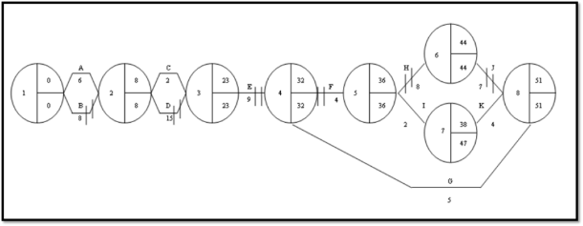
Write the definition of CPA here:

________________________________________________________________________________________________________________________________________________________________________________________________________________________________________________________________________________________________________________________________________
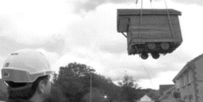
Uses of CPA

________________________________________________________________________________________________________________________________________________________________________________________________________________________________________________________________________________________________________________________________________

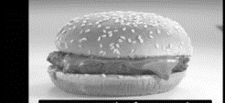
Other uses of CPA

________________________________________________________________________________________________________________________________________________________________________________________________________________________________________________________________________________________________________________________________________
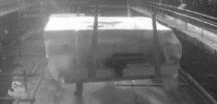
Benefits to a business of using CPA

A

B

C

D

How a CPA diagram works – step 1

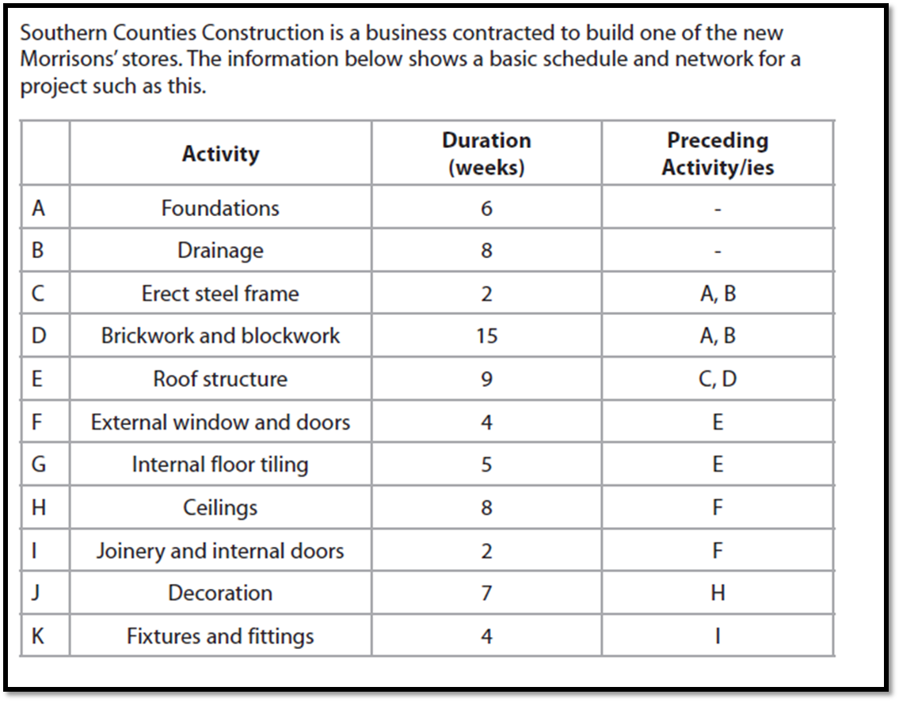
________________________________________________________________________________________________________________________________________________________________________________________________________________________________________________________________________________________________________________________________________
What tasks come before tiling the floor (letters)___________________

How a CPA diagram works – step 2
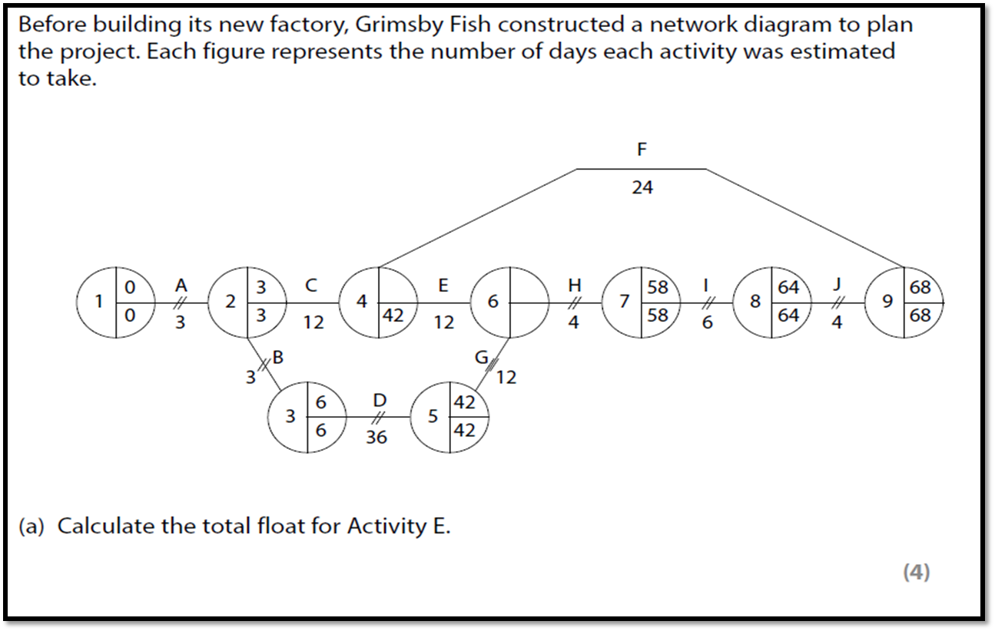

________________________________________________________________________________________________________________________________________________________________________________________________________________________________________________________________________________________________________________________________________
How a CPA diagram works – step 3

1
0
0

How a CPA diagram works – step 4
____________________________________________________________________________________________________________________________________________________________________
How a CPA diagram works – step 5
____________________________________________________________________________________________________________________________________________________________________

How to calculate the EST
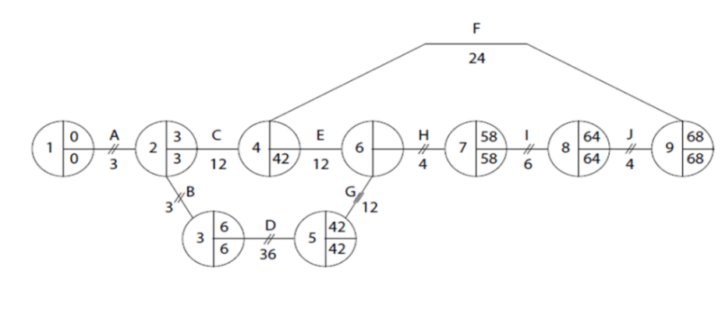
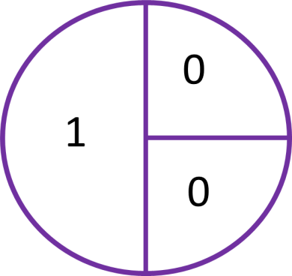

How to calculate the LFT

Identifying the critical path
____________________________________________________________________________________________________________________________________________________________________
__________________________________________________________________________________
What is the critical path of the diagram?
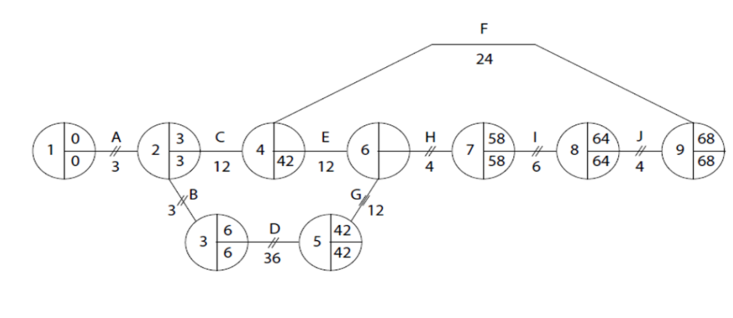
____________________________________

How to calculate the Float time
________________________________________________________________________________________________________________________________________________________________________________________________________________________________________________________________________________________________________________________________________

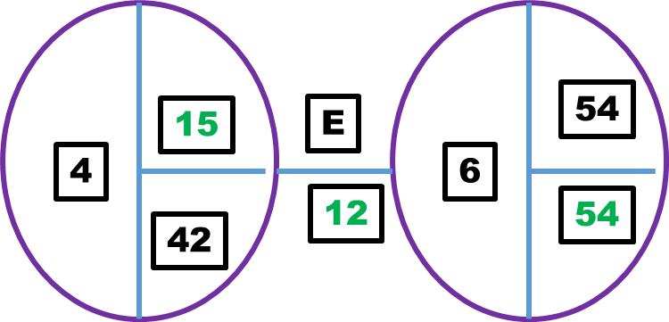

Limitations of CPA
________________________________________________________________________________________________________________________________________________________________________________________________________________________________________________________________________________________________________________________________________

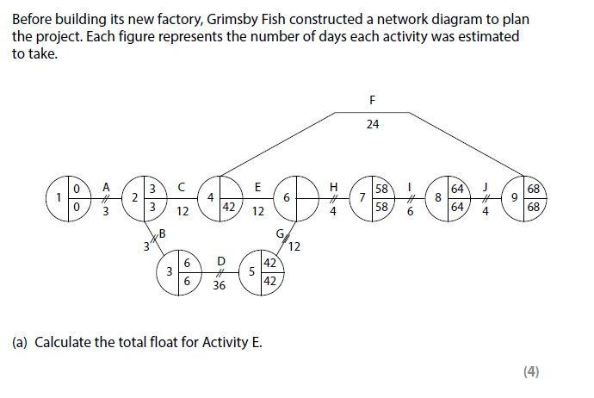

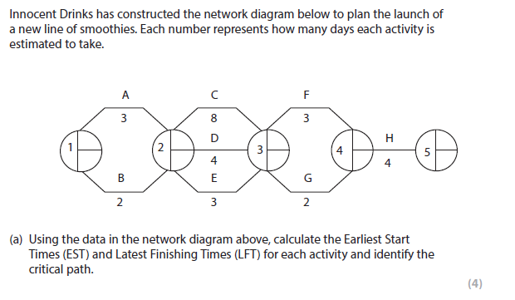

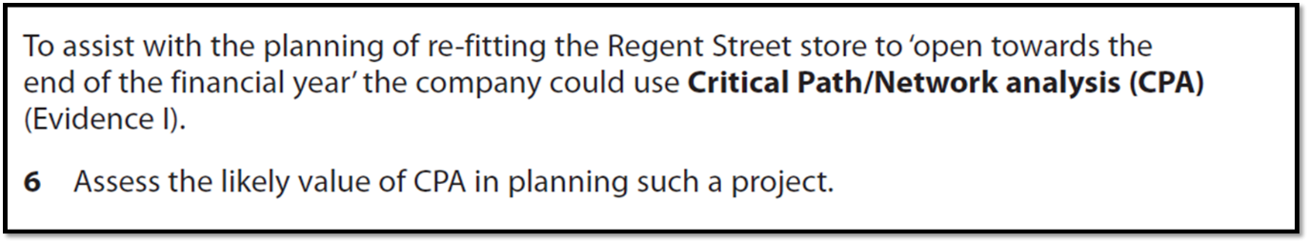
[10]

