Petrol and Price Elasticity of Demand
The data below shows the price of petrol and taxation over time.
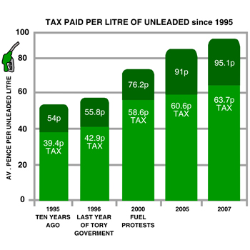
- Draw what you think the demand curve for petrol would look like:
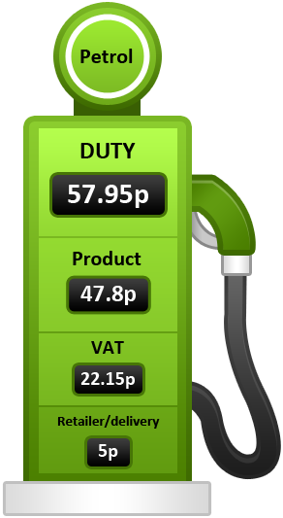

- Identify and explain one factor impacting the PED of petrol.
- Why do the government choose to place such a proportionately high amount of tax upon fuel?

PED – Cause and Effects
1 a) Cigarettes tend to be relatively price inelastic because they are __________ _______________
b) Computers tend to be relatively price ______________ because they take up a large proportion of income.
c) Emergency plumbing services tend to be relatively price _______________ because it takes time for a consumer to locate an alternative plumber.
2. Calculations and Decisions
a) A retailer knows that his price elasticity of demand is – 4. Should he lower or raise price to maximise revenue?

b) A cinema finds that if it raises the price of a ticket from £8 to £9.20 then the number of cinema goers will fall from 750 a week to 600. Calculate the change in total revenue.

c) An airline finds that a rise in price of flights by 10% causes a fall in the number of passengers per flight from 175 to 140. Calculate the price elasticity of demand and explain whether the airline flights are therefore price elastic or price inelastic.

d) An oil company finds that as the price of oil increases from $80 a barrel to $147 a barrel demand for their oil falls but their revenue increases. Explain, using a TR and D diagram, how this could happen.

3. A pizzeria wishes to raise revenue. It has adjusted the price of the pizza it manufactures from £10 to £12 and found that sales fall from 240 pizzas a week to 200 pizzas a week. It has also lowered the price of each pizza from £10 to £7.50 and found that sales rise from 240 pizzas a week to 300 pizzas a week. Explain to the pizzeria owner what she should do?

ANSWERS
1a Cigarettes tend to be relatively price inelastic because they are highly addictive (or similar)

1b Computers tend to be relatively price elastic because they take up a large proportion of income.

1c Emergency plumbing services tend to be relatively price inelastic because it takes time for a consumer to locate an alternative plumber.

2a Lower price

2b Fall of £480 (£8 x 750 = £6000, £9.20 x 600 = £5520 therefore £6000 - £5520 = Fall of £480 in revenue)

2c – 2 therefore price elastic (Fall in passenger number is 35 (175 -140 =35) which is 20 %. -20% =-2
+10

2d Clearly in this case oil is price inelastic and therefore an increase in price from $80 to $147 is the equivalent of moving from P2 to P1 and therefore despite demand falling revenue will rise.

3. Do nothing. If the price elasticity of demand is calculated it can be found to equal 1 at a price of £10. A rise in price of 20% results in a fall in demand of 20% and a fall in price of 25% causes demand to rise by 25%. Therefore the pizzeria is already revenue maximising – see worksheet 3 or above diagram for an illustration of this principle.

