Revision questions
(30 marks; 30 minutes)

1 From Figure 32.3 calculate the ratio of minimum wage pay in India to the level in the UK. (3)
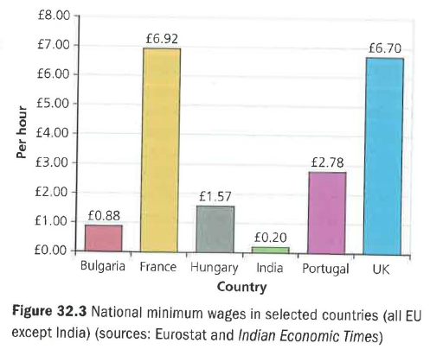
2 Explain two possible risks to a UK firm of outsourcing its customer service call centre to a lower-wage country. (6)

3 Explain how starting to sell a product overseas can extend its life cycle. (4)

4 Explain three potential reasons why a UK business may decide to reverse a decision to offshore manufacturing. (9)

5 Assess how entering foreign markets might lead to two different types of economy of scale. (8)

