- Information gaps
“To what extent has the government’s intervention in the property market (including Help To Buy) resulted in government failure?”
KAA – Government failure because…
EV – Not government failure… (Successes of the intervention)/critique the KAA
- Distortion of price signals
- Unintended consequences
- Excessive administrative costs

Help To Buy: Scheme in which the government supports first time buyers in a number of ways. Including topping-up deposits for mortgages; creating ISAs to support deposit saving; forcing developers to sell some properties below market value (affordable housing) and providing subsidies to encourage new construction.
Also consider: planning permission/green belts.

- Information gaps
“To what extent might regulations on the sale of cigarettes and high taxes on tobacco result in government failure?”
KAA – Government failure because…
EV – Not government failure… (Successes of the intervention)/ critique the KAA
- Distortion of price signals
- Unintended consequences
- Excessive administrative costs

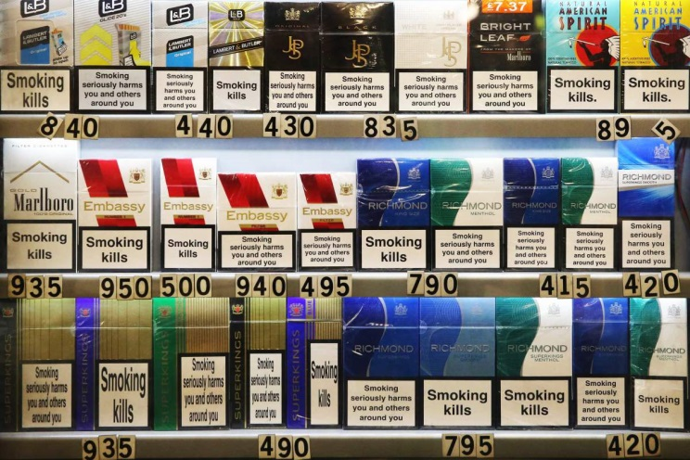
Cigarette intervention includes taxation and regulations such as warning signs, blank packaging, no smoking in cars/public places.
Effectiveness?
Intended outcome?
Shifting the problem?

- Information gaps
“To what extent has the high taxation of fuel and intervention within the railway industry resulted
in government failure?”
KAA – Government failure because…
EV – Not government failure… (Successes of the intervention)/ critique the KAA
- Distortion of price signals
- Unintended consequences
- Excessive administrative costs

Around 70% of the price of petrol is a tax.
Railways are subsidised and Network Rail (owns infrastructure - tracks) is nationalised.
Intended outcomes?
Impact upon consumers?
Effectiveness?
Knock-on effects elsewhere?
Inefficiencies of government ownership?

- Information gaps
- Distortion of price signals
- Unintended consequences
- Excessive administrative costs
“To what extent has the government’s intervention in the labour market (including income tax and the minimum wage) resulted in government failure?
KAA – Government failure because…
EV – Not government failure… (Successes of the intervention) / critique the KAA

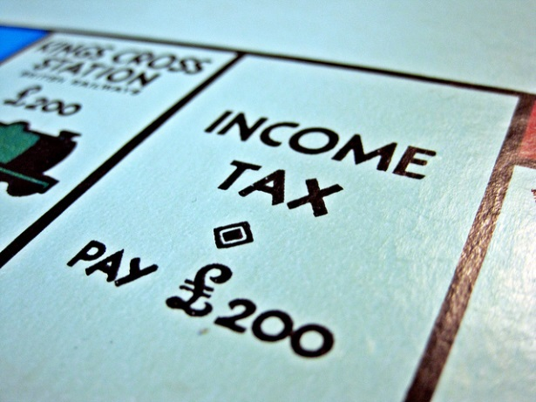
The top rate of income tax (over £150,000) is 45% and £42k-£150k is 40%.
Intended outcome?
Discouragement?
Role of benefits?
How do the rich react?
Impact of minimum wage?

