Revision Questions
(25 marks; 25 minutes)

1 Explain why average price levels may be higher in niche than in mass markets.

2 Give three reasons why a large firm may wish to enter a non-luxury, global niche market.

3 Explain the value to a business of understanding the different interests of consumers in different countries.

4 Look carefully at Figure 38.2. Use the data to explain whether America is a relatively enthusiastic cinema-going country.

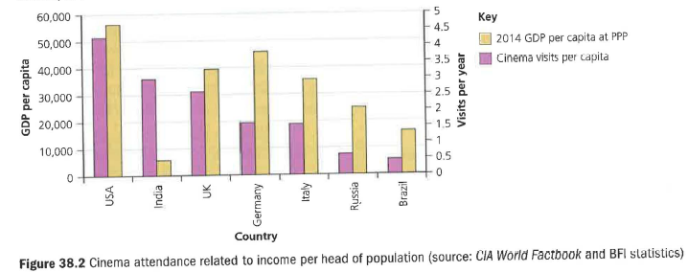

5 Explain two reasons why values may differ in different countries.

6 Look carefully at Figure 38.3. Explain why it’s possible to conclude that Thailand's record on corruption is relatively worse than that of China.

