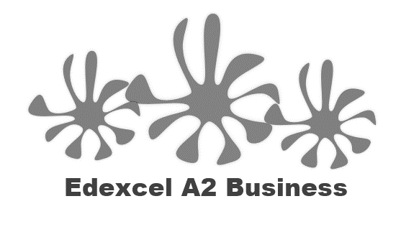
2.4.3 Stock Control

Starter question:
- You have two cats.
- Each cat eats 2 pouches of wet food a day (one at 6 am one at 2pm)
- Each cat also eats 25g of dry food a day
- You shop once a week and only have limited money

  - How many wet cat food pouches would you buy for one 7 day week?

  - What size bag of dry cat food would you buy for 7 days?

  - Is there an efficient way to ensure that you never run out of cat food?

  - What if you don’t have the storage space?

  - What if you have a tight weekly budget?

  - On which day would you go shopping (assume your week starts on Sunday) to ensure a constant supply?

Write a definition of stock control here:
________________________________________________________________________________________________________________________________________________________________________________________________________________________________________________________________________________________________________________________________________

4 types of stock:

Stock management diagram
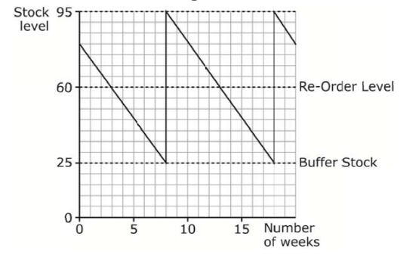
_________________________________________________________________________________________________________________________________________________________________________________________________________________________________________________________________________________________________________________________________________________________________________________________________________________________

Step 1: Know the diagram

__________________________________________________________________________________________________________________________________________________________________________________________________________________________________________________________________________________________________________________________________________________________________________________________________________________________

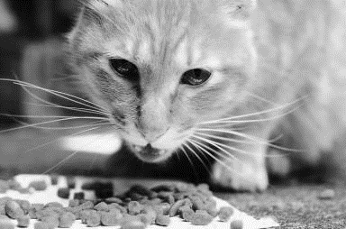
Step 2: Understand about holding stock

__________________________________________________________________________________________________________________________________________________________________________________________________________________________________________________________________________________________________________________________________________________________________________________________________________________________

Draw the stock control diagram here:
Time in weeks
Stock Level – boxes of cat food
2
4
6
8
5
10
15
20

Read the diagram:

What is the max stock level that the business can hold?
What is the minimum stock level that the business can hold?
What is the re-order level?

What is the buffer stock level?

How long does it take for stock to arrive after it has been ordered? (this is the lead time)

What is the max stock level that the business can hold?
What is the minimum stock level that the business can hold?
What is the re-order level?
What is the buffer stock level?
How long does it take for stock to arrive after it has been ordered? (this is the lead time)
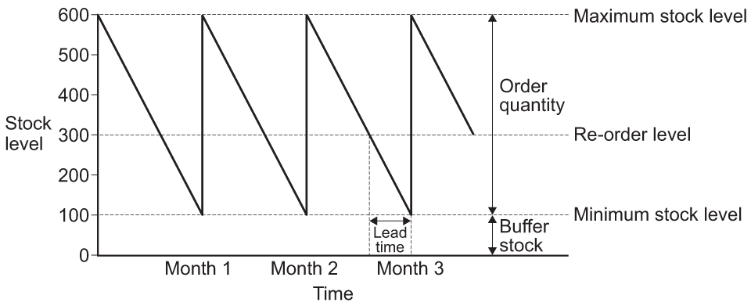

What is the max stock level that the business can hold?
What is the minimum stock level that the business can hold?
What is the re-order level?
What is the buffer stock level?
How long does it take for stock to arrive after it has been ordered? (this is the lead time)

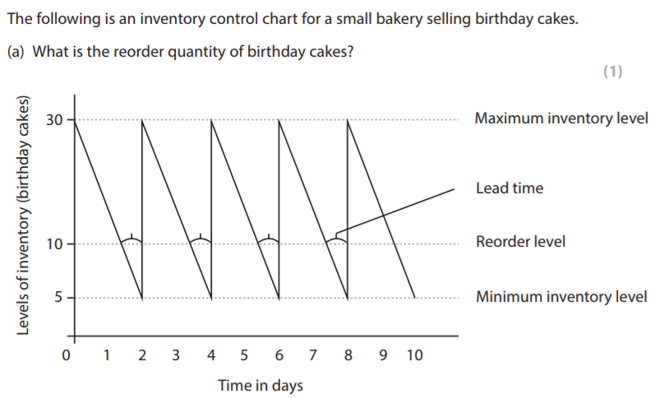
Carry out your calculations here:

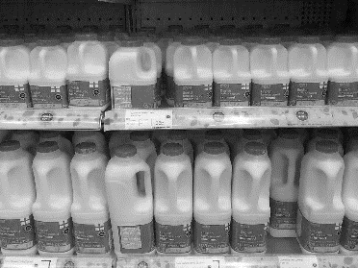
Buffer stocks

________________________________________________________________________________________________________________________________________________________________________________________________________________________________________________________________________________________________________________________________________

Advantages | Disadvantages

Implications of poor stock control
____________________________________________________________________________________________________________________________________________________________________

Stock out costs:
1

2

3

4

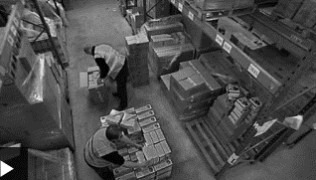
Just in time (JIT) management of stock

Just-in-time delivery

________________________________________________________________________________________________________________________________________________________________________________________________________________________________________________________________________________________________________________________________________

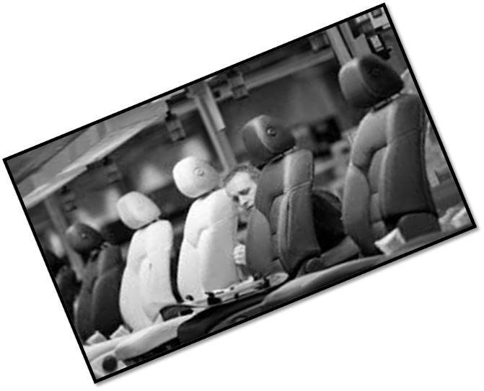
JIT and suppliers

________________________________________________________________________________________________________________________________________________________________________________________________________________________________________________________________________________________________________________________________________
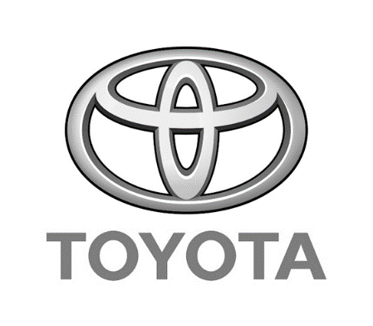

Where JIT is most suitable

________________________________________________________________________________________________________________________________________________________________________________________________________________________________________________________________________________________________________________________________________

JIT + Waste + Lean Management

________________________________________________________________________________________________________________________________________________________________________________________________________________________________________________________________________________________________________________________________________

Advantages | Disadvantages

Write a definition of waste here:
________________________________________________________________________________________________________________________________________________________________________________________________________________________________________________________________________________________________________________________________________

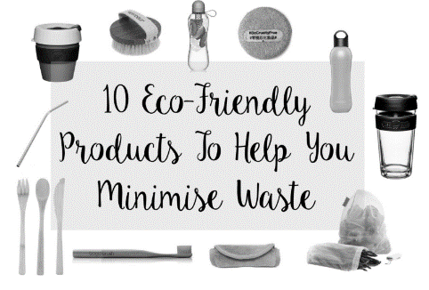
Waste minimisation

________________________________________________________________________________________________________________________________________________________________________________________________________________________________________________________________________________________________________________________________________
7 Deadly wastes:

#1 Over production

#2 Waiting time

#3 Transportation time

#4 Excess processing

#5 Excess stock

#6 Excess motion

#7 Product quality

Lean production
____________________________________________________________________________________________________________________________________________________________________
A
B
C
D
E

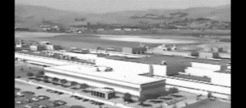
Lean production cost savings

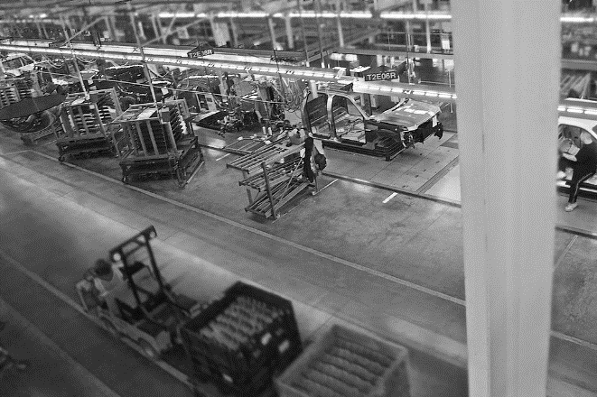
________________________________________________________________________________________________________________________________________________________________________________________________________________________________________________________________________________________________________________________________________
Benefits of lean production

_______________________________________________________________________________________________________________________________________________________________________________________________________________________________________________________________________________________________________________________________________
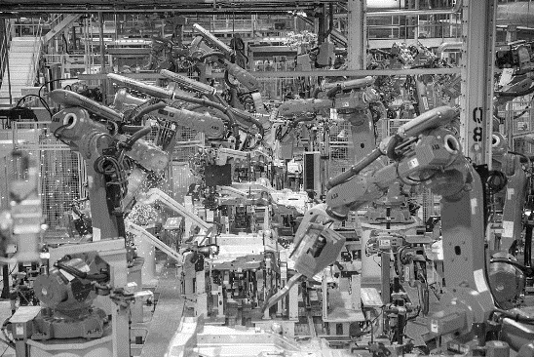
More benefits of lean production

________________________________________________________________________________________________________________________________________________________________________________________________________________________________________________________________________________________________________________________________________

