Revision questions
(45 marks; 45 minutes)
1 What is meant by the term 'global competitiveness'?

2 Explain why a decision by management to pay car workers a pay rise might not increase the cost of producing each car.

3 In 2014, 3,036,773 cars were sold in Germany, compared with 2,952,421 the year before. Using the information in Table 36.1, calculate what happened to the VW Golf's market share between 2013 and 2014.

4 Before modernisation, the Dacia factory employed 30,000 workers who made a total of 110,000 cars a year. By 2014, the same factory produced 340,000 cars per year from a workforce of just 14,000.
- Calculate Dacia's labour productivity level then and in 2014.
- Explain how Dacia benefits from that change.

5 Using Figure 36.2, compare the change in Greece and Germany's unit labour costs over the period shown.
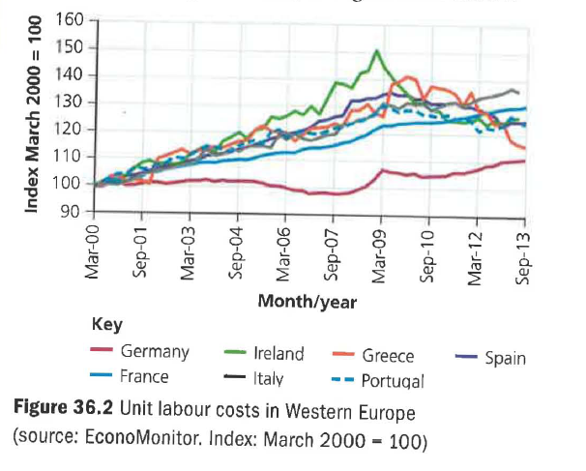

6 Explain two ways in which a firm might choose to lower its unit labour costs.

7 Distinguish between outsourcing and offshoring.

8 Product differentiation and cost competitiveness both affect a firm's profitability. Assess the view that product differentiation will always be more important than cost competitiveness for businesses like BMW and Lindt.

