How Poundland makes its millions

What are the tricks of the trade that allow the thriving discount chain Poundland to sell so cheaply

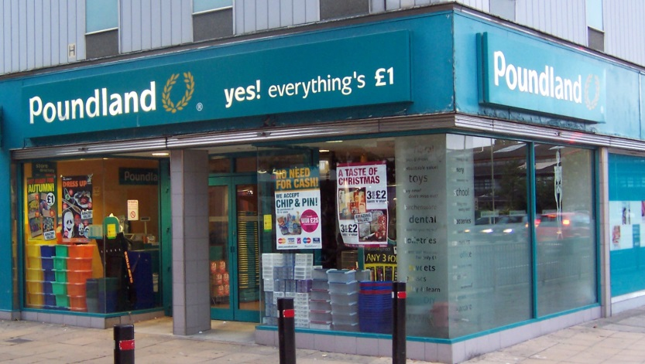
Deptford, in south-east London, was declared as having the capital’s “most vibrant and diverse high street” in a study back in 2005. Independent cafés, grocers, ironmongers, halal butchers, a watch repairer and, remarkably, three fishmongers – it had the lot.
Even post-credit crunch, which changed the face of the nation’s high streets, Deptford’s remains vibrant. But it could no longer be described as diverse. One type of business has come to dominate the street: discount shops.
Danny’s Pound Shop Plus, My £ shop, 99+ store, Terry’s Discount and 99p Stores can all be found here. And then, this year, the biggest of them all moved in: Poundland, taking over the site of the old Jobcentre.
Maureen, a long-time local who was out shopping this week, said: “The street has changed a lot during my lifetime, but I really do think Poundland is a good thing, especially when money is tight.”
Many would agree with her. The company now has 400 shops and four million weekly shoppers. It has an ambition to have 1,000 shops, which would make it one of the country’s largest retail chains.
It has become one of the great success stories of the recession, taking over many of the shops left vacant when Woolworths went bust in 2008 and winning over an army of consumers struggling with ever-tighter wallets and rising prices.
Initially, the company sold an odd assortment of homeware products, end-of-line chocolates and biscuits, and food destined for export that never quite made it. Now it sells fresh food, including mince, milk and bread, along with a dazzling array of different products: four-packs of loo roll, nativity sets, children’s socks, cans of dog food, reading glasses, pregnancy tests (14,000 are sold every week) and jars of organic baby food – all for exactly £1.
More than that, most of the country’s biggest manufacturers, such as Nestlé, Kraft and United Biscuits, now negotiate directly with Poundland, making special value packs of their products for the discount sector. .
How can a company, faced with rising inflation, which has sent the price of most raw materials rocketing in recent years, increase its profits by 50 per cent to £18.3 million (in the year to April 2012) when everything it sells costs just £1?
It is an impressive achievement, one that the company boasts about on posters by its tills: “Our inflation-busting style gives you irresistible value… the same amazing prices since 1990”.
Well, it is not inflation-busting in the strictest definition of the term. To keep items priced at £1, many have been shrunk, as Jim McCarthy, Poundland’s ebullient and enthusiastic chief executive, admitted to me.
In recent years, this “re-engineering” of products, as McCarthy calls it, has been quite severe. Back in 2007, shoppers would have got 10 packs of Quavers in a family bag for £1. This was reduced to seven packs last year, and more recently shrunk further to just five packs. Last year, £1 got you 12 Kodak AA batteries; now it is far fewer.
Poundland also sells a number of popular items in non-standard sizes. A loaf of Warburton’s sliced white bread for £1 appears to be fantastic value, until you realise it is a 600g loaf, rather than the 800g size that has been the industry standard since the Victorian era. This week at Tesco, you can pick up two 800g Warburton loaves for £2. Take milk, too, which supermarkets sell mostly in “metric pints” such as 500ml, 1 litre or 2 litre bottles. Poundland sells milk as part of a two-for-£1 offer – in unusually sized 750ml bottles.
Another clever tactic espoused by Poundland, and indeed the other discount shops, is to shout very loudly about the bargains that shoppers are receiving. It sells a number of well-known brands with “50pc Extra Free”, or even “100pc Extra Free”, on the packaging. So shoppers can pick up eight bars of two-finger Kit-Kats for £1. This is sold with a large yellow banner around the multipack saying “5+3 bars, 60pc Extra Free”. Asda is currently selling the same eight Kit-Kats for £1, too, but without the “60pc Extra Free” flash.
Poundland’s clever marketing tactics and canny packaging help underline the impression that it is a cheeky upstart on the high street, taking on the big boys. Its own research suggests it was cheaper than the big four supermarkets and Boots on 85 per cent of 246 identical products it tested this year.
But it is becoming a big boy itself, hiring the former finance director of Tesco as chairman, in advance of a possible flotation on the London stock market. Most analysts think it could be worth at least £500 million, netting a tidy profit for its American private equity owner, Warburg Pincus, which bought it for £200 million two years ago.
QUESTIONS:
How do Poundland maintain their profit margins, despite not being able to change the price?

SYNOPTIC QUESTION: During a recession (economic downturn) unemployment tends to rise, which is bad for most businesses. Why is this not the case for Poundland? Can you think of any other examples of businesses that might benefit during a recession?

What type of goods (in terms of YED) do you think Poundland generally sells?

