1.4.2 Recruitment, selection and training

Starter – identify the reasons these employees have left their job:

Write a definition of recruitment here:
____________________________________________________________________________________________________________________________________________________________________
Stage 1

________________________________________________________________________________________________________________________________________________________________________________________________________________________________________________________________________________________________________________________________________

Stage 2

________________________________________________________________________________________________________________________________________________________________________________________________________________________________________________________________________________________________________________________________________

Stage 3

________________________________________________________________________________________________________________________________________________________________________________________________________________________________________________________________________________________________________________________________________
Stage 4

_______________________________________________________________________________________________________________________________________________________________________________________________________________________________________________________________________________________________________________________________________

Stage 5
_______________________________________________________________________________________________________________________________________________________________________________________________________________________________________________________________________________________________________________________________________

Stage 5 continued - CVs

_______________________________________________________________________________________________________________________________________________________________________________________________________________________________________________________________________________________________________________________________________
Stage 5 continued – Letter of application

_______________________________________________________________________________________________________________________________________________________________________________________________________________________________________________________________________________________________________________________________________
Stage 6 continued – Letter of application

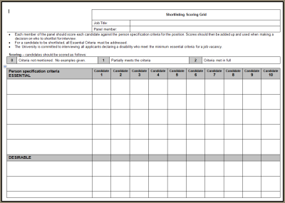

_______________________________________________________________________________________________________________________________________________________________________________________________________________________________________________________________________________________________________________________________________

Stage 7

________________________________________________________________________________________________________________________________________________________________________________________________________________________________________________________________________________________________________________________________________

Stage 8

_______________________________________________________________________________________________________________________________________________________________________________________________________________________________________________________________________________________________________________________________________

Stage 8 continued

_______________________________________________________________________________________________________________________________________________________________________________________________________________________________________________________________________________________________________________________________________
Stage 8 continued

_______________________________________________________________________________________________________________________________________________________________________________________________________________________________________________________________________________________________________________________________________

Costs of recruitment, selection and training
Advertising costs

Agency fees

Types of training

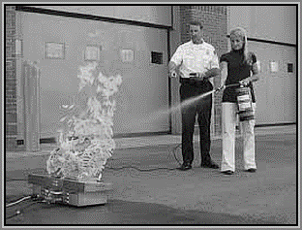Induction
________________________________________________________________________________________________________________________________________________________________________________________________________________________________________________________________________________________________________________________________________

Advantages | Disadvantages

On-the-job training
________________________________________________________________________________________________________________________________________________________________________________________________________________________________________________________________________________________________________________________________________

Advantages | Disadvantages

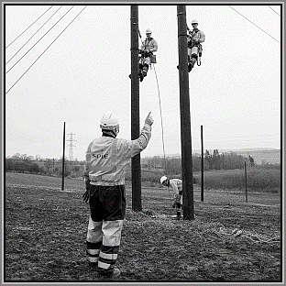Off-the-job training
________________________________________________________________________________________________________________________________________________________________________________________________________________________________________________________________________________________________________________________________________

Advantages | Disadvantages

[8]

