Command economies vs free market/mixed economies
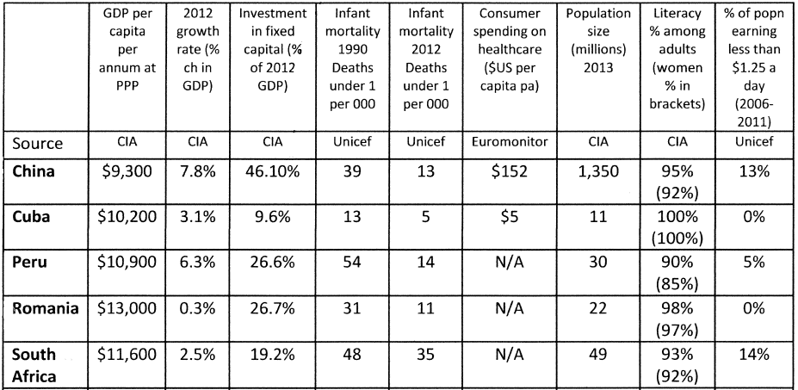
All 5 economies have approximately equal GDP per head (size of economy divided by population).
Romania: former command economy
China: part-command/part-mixed
Cuba: command economy
Peru: Free/mixed economy
South Africa: Free/mixed economy
- Analyse the data and write down 3 conclusions about the advantages and disadvantages of mixed/free market economies, when compared with command economies.
- Mixed economies have a free-market, with elements of government intervention. Identify three examples of how the government might intervene in an economy.
- No economy is an entirely free-market, all have some form of intervention by the state. Explain why you think mixed economies exist and reasons for which intervention is necessary.

