Q1.A student was asked to estimate how many clover plants there are in the school field.
The image below shows the equipment used.
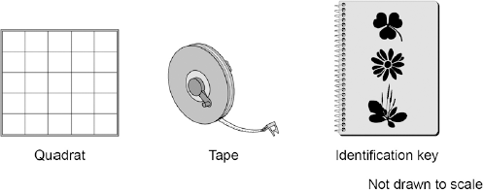
This is the method used.
1. Throw a quadrat over your shoulder.
2. Count the number of clover plants inside the quadrat.
3. Repeat step 1 and step 2 four more times.
4. Estimate the number of clover plants in the whole field.
(a) What is the tape in the image above used for in this investigation?
.............................................................................................................................
.............................................................................................................................
(1)

(b) The teacher told the student that throwing the quadrat over his shoulder was not random.
The method could be improved to make sure the quadrats were placed randomly.
Suggest one change the student could make to ensure the quadrats were placed randomly.
.............................................................................................................................
.............................................................................................................................
(1)

(c) How could the student improve the investigation so that a valid estimate can be made?

Tick two boxes.
Weigh the clover plants
Compare their results with another student’s results
Count the leaves of the clover plants
Place more quadrats
Place the quadrats in a line across the field

(2)

(d) The table below shows the student’s results.

 | Quadrat number | Number of clover plants counted
 | 1 | 11
 | 2 | 8
 | 3 | 11
 | 4 | 9
 | 5 | 1
 | Total | 40

The area of the school field was 500 m².
The quadrat used in the table above had an area of 0.25 m².
Calculate the estimated number of clover plants in the school field.
.............................................................................................................................
.............................................................................................................................
.............................................................................................................................
Estimated number of clover plants = .................................
(3)

(e) What was the mode for the results in the table above?

Tick one box.
1
8
11
40

(1)

(f) Suggest which quadrat could have been placed under the shade of a large tree.
Give one reason for your answer.
Quadrat number ....................................
Reason ...............................................................................................................
.............................................................................................................................
(1)
(Total 9 marks)

Q2.Ragwort is a plant that often grows as a weed in grassland.
The image below shows a ragwort plant.
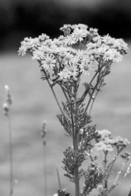
© Difydave/iStock

Some students estimated the number of ragwort plants growing in a field on a farm.
The students:
• placed a quadrat at 10 random positions in the field
• counted the number of ragwort plants in each quadrat.
The quadrat measured 1 metre × 1 metre. The area of the field was 80 000 m².

The table below shows the students’ results.

 | Quadrat number | Number of ragwort plants
 | 1 | 1
 | 2 | 0
 | 3 | 3
 | 4 | 0
 | 5 | 0
 | 6 | 0
 | 7 | 5
 | 8 | 0
 | 9 | 0
 | 10 | 2

(a) Complete the following calculation to estimate the number of ragwort plants in the field.
Use information from the table above.
Total number of ragwort plants in 10 quadrats = ..........................................
Mean number of ragwort plants in 1 m² = ....................................................
Therefore estimated number of ragwort plants in field = ..............................
(2)

(b) What could the students do to get a more accurate estimate?

Tick (✔) one box.
Place the quadrat in 100 random positions.
Place the quadrat only in areas where they could see ragwort plants.
Place the quadrat in positions at the edge of the field.

(1)

(c) The farmer who owned the field kept horses.
If horses eat ragwort, the ragwort can poison them.
The farmer considered two methods of controlling ragwort in his field.
Method 1: Spraying with a selective weed killer
Method 2: Pulling out the ragwort plants by hand
In Method 1:
• the cost of the weed killer was £420
• the weed killer would not harm the grass but would kill all other plants
• the farmer could apply the weed killer from a sprayer towed by a tractor.
Method 2 could be done by local volunteers.
What are the advantages and disadvantages of using Method 2 instead of Method 1 for controlling ragwort?
Advantages of Method 2 ...............................................................................
.............................................................................................................................
.............................................................................................................................
.............................................................................................................................
Disadvantages of Method 2 ...............................................................................
.............................................................................................................................
.............................................................................................................................
.............................................................................................................................
(3)
(Total 6 marks)

Q3.Some students were asked to investigate the distribution of clover in a field of grass.
They noticed that the clover grew in patches amongst the grass.
(a) The students decided to use quadrats.
Describe how the students should decide where to place the quadrats to investigate the distribution of the clover.
........................................................................................................................
........................................................................................................................
........................................................................................................................
........................................................................................................................
(2)

(b) The diagram shows one of the quadrats the students used.
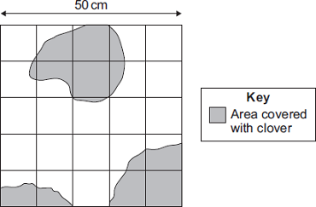
(i) Estimate the number of squares of the quadrat covered with clover.
...............................................................................................................
...............................................................................................................
Number of squares = ..............................
(1)

(ii) Describe how you worked out your answer to part (b)(i).
...............................................................................................................
...............................................................................................................
...............................................................................................................
(1)

(iii) Use your answer from part (b)(i) to calculate the percentage of the quadrat covered by the clover.
...............................................................................................................
...............................................................................................................
...............................................................................................................
Answer = .......................................... %
(2)

(c) Suggest one factor that could account for the distribution of the clover plants.
........................................................................................................................
(1)
(Total 7 marks)

Q4.A gardener investigates if turning over the waste in a compost heap makes the waste decay more quickly.
The gardener:
• makes two separate heaps of garden waste, heap A and heap B
• turns over the material in heap A every 2 weeks
• does not turn over the material in heap B
• estimates the amount of decay in the two heaps after 6 months.
The diagram shows the two heaps of garden waste at the beginning of the investigation.
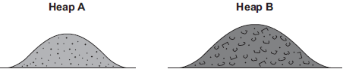
(a) Suggest two factors, other than time, the gardener should control to make the investigation fair.
1......................................................................................................................
........................................................................................................................
2......................................................................................................................
........................................................................................................................
(2)
(b) Name one type of living thing that causes decay.
........................................................................................................................
(1)

(c) The gardener’s results are shown in the table.

 | Compost heap | Estimated amount of decay
 | A | A lot
 | B | Very little

(i) Why does turning over the material in heap A make the material decay more quickly?
...............................................................................................................
...............................................................................................................
(1)
(ii) The gardener puts decayed material around his plants to help them grow.
Suggest why the plants in a woodland grow well each year without material from compost heaps being added.
...............................................................................................................
...............................................................................................................
...............................................................................................................
...............................................................................................................
(2)
(Total 6 marks)

Q5.This question is about carbon.
The graph shows the mass of carbon added to and removed from the atmosphere each year.
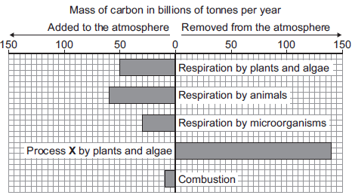
(a) Name process X.
........................................................................................................................
(1)

(b) (i) Calculate the mass of carbon added to the atmosphere by respiration per year.
Answer = .......................................... billion tonnes
(1)
(ii) Some scientists are concerned that the mass of carbon in the atmosphere is changing.
How does the data in the graph support this idea?
...............................................................................................................
...............................................................................................................
(1)
(Total 3 marks)

Q6.A gardener wants to add compost to the soil to increase his yield of strawberries.
The gardener wants to make his own compost.
(a) An airtight compost heap causes anaerobic decay.
Explain why the gardener might be against producing compost using this method.
.............................................................................................................................
.............................................................................................................................
.............................................................................................................................
.............................................................................................................................
(2)

(b) The gardener finds this research on the Internet:
‘A carbon to nitrogen ratio of 25:1 will produce fertile compost.’
Look at the table below.

 | Type of material to compost | Mass of carbon in sample in g | Mass of nitrogen  in sample in g | Carbon:nitrogen ratio
 | Chicken manure | 8.75 | 1.25 | 7:1
 | Horse manure | 10.00 | 0.50 | 20:1
 | Peat moss | 9.80 | 0.20 | X

Determine the ratio X in the table above.
.............................................................................................................................
Ratio ................................
(1)

(c) Which type of material in the table above would be best for the gardener to use to make his compost?
Justify your answer.
.............................................................................................................................
.............................................................................................................................
(1)

(d) Some of the leaves from the gardener’s strawberry plant die.
The dead leaves fall off the strawberry plant onto the ground.
The carbon in the dead leaves is recycled through the carbon cycle.
Explain how the carbon is recycled into the growth of new leaves.
.............................................................................................................................
.............................................................................................................................
.............................................................................................................................
.............................................................................................................................
.............................................................................................................................
.............................................................................................................................
.............................................................................................................................
.............................................................................................................................
.............................................................................................................................
.............................................................................................................................
(6)

(e) The diagram below shows two strawberries.
• Both strawberries were picked from the same strawberry plant.
• Both strawberries were picked 3 days ago.
• The strawberries were stored in different conditions.
Strawberry A Strawberry B
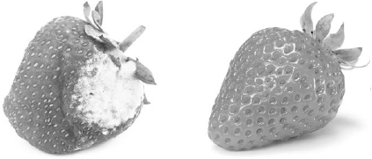
A © sarahdoow/iStock/Thinkstock, B © Mariusz Vlack/iStock/Thinkstock
Give three possible reasons that may have caused strawberry A to decay.
1 ..........................................................................................................................
.............................................................................................................................
2 ..........................................................................................................................
.............................................................................................................................
3 ..........................................................................................................................
.............................................................................................................................
(3)
(Total 13 marks)

Q7.Students investigated decomposition.
The students:
• put some decaying grass cuttings into a vacuum flask
• put a carbon dioxide sensor and a temperature sensor in the flask
• attached the sensors to a data logger
• closed the flask with cotton wool.
A vacuum flask was used to reduce the loss of thermal energy.
Figure 1 shows the investigation.
Figure 1
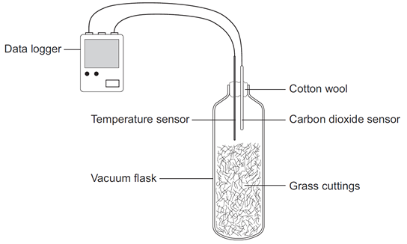
(a) Give one advantage of using a temperature sensor attached to a data logger instead of a thermometer.
.............................................................................................................................
.............................................................................................................................
(1)

(b) Figure 2 shows the results from the data logger for carbon dioxide concentration in the flask for the next 25 days.
Figure 2
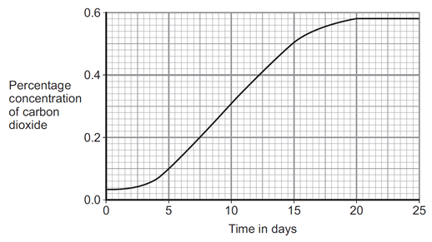
(i) Why did the concentration of carbon dioxide in the flask increase?
...................................................................................................................
...................................................................................................................
...................................................................................................................
...................................................................................................................
...................................................................................................................
...................................................................................................................
(3)

(ii) Suggest what has happened in the flask to cause the carbon dioxide concentration to level off after 20 days.
...................................................................................................................
...................................................................................................................
(1)
(Total 5 marks)

Q8. The diagram shows the annual flow of energy through a habitat.
The figures are in kJ m^{–2}.
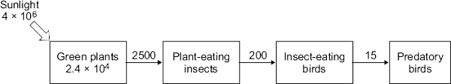
(a) (i) Calculate the percentage of the energy in sunlight that was transferred into energy in the green plants.
Show clearly how you work out your answer.
...............................................................................................................
...............................................................................................................
...............................................................................................................
...............................................................................................................
Answer = ........................................ %
(2)

(ii) Suggest reasons why the percentage energy transfer you calculated in part (a)(i) was so low.
...............................................................................................................
...............................................................................................................
...............................................................................................................
...............................................................................................................
(2)

(b) Compare the amount of energy transferred to the insect-eating birds with the amount transferred to the predatory birds.
Suggest explanations for the difference in the amount of energy transferred to the two types of bird.
........................................................................................................................
........................................................................................................................
........................................................................................................................
........................................................................................................................
........................................................................................................................
........................................................................................................................
........................................................................................................................
........................................................................................................................
(3)
(Total 7 marks)

M1.(a) measure the length / area of the field
1

(b) use (a) random number(s) (generator)
or
use coordinates method explained
1

(c) compare their results with another student’s results
1

place more quadrats
1

(d) 0.25 × 5 = 1.25
1

500 / 1.25 = 400
1

(40 × 400 =) 16 000
allow 16 000 with no working shown for 3 marks
1

(e) 11
1

(f) (quadrat) 5
both quadrat number and correct reason must be given for 1 mark
1

very few or only 2 growing (here)
[9]

M2.(a) 88 000
correct answer = 2 marks
allow 1 mark for 1.1 (in 1 m²)
or
allow 1 mark for answer = [candidate’s value in 1m²] × 80 000
2

(b) Place the quadrat in 100 random positions.
1

(c) any three from:
must include at least one advantage and one disadvantage for full marks
Advantages:
• less cost / free
• less likely to kill other (harmless species of) plants
• weedkiller may be toxic or may cause water pollution
• weedkiller may accumulate up food chains
allow uneven distribution of ragwort so much wastage of weedkiller
Disadvantages:
• volunteers may mistake other species for ragwort
• volunteers may miss plants
allow weeds will grow back
• some ragwort left to poison horses
• time consuming
• difficulties getting enough volunteers
if no other disadvantages; allow ref. to issues with volunteers – eg don’t turn up / not careful / don’t finish the job
3
[6]

M3.(a) chose places randomly
1

method of obtaining randomness, e.g. (grid and) random numbers
allow thrown qualified e.g. over shoulder, eyes shut
allow max 1 for mention of a transect with sampling at regular or random intervals
1

(b) (i) 7 or 8
allow fractions / decimals between 7 and 8
1

(ii) count number of whole squares and add estimate of area covered by part squares
allow reference to counting squares with ½ cover or more
allow clear working on diagram and / or (b)(i)
1

(iii) 28 – 32 (in range)
allow ecf
if answer incorrect allow 1 mark for reasonable reference to divided by 25 or multiplied by 4
2

(c) nutrients / minerals / ions / fertiliser / water
allow light / pH / trampling / soil texture / grazing / mowing / weed killer / where seeds originally fell
ignore pollution / soil / competition if unqualified
ignore temperature / wind
1
[7]

M4.(a) any two from:
• amount of waste on each heap
allow size of heap
• (type of) materials on each heap
if neither marking points one or two awarded, allow 1 mark for same waste
• put heaps in same (environmental) conditions.
e.g. keep at same (outside) temperature
allow put in same place
2

(b) microorganisms / microbes / bacteria / fungi / decomposers
ignore detritivores / examples (such as worms, maggots, insects)
ignore pathogens / germs
do not allow viruses
1

(c) (i) oxygen / air added (when turning over)
allow idea that decay will be aerobic
allow bacteria / microorganisms need oxygen / air
allow (microorganisms) respire faster
1

(ii) any two from:
• dead leaves / fruit / plants (fall off / onto the ground)
• (fallen dead leaves / fruit / plants) decay
• minerals / ions / nutrients are recycled / released.
ignore references to carbon dioxide
allow animal waste or dead animals
2
[6]

M5.(a) photosynthesis
1

(b) (i) 140
1

(ii) (10 billion tonnes) more added (to atmosphere) than removed
allow ecf from part (b)(i)
1
[3]

M6.(a) methane is produced
ignore bad smell
1

which is a greenhouse gas / causes global warming
1

(b) (9.80 / 0.20 = 49 therefore) 49:1
1

(c) horse (manure)
allow ecf from 11.2
closest to 25:1 (ratio)
1

(d) Level 3 (5–6 marks):
A detailed and coherent explanation is given, which logically links how carbon is released from dead leaves and how carbon is taken up by a plant then used in growth.
Level 2 (3–4 marks):
A description of how carbon is released from dead leaves and how carbon is taken up
by a plant, with attempts at relevant explanation, but linking is not clear.
Level 1 (1–2 marks):
Simple statements are made, but no attempt to link to explanations.
0 marks:
No relevant content.
Indicative content
statements:
• (carbon compounds in) dead leaves are broken down by microorganisms / decomposers / bacteria / fungi
• photosynthesis uses carbon dioxide
explanations:
• (microorganisms) respire
• (and) release the carbon from the leaves as carbon dioxide
• plants take in the carbon dioxide released to use in photosynthesis to produce
glucose
use of carbon in growth:
• glucose produced in photosynthesis is used to make amino acids / proteins / cellulose
• (which are) required for the growth of new leaves
6

(e) any three from:
(storage conditions)
• (at) higher temperature / hotter
• (had) more oxygen
• (had) more water / moisture
• (contained) more microorganisms (that cause decay)
allow reference to bacteria / fungi / mould
3
[13]

M7.(a) any one from:
• continuous readings
• do not need to be there
allow automatic readings
• (more likely to be) accurate
allow greater resolution
do not allow valid
• reduces human error
allow easier to read
1

(b) (i) microorganisms
allow microbes / bacteria / fungi / decomposers for microorganisms, throughout
1
(microorganisms) respire
1
respiration / decay / microorganisms releases carbon dioxide
ignore carbon released
1

(ii) all grass decomposed / decayed / rotted
allow idea that all microorganisms dead (due to accumulation of waste or lack of oxygen)
allow lack of / no oxygen (for respiration of microorganisms)
1
[5]

M8. (a) (i) 0.6 or 6 x 10⁻¹
for correct answer
if no / incorrect answer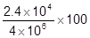
or
0.006 or 6 x 10⁻³ gains 1 mark
2

(ii) any two from:
• reflected
ignore some of light is green
• not absorbed or misses chloroplasts / chlorophyll
allow transmitted or passes through leaves
allow hits other plant parts
• wrong wavelength
• photosynthesis inefficient
accept other limiting factors / named
• allow some lost through respiration / as heat (from respiration)
2

(b) energy lost via faeces / not digested / waste / excreted (of insect-eating birds)
1

energy loss via respiration / movement / muscle contraction / heat (by insect-eating bird)
accept examples of muscle contraction
do not accept energy used for respiration
1

some of (insect eating) bird not eaten but all / most / more of insect is eaten
1
[7]

