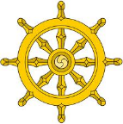

A Level RS Buddhism – Key Terms.

|  |  |
| --- | --- |
| **Word/Term** | **Definition** |
|  |  |
|  |  |
|  |  |
|  |  |
|  |  |
|  |  |
|  |  |
|  |  |
|  |  |
|  |  |
|  |  |
|  |  |
|  |  |
|  |  |
|  |  |
|  | ANd9GcSudc-lbQlIecsJxSu0_MgTN590h7fOWI70WLazLA5jSoGutgkn |

