

4.3.3 Social and cultural factors

Write a definition of cultural factors here:

______________________________________________________________________________________________________________________________________________________________________________________________________________________________________________________

Write a definition of social factors here:

______________________________________________________________________________________________________________________________________________________________________________________________________________________________________________________





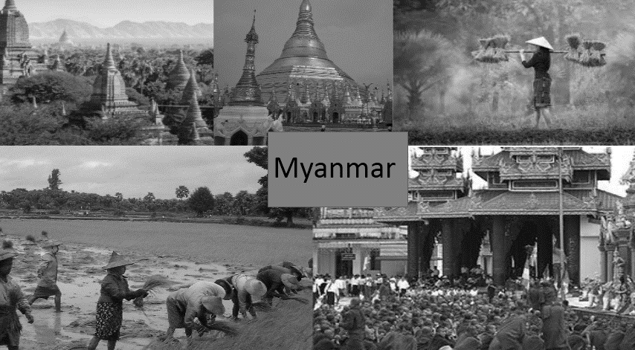



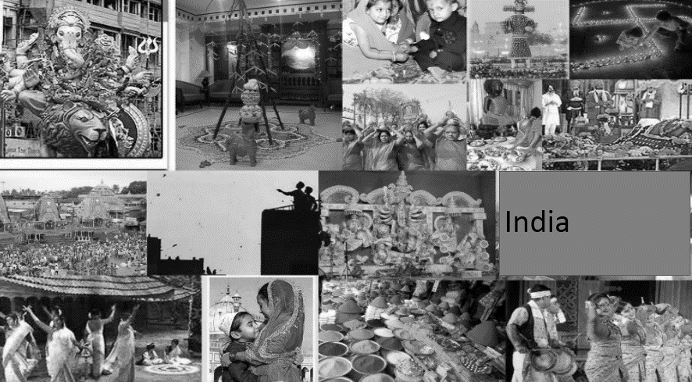

High context vs Low context countries

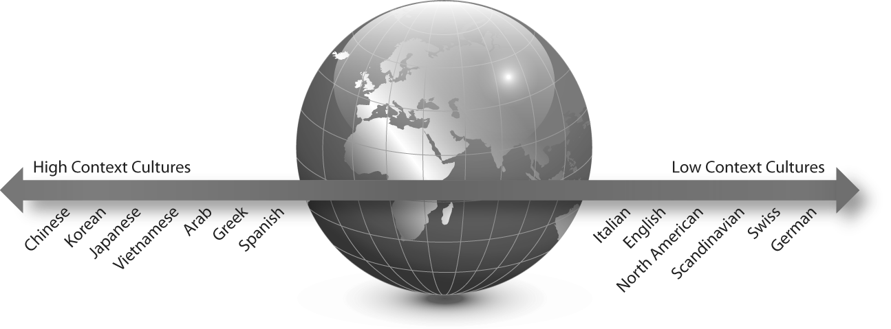

**Different tastes**

[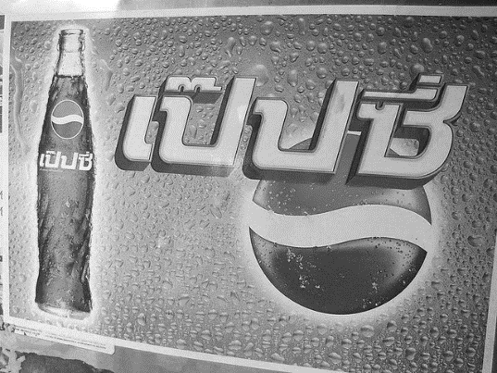](http://ri.search.yahoo.com/_ylt=A0LEVjpmckZTnE8AYpoPxQt.;_ylu=X3oDMTBtdXBkbHJyBHNlYwNmcC1hdHRyaWIEc2xrA3J1cmw-/RV=2/RE=1397154535/RO=10/RU=http:/www.flickr.com/photos/kitsh/2416676/RK=0/RS=ugWediItHIK9ZNr..nlEoTybUSw-)

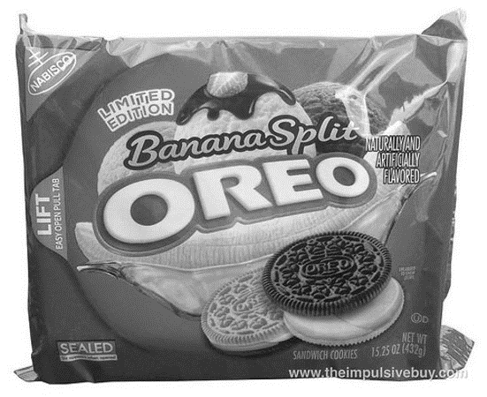

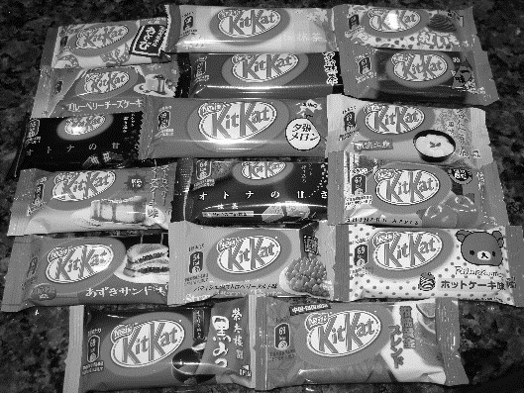

**Language**



Coca cola in China

[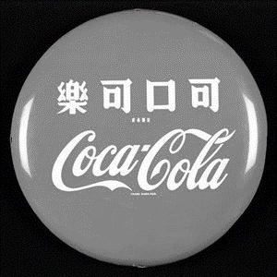](http://www.deadlysins.info/wordpress/wp-content/uploads/2009/03/cocal-cola-china.jpg)

**Unintended meanings**

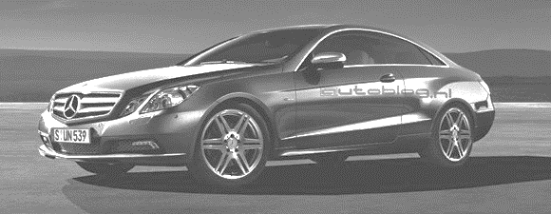

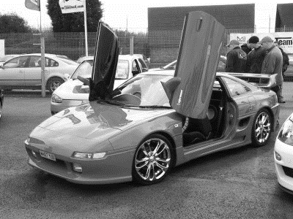

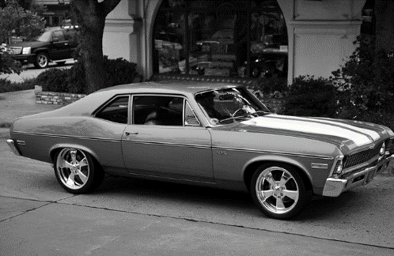

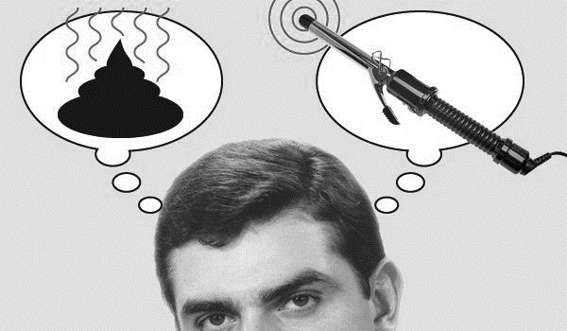



[](http://www.google.co.uk/url?sa=i&rct=j&q=&esrc=s&frm=1&source=images&cd=&cad=rja&docid=IySF2GY6-5A6VM&tbnid=p7OG8qTSbqHqMM:&ved=0CAUQjRw&url=http://impulsapublicidad.wordpress.com/2013/02/01/kraft-foods-cambia-su-nombre-a-mondelez-internacional/&ei=5TArUuboM_LP0AW9s4GwDQ&bvm=bv.51773540,d.d2k&psig=AFQjCNHwN955w6AlqJlSAAOz6e15y2Lg3g&ust=1378648667562820)

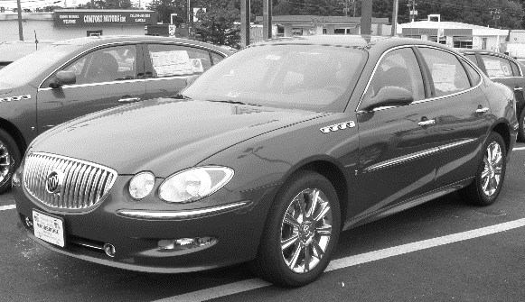

**Inappropriate/inaccurate translations**

|  |  |
| --- | --- |
| Parker Pen |  |
| Pepsi |  |
| Bugatti |  |



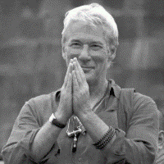

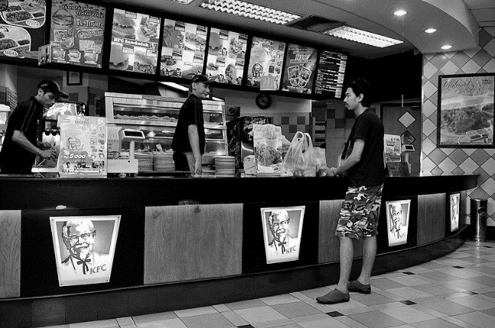

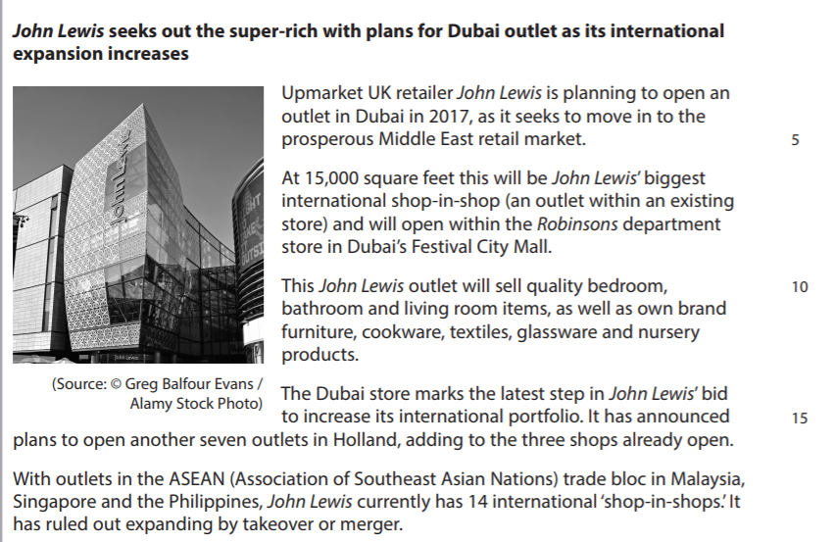



[6]

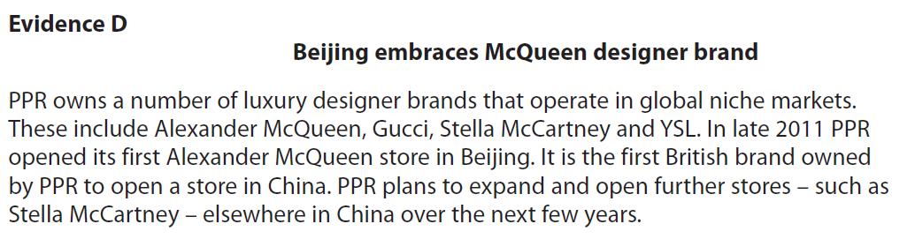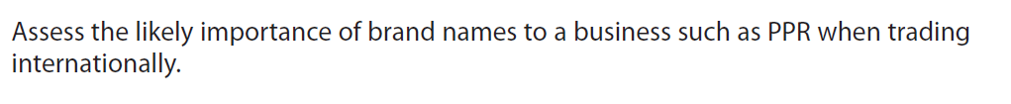

[8]