

3.2.3 Organic Growth

Write a definition of organic growth here:

____________________________________________________________________________________________________________________________________________________________________

**Distinction between inorganic and organic growth**

|  |  |
| --- | --- |
| glaxo |  |
|  |  |

Methods of organic growth

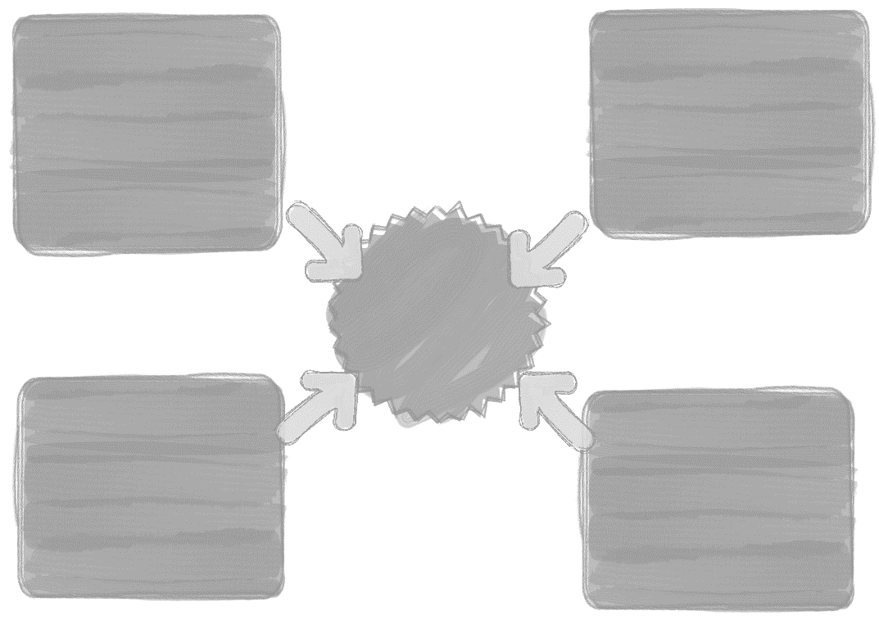

**Advantages and disadvantages of organic growth**

|  |  |
| --- | --- |
| ADVANTAGES | DISADVANTAGES |
|  |  |

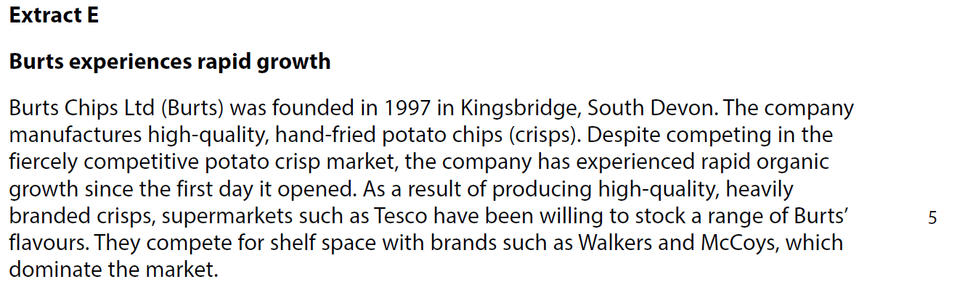







[4]





[4]