

2.2.1 Sales forecasting

Write a definition of sales forecasts here:

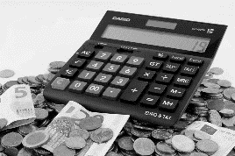________________________________________________________________________________________________________________________________________________________________________________________________________________________________________________________________________________________________________________________________________

**Purpose of sales forecasts**

|  |  |
| --- | --- |
| #1 |  |
| #2 |  |
| #3 |  |
| #4 |  |
| #5 |  |

**Factors affecting sales forecasts**

Consumer trends

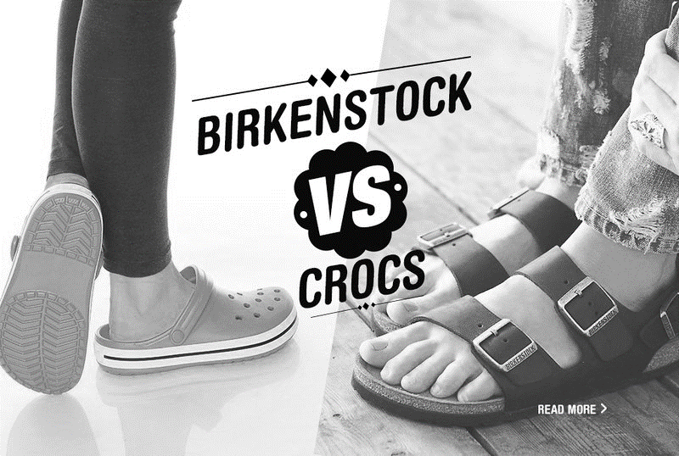

Economic variables

Action of competitors

**Difficulties of sales forecasting**

No guarantees

Dynamic markets

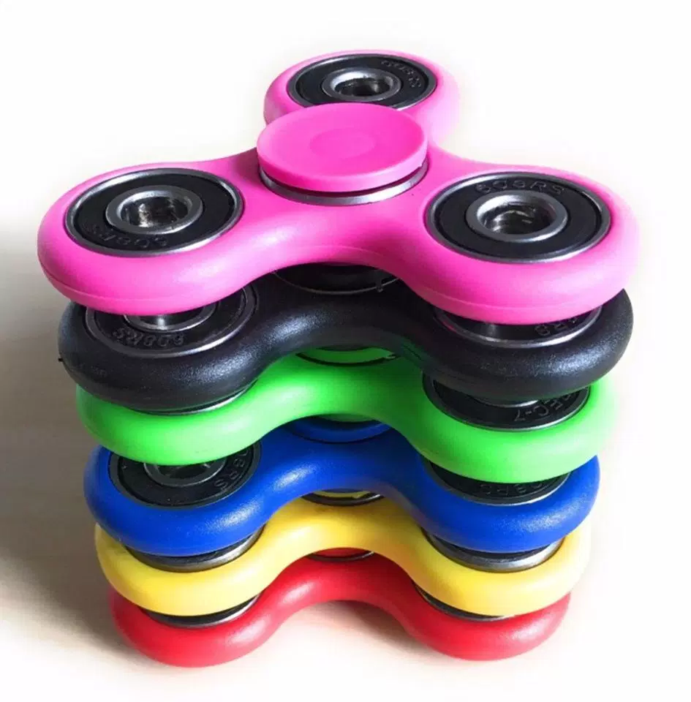

Short-term thinking

