

4.3.1 Marketing

Which of these products can be sold all over the world?

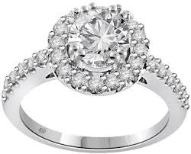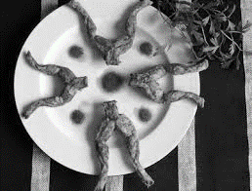

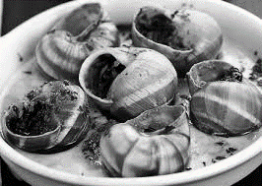

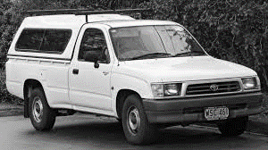



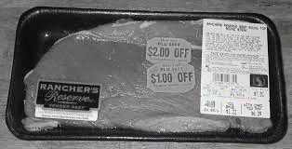







________________________________________________________________________________________________________________________________________________________________________________________________________________________________________________________________________________________________________________________________________

Global brands



________________________________________________________________________________________________________________________________________________________________________________________________________________________________________________________________________________________________________________________________________

Global marketing decisions



________________________________________________________________________________________________________________________________________________________________________________________________________________________________________________________________________________________________________________________________________

Global marketing brand – Disney



_______________________________________________________________________________________________________________________________________________________________________________________________________________________________________________________________________________________________________________________________________

Global marketing advantages and disadvantages

|  |  |
| --- | --- |
| Advantages | Disadvantages |
|  |  |

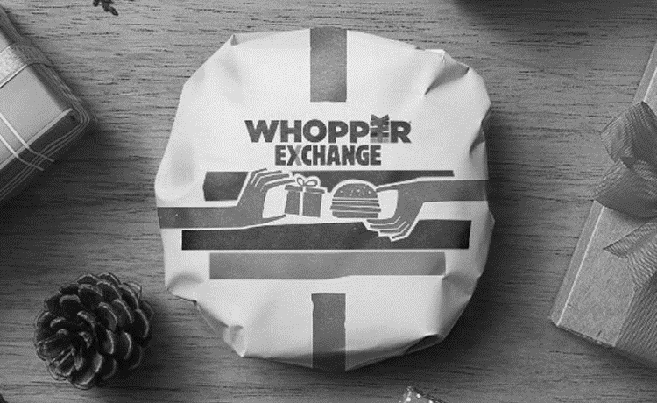

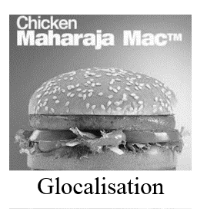**Glocalisation defined**

_______________________________________________________________________________________________________________________________________________________________________________________________________________________________________________________________________________________________________________________________________

Glocalisation and the local market

[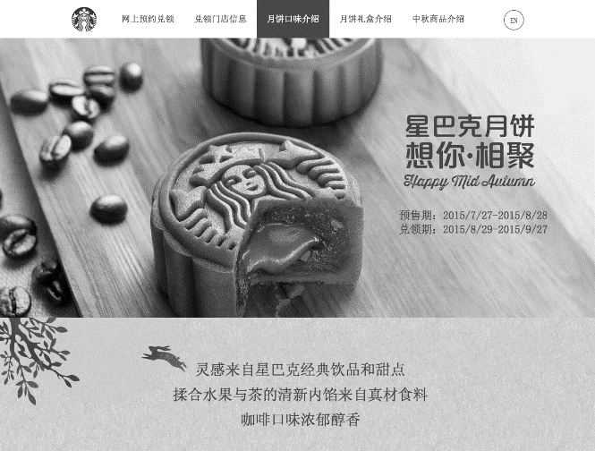](http://www.huffingtonpost.co.uk/april-xiaoyi-xu/to-what-extent-should-sta_b_4222328.html)

_____________________________________________________________________________________________________________________________________________________________________________________________________________________________________________________________________________________________________________________________________

|  |  |
| --- | --- |
|  |  |
|  |  |
|  |  |

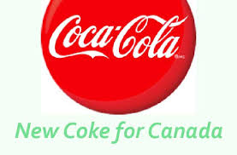

Product

|  |  |
| --- | --- |
| Standardised | Adapted |
|  |  |

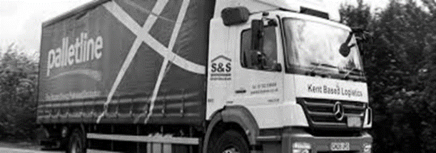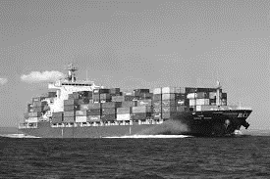

Place

|  |  |
| --- | --- |
| Standardised | Adapted |
|  |  |

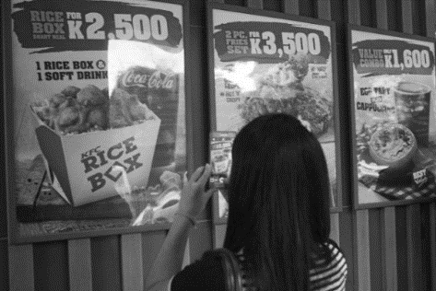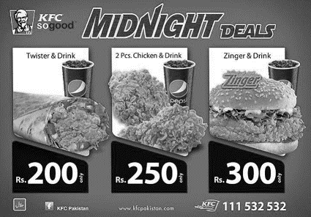

Price

|  |  |
| --- | --- |
| Standardised | Adapted |
|  |  |

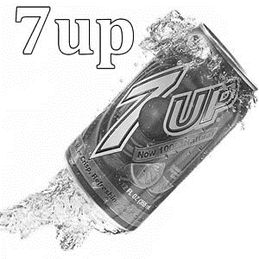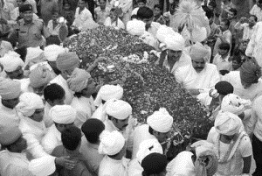

Promotion

|  |  |
| --- | --- |
| Standardised | Adapted |
|  |  |

Application and adaptation of Ansoff’s matrix to global markets

|  |  |
| --- | --- |
|  | 1. |
| 2. |
| 3. |
| 4. |

|  |  |  |
| --- | --- | --- |
|  | **Existing Product or Service** | **New Product or Service** |
| **Existing market** |  |  |
| **New Market** |  |  |

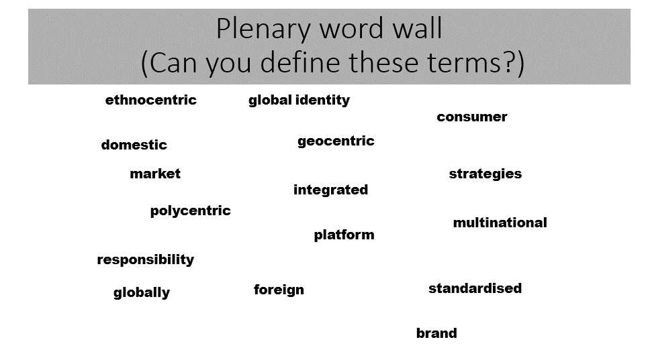

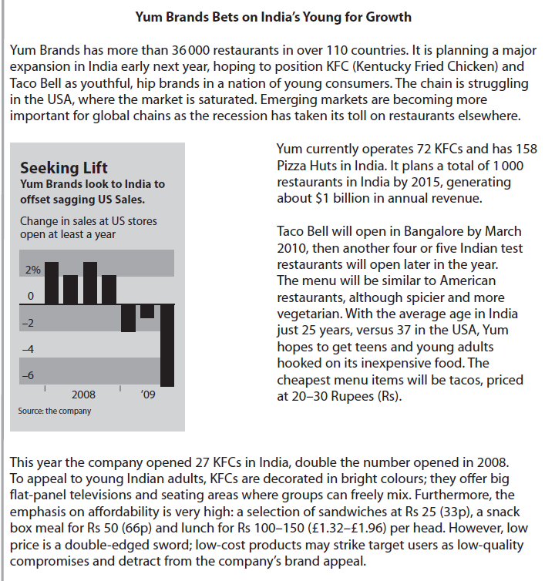

Case study continues with question on next page

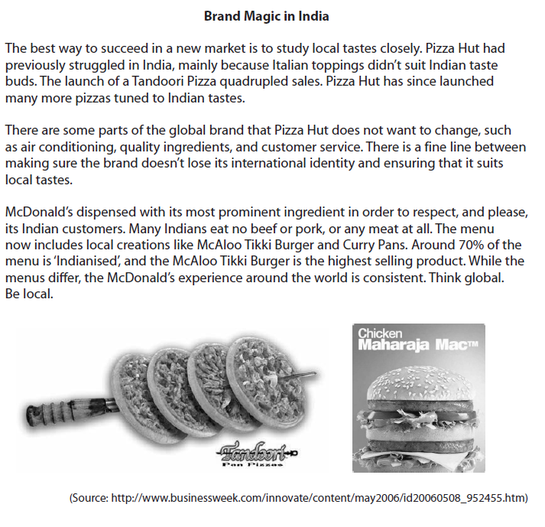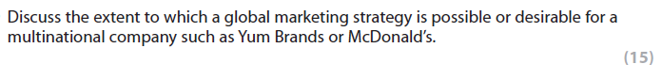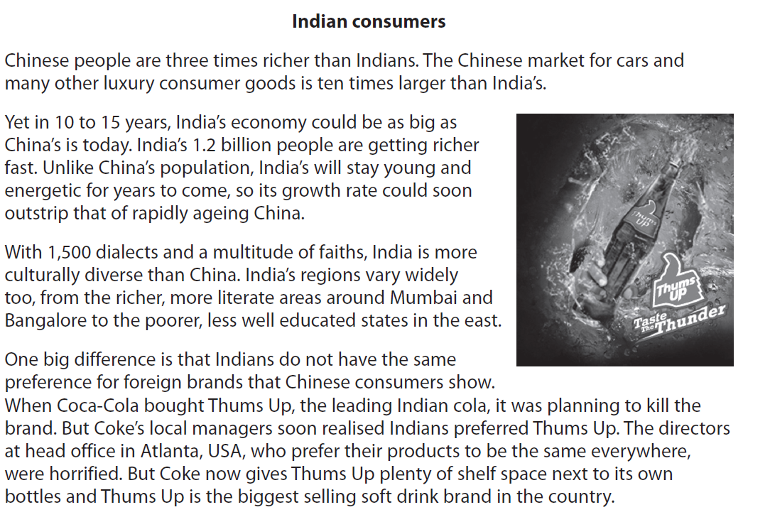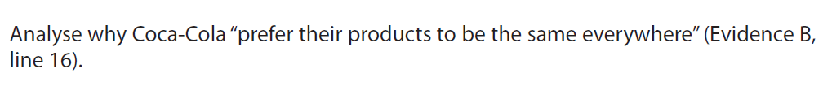

[6]

