Suggestions for Independent Learning.

Books;

*Sophie’s World -* Jostein Gaarder – an excellent introduction to philosophy, a very readable and enjoyable novel.

*Religious Experience* – Peter Cole

*The Puzzle of God* – Peter Vardy.

*An Introduction to Philosophy & Ethics* - Mel Thompson

Publications;

Dialogue; A Journal of Philosophy & Religion. A bi-yearly publication and subscriber website specifically designed for ‘A’ level RS students.

DVDs;

The Cross and the Switchblade (The Nicky Cruz story).

Websites;

<http://qualifications.pearson.com/en/qualifications/edexcel-a-levels/religious-studies-2016.html>

<http://plato.stanford.edu/> An excellent online encyclopaedia of philosophy.

<https://philosophydungeon.weebly.com/>

bd06662_[1]

About the course.

The A level course taught at BHS involves a study of the philosophy of religion including arguments for and against the existence of God with a focus on religious experience and their validity and evidence of God. We also consider the problems suffering and evil pose for the existence of God.



BD05729_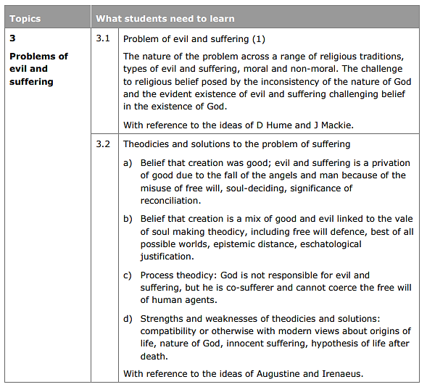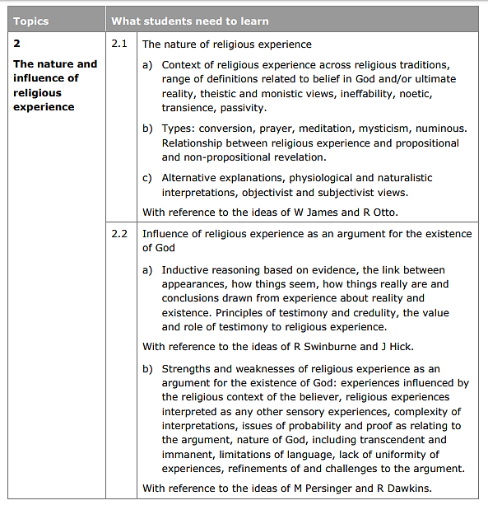

Outline of the AS course;

Philosophy of Religion

* Philosophical issues and questions – Arguments for the existence of God and the strengths and weaknesses of these arguments;
* The nature and influence of religious experience – Different types, examples, and ways of verifying religious experiences;
* Problems of evil and suffering – the nature and problem of evil across different religions and theodicies and solutions to suffering and evil.

Religion and Ethics

* Significant concepts in issues or debates in religion and ethics – environmental issues and equality;
* A study of three ethical theories – utilitarianism, situation ethics, natural moral law;
* Application of ethical theories to issues of importance – war and peace and sexual ethics.

Buddhism

* Religious beliefs, values and teachings – Three Lakshanas, Four Noble Truths, Eightfold path, Five Skhandas, Three Refuges, Five Precepts;
* Sources of wisdom and authority – the life of Buddha, the Tipitaka;
* Practices that shape and express religious identity – Theravada and Mahayana Buddhism, meditation.

The Exam;

*Three exam papers (one paper for each topic) each of one hour in length.*

* Each paper has 2 sections – Section A (3 shorter answer questions and section B, 1 short answer question and 1 essay question).
* Section A – 1 ‘Explore’ question (8 marks AO1) + 2 ‘Assess’ questions (both 9 marks AO2)
* Section B – 4a ‘Explore’ (8 marks AO1) + 4b ‘Analyse’ (20 marks AO2)
* There is no coursework.

BD05729_





Marking and assessments;

Your independent learning tasks will be checked and marked when appropriate.

Practice exam questions and assessments will be marked and graded using the level descriptors provided by the exam board (Edexcel). These will be set at the most appropriate times during the course.



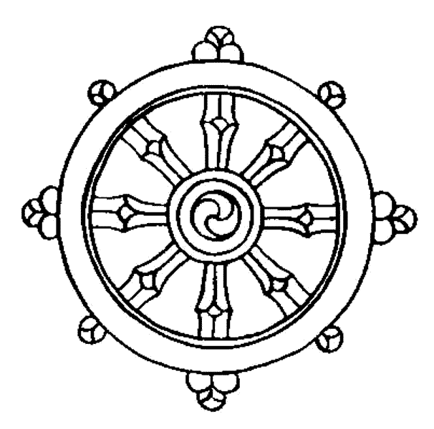

To do well;

* Obviously work hard! This means in lesson time and when doing independent learning.
* Read! Investigate the topics we look at in class further, don’t just rely on what your teacher gives you or the content of text books.
* Practice and review. Practice exam style questions and review work you have done in lesson.



AQA A-level Religious Studies 1

AQA A-level Religious Studies 1

Authors: John Frye

Publisher: Hodder Education

ISBN-13: 978-1-47-187395-9

Price: £24.99

Publication date: February 2017

Digital version available: April 2017